Equivalent Ratios — Homework
Lesson 3-9 • Standard 6.AT.3
Name: ______________________ Period: ______ Date: ____________

Today's Goals
Content: I can find and check equivalent ratios using multiplication and division.
Language: I can explain my reasoning using the words equivalent ratios, rate, proportion, and simplify.

Key Words
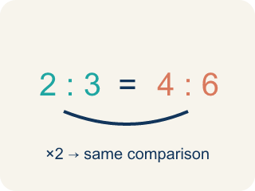
Equivalent Ratios (Razones equivalentes) — Ratios that compare quantities in the same relationship.
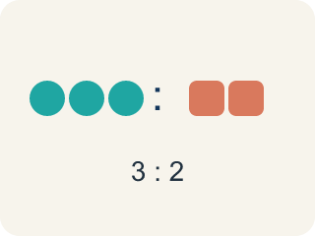
Ratio (Razón) — A way to compare two amounts, like 3 to 2.
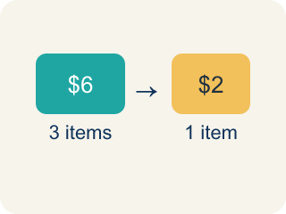
Rate (Tasa) — A ratio comparing two amounts with different units, like miles per hour.
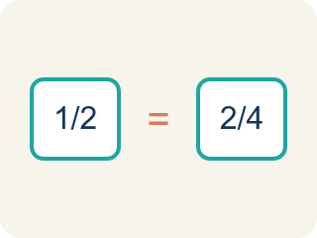
Proportion (Proporción) — A math sentence saying two ratios are equal.
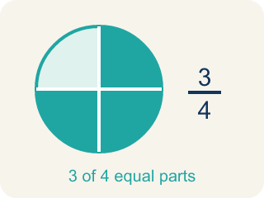
Simplify (Simplificar) — To make a ratio smaller while keeping the same comparison.
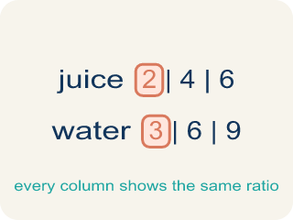
Ratio table (Tabla de razones) — A table of equal ratios that shows a pattern.

Practice
Show your work. Use the blank space under each problem.
1. Which ratio is equivalent to 2:5?
A. 4:10
B. 3:6
C. 2:10
D. 5:2
______________________________________________________________________
2. A recipe uses 4 eggs for every 6 cups of flour. Which ratio is equivalent?
A. 2:3
B. 8:10
C. 4:3
D. 6:4
______________________________________________________________________
3. Sort these ratios — which are equivalent to 3:4 and which are not?
Groups: Equivalent to 3:4 | NOT Equivalent to 3:4
• 6:8 → __________________
• 9:12 → __________________
• 15:20 → __________________
• 3:5 → __________________
• 4:3 → __________________
• 6:12 → __________________
______________________________________________________________________
4. Marcus earns $45 for every 3 hours of work. How much does he earn in 8 hours?
A. $120
B. $90
C. $135
D. $105
______________________________________________________________________
5. Find the missing value that makes each pair of ratios equivalent.
Ratio 1 | Ratio 2 | Missing Value
3:7 | 9:?
5:8 | ?:24
4:6 | ?:3
______________________________________________________________________
6. Spot the Common Mistake — Simplifying a Ratio
Step 1 (Set up the ratio): A student wants to write 12:18 in simplest form.
Step 2 (Find the common factor): Both 12 and 18 can be divided by 6.
Step 3 (Divide each part): 12 ÷ 6 = 2 and 18 ÷ 3 = 6, so they wrote 2:6.
Step 4 (Answer): 12:18 simplifies to 2:6
Which step has the mistake? Explain and fix it:
______________________________________________________________________
______________________________________________________________________
______________________________________________________________________
7. Chef Montoya's dressing uses 3 spoons of oil to 4 spoons of vinegar (3:4). Which recipe card shows an EQUIVALENT ratio?
A. 9:12
B. 4:3
C. 3:8
D. 6:7
______________________________________________________________________
8. The lemonade station mixes 5 cups of lemon juice to 2 cups of sugar (5:2). Which batch keeps the SAME taste?
A. 15:6
B. 10:6
C. 5:4
D. 7:4
______________________________________________________________________
9. Match each recipe ratio to a batch that tastes exactly the same.
Item | Answer choices
____ 2:3 | D. 10:12
____ 3:5 | C. 12:21
____ 4:7 | B. 9:15
____ 5:6 | A. 8:12
______________________________________________________________________
10. The recipe ratio is 2 cups flour to 5 cups milk (2:5). Sort each batch: does it taste the same (equivalent) or not?
Groups: Equivalent to 2:5 | NOT Equivalent to 2:5
• 4:10 → __________________
• 6:15 → __________________
• 8:20 → __________________
• 4:9 → __________________
• 2:7 → __________________
• 5:2 → __________________
______________________________________________________________________

Answer Key (Teacher)
1. A. 4:10
Multiply both parts by 2: 2×2 = 4 and 5×2 = 10, so 4:10 is equivalent to 2:5.
Watch for: A common mistake in Equivalent Ratios is ADDING the scale factor to one part instead of MULTIPLYING both parts by it. For example, scaling 2:5 by a factor of 4 should give 8:20 (2×4 and 5×4) — not 6:9 (2+4 and 5+4). Adding changes the taste of the recipe (and the value of the ratio); only multiplying or dividing both numbers by the same amount keeps it equivalent.
2. A. 2:3
Divide both by 2: 4÷2 = 2 and 6÷2 = 3. The ratio 2:3 is equivalent to 4:6.
Watch for: A common mistake in Equivalent Ratios is ADDING the scale factor to one part instead of MULTIPLYING both parts by it. For example, scaling 2:5 by a factor of 4 should give 8:20 (2×4 and 5×4) — not 6:9 (2+4 and 5+4). Adding changes the taste of the recipe (and the value of the ratio); only multiplying or dividing both numbers by the same amount keeps it equivalent.
3. Correct groups:
6:8 → Equivalent to 3:4
9:12 → Equivalent to 3:4
15:20 → Equivalent to 3:4
3:5 → NOT Equivalent to 3:4
4:3 → NOT Equivalent to 3:4
6:12 → NOT Equivalent to 3:4

4. A. $120
Unit rate: $45 ÷ 3 = $15/hour. In 8 hours: $15 × 8 = $120.
Watch for: A common mistake in Equivalent Ratios is ADDING the scale factor to one part instead of MULTIPLYING both parts by it. For example, scaling 2:5 by a factor of 4 should give 8:20 (2×4 and 5×4) — not 6:9 (2+4 and 5+4). Adding changes the taste of the recipe (and the value of the ratio); only multiplying or dividing both numbers by the same amount keeps it equivalent.
5. Find the missing value that makes each pair of ratios equivalent.
3:7 — Missing Value: 21
5:8 — Missing Value: 15
4:6 — Missing Value: 2

6. Spot the Common Mistake — Simplifying a Ratio
The mistake is in Step 3.
Correct work: Divide BOTH parts by the same number: 12 ÷ 6 = 2 and 18 ÷ 6 = 3, so 12:18 simplifies to 2:3.
Watch for: The "Divide each part" step uses two different divisors: 12 ÷ 6 but 18 ÷ 3. Simplifying only keeps a ratio equivalent when both parts are divided by the same number, so 12 ÷ 6 = 2 and 18 ÷ 6 = 3 give 2:3. The student's 2:6 simplifies to 1:3, which is not the same comparison as 12:18.
7. A. 9:12
Multiply both parts of 3:4 by 3: 3 x 3 = 9 and 4 x 3 = 12, so 9:12 is equivalent to 3:4.
Watch for: A common mistake in Equivalent Ratios is ADDING the scale factor to one part instead of MULTIPLYING both parts by it. For example, scaling 2:5 by a factor of 4 should give 8:20 (2×4 and 5×4) — not 6:9 (2+4 and 5+4). Adding changes the taste of the recipe (and the value of the ratio); only multiplying or dividing both numbers by the same amount keeps it equivalent.
8. A. 15:6
Multiply both parts of 5:2 by 3: 5 x 3 = 15 and 2 x 3 = 6, so 15:6 is equivalent to 5:2.
Watch for: A common mistake in Equivalent Ratios is ADDING the scale factor to one part instead of MULTIPLYING both parts by it. For example, scaling 2:5 by a factor of 4 should give 8:20 (2×4 and 5×4) — not 6:9 (2+4 and 5+4). Adding changes the taste of the recipe (and the value of the ratio); only multiplying or dividing both numbers by the same amount keeps it equivalent.
9. Matches:
2:3 → 8:12
3:5 → 9:15
4:7 → 12:21
5:6 → 10:12

10. Correct groups:
4:10 → Equivalent to 2:5
6:15 → Equivalent to 2:5
8:20 → Equivalent to 2:5
4:9 → NOT Equivalent to 2:5
2:7 → NOT Equivalent to 2:5
5:2 → NOT Equivalent to 2:5

