4.1–4.3 Catch-Up — Homework
Lesson 4-1-catchup • Standard 6.AT.4
Name: ______________________ Period: ______ Date: ____________

Today's Goals
Content: I can show I am caught up on Lessons 4.1–4.3 by using each lesson's big idea in mixed practice.
Language: I can explain which lesson's big idea I used and how, using key vocabulary from Lessons 4.1–4.3.

Key Words
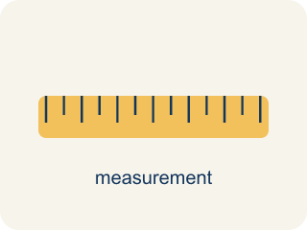
Rates and Unit Rates (Tasas y tasas unitarias) — A rate compares different units; a unit rate compares a quantity to 1 unit.
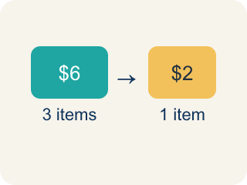
Rate (Tasa) — A ratio comparing two amounts with different units, like miles per hour.
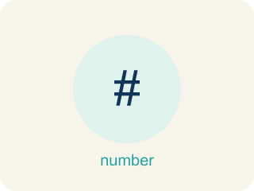
Fractions, Decimals, and Percents (Fracciones, decimales y porcentajes) — Three equivalent ways to name the same part of a whole.
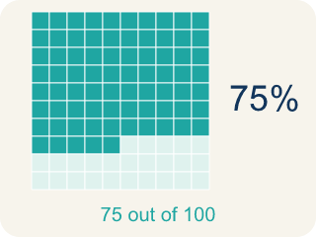
Percent (Porcentaje) — A way to compare a number to 100, shown with the % sign.

Percents Greater Than 100% and Less Than 1% (Porcentajes mayores que 100% y menores que 1%) — Percents can describe amounts greater than one whole or smaller than one hundredth of a whole.

Unit Rate (Tasa unitaria) — A rate for just 1 of something, like cost for 1 item.
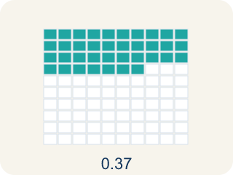
Decimal (Decimal) — A number with a dot, like 0.5, that shows a part less than one.

Greater than 100% (Mayor que 100%) — A percent bigger than 100%, more than the whole thing.

Practice
Show your work. Use the blank space under each problem.
1. (Lesson 4.1) A booth charges $4.50 for 9 games. What is the unit rate?
A. $0.50 per game
B. $0.45 per game
C. $2.00 per game
D. $4.50 per game
______________________________________________________________________
2. (Lesson 4.1) A car travels 180 miles using 6 gallons of gas. What is the unit rate in miles per gallon?
A. 30 miles per gallon
B. 6 miles per gallon
C. 180 miles per gallon
D. 36 miles per gallon
______________________________________________________________________
3. (Lesson 4.1) Which token pack from the table above is the best deal?
A. Pack A
B. Pack B
C. Pack C
D. They are all the same
______________________________________________________________________
4. (Lesson 4.1) Runner A completes 4 laps in 12 minutes. Runner B completes 5 laps in 14 minutes. Who runs more laps per minute?
A. Runner B
B. Runner A
C. Same rate
D. Cannot determine
______________________________________________________________________
5. (Lesson 4.2) A game shows your score as 7/8 complete. What percent is that?
A. 87.5%
B. 78%
C. 75%
D. 88%
______________________________________________________________________
6. (Lesson 4.2) Spot the Common Mistake
Step 1 (Convert 5/8 to a percent): 5/8
Step 2 (Divide the bottom by the top): 8 ÷ 5 = 1.6
Step 3 (Multiply by 100): 1.6 × 100 = 160%
Step 4 (Final answer): 5/8 = 160%
Which step has the mistake? Explain and fix it:
______________________________________________________________________
______________________________________________________________________
______________________________________________________________________
7. (Lesson 4.3) A player scored 0.4% of the bonus points. Which decimal represents this percent?
A. 0.4
B. 0.04
C. 0.004
D. 4.0
______________________________________________________________________
8. (Lesson 4.3) Spot the Common Mistake
Step 1 (Read the problem): A rare item has a 0.8% drop chance. Write 0.8% as a decimal.
Step 2 (Attempt): The student divides 0.8 by 10 instead of 100, moving the decimal only one place.
Step 3 (Final answer): 0.8% = 0.08
Which step has the mistake? Explain and fix it:
______________________________________________________________________
______________________________________________________________________
______________________________________________________________________
9. (Lesson 4.1) The Star Blaster cabinet scored 90 points in 3 games. What is the unit rate in points per game?
A. 30 points per game
B. 270 points per game
C. 3 points per game
D. 93 points per game
______________________________________________________________________
10. (Lesson 4.2) Your arcade scoreboard reads 0.25 of the level cleared. What percent and fraction match this score?
A. 25% and 1/4
B. 2.5% and 1/4
C. 25% and 1/5
D. 250% and 1/40
______________________________________________________________________

Answer Key (Teacher)
1. A. $0.50 per game
$4.50 ÷ 9 = $0.50 per game.
Watch for: A common mistake in Percents Greater Than 100% and Less Than 1% is treating every percent-to-decimal conversion the same way regardless of size — for example, writing 150% as 0.15 (as if it were an ordinary under-100% percent) instead of 1.5, or writing 0.5% as 0.5 (forgetting to divide by 100 at all) instead of 0.005. Before finalizing an answer, check that the decimal for any percent over 100% is greater than 1, and the decimal for any percent under 1% is less than 0.01.
2. A. 30 miles per gallon
180 miles ÷ 6 gallons = 30 miles per gallon.
Watch for: A common mistake in Percents Greater Than 100% and Less Than 1% is treating every percent-to-decimal conversion the same way regardless of size — for example, writing 150% as 0.15 (as if it were an ordinary under-100% percent) instead of 1.5, or writing 0.5% as 0.5 (forgetting to divide by 100 at all) instead of 0.005. Before finalizing an answer, check that the decimal for any percent over 100% is greater than 1, and the decimal for any percent under 1% is less than 0.01.
3. B. Pack B
Pack B has a unit rate of $0.20 per token, which is the lowest cost per token.
Watch for: A common mistake in Percents Greater Than 100% and Less Than 1% is treating every percent-to-decimal conversion the same way regardless of size — for example, writing 150% as 0.15 (as if it were an ordinary under-100% percent) instead of 1.5, or writing 0.5% as 0.5 (forgetting to divide by 100 at all) instead of 0.005. Before finalizing an answer, check that the decimal for any percent over 100% is greater than 1, and the decimal for any percent under 1% is less than 0.01.
4. A. Runner B
Runner A: 4÷12 ≈ 0.33 laps/min. Runner B: 5÷14 ≈ 0.36 laps/min. Runner B runs slightly more laps per minute.
Watch for: A common mistake in Percents Greater Than 100% and Less Than 1% is treating every percent-to-decimal conversion the same way regardless of size — for example, writing 150% as 0.15 (as if it were an ordinary under-100% percent) instead of 1.5, or writing 0.5% as 0.5 (forgetting to divide by 100 at all) instead of 0.005. Before finalizing an answer, check that the decimal for any percent over 100% is greater than 1, and the decimal for any percent under 1% is less than 0.01.
5. A. 87.5%
8 does not scale to 100 by a whole number, so divide: 7 ÷ 8 = 0.875, and 0.875 × 100 = 87.5%. That is 87.5 out of 100.
Watch for: A common mistake in Percents Greater Than 100% and Less Than 1% is treating every percent-to-decimal conversion the same way regardless of size — for example, writing 150% as 0.15 (as if it were an ordinary under-100% percent) instead of 1.5, or writing 0.5% as 0.5 (forgetting to divide by 100 at all) instead of 0.005. Before finalizing an answer, check that the decimal for any percent over 100% is greater than 1, and the decimal for any percent under 1% is less than 0.01.
6. (Lesson 4.2) Spot the Common Mistake
The mistake is in Step 2.
Correct work: The student divided in the wrong order. To turn a fraction into a decimal, divide the TOP by the bottom: 5 ÷ 8 = 0.625, then × 100 → 62.5%. So 5/8 = 0.625 = 62.5%. (A check: 5/8 is less than 1, so the percent must be under 100%, never 160%.)
Watch for: The fraction bar means numerator ÷ denominator, so this division is upside down. It should be 5 ÷ 8 = 0.625, and 0.625 × 100 = 62.5%. A quick check catches it: 5/8 is less than one whole, so its percent must be under 100% — 160% was impossible.
7. C. 0.004
0.4% = 0.4 ÷ 100 = 0.004. Move the decimal point two places to the left.
Watch for: A common mistake in Percents Greater Than 100% and Less Than 1% is treating every percent-to-decimal conversion the same way regardless of size — for example, writing 150% as 0.15 (as if it were an ordinary under-100% percent) instead of 1.5, or writing 0.5% as 0.5 (forgetting to divide by 100 at all) instead of 0.005. Before finalizing an answer, check that the decimal for any percent over 100% is greater than 1, and the decimal for any percent under 1% is less than 0.01.
8. (Lesson 4.3) Spot the Common Mistake
The mistake is in Step 2.
Correct work: To change a percent to a decimal, always divide by 100 — move the decimal point TWO places to the left, not one. 0.8 ÷ 100 = 0.008. So 0.8% = 0.008, which is far less than 1% (0.01), matching the tiny drop chance in the problem.
Watch for: In the Attempt step the student divided by 10 and moved the decimal only one place. Percent to decimal always means dividing by 100, so 0.8 ÷ 100 = 0.008 — a value below 0.01, which matches a drop chance smaller than 1%.
9. A. 30 points per game
Divide points by games: 90 ÷ 3 = 30 points per game.
Watch for: A common mistake in Percents Greater Than 100% and Less Than 1% is treating every percent-to-decimal conversion the same way regardless of size — for example, writing 150% as 0.15 (as if it were an ordinary under-100% percent) instead of 1.5, or writing 0.5% as 0.5 (forgetting to divide by 100 at all) instead of 0.005. Before finalizing an answer, check that the decimal for any percent over 100% is greater than 1, and the decimal for any percent under 1% is less than 0.01.
10. A. 25% and 1/4
Move the decimal two places: 0.25 = 25%. As a fraction, 0.25 = 25/100 = 1/4.
Watch for: A common mistake in Percents Greater Than 100% and Less Than 1% is treating every percent-to-decimal conversion the same way regardless of size — for example, writing 150% as 0.15 (as if it were an ordinary under-100% percent) instead of 1.5, or writing 0.5% as 0.5 (forgetting to divide by 100 at all) instead of 0.005. Before finalizing an answer, check that the decimal for any percent over 100% is greater than 1, and the decimal for any percent under 1% is less than 0.01.

