4.1 Small Group · Group 1 — Homework
Lesson 4-1-group1 • Standard 6.AT.4
Name: ______________________ Period: ______ Date: ____________

Today's Goals
Content: With my small group, I can write and interpret percents greater than 100% and less than 1% — one step at a time, with support.
Language: I can talk through each step out loud using a sentence frame and the lesson's key words.

Key Words
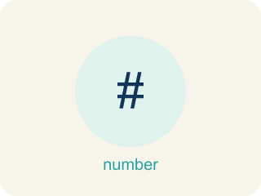
Percents Greater Than 100% and Less Than 1% (Porcentajes mayores que 100% y menores que 1%) — Percents can describe amounts greater than one whole or smaller than one hundredth of a whole.
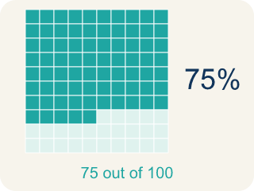
Percent (Porcentaje) — A way to compare a number to 100, shown with the % sign.

Greater than 100% (Mayor que 100%) — A percent bigger than 100%, more than the whole thing.

Less than 1% (Menor que 1%) — A percent smaller than 1%, a very tiny part.
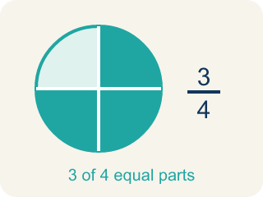
Equivalent (Equivalente) — Having the same value, just written a different way.
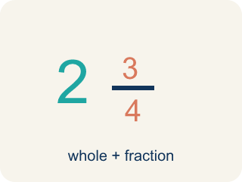
Mixed number (Número mixto) — A whole number plus a fraction, like 2 1/3.

Practice
Show your work. Use the blank space under each problem.
1. Which of the following is greater than 100%?
A. 0.75
B. 3/4
C. 1.25
D. 99/100
______________________________________________________________________
2. What is 200% written as a decimal?
A. 2.0
B. 0.2
C. 20.0
D. 0.02
______________________________________________________________________
3. A power-up boosts your damage to 150% of normal. Written as a decimal and a fraction, 150% equals:
A. 1.5 = 3/2
B. 0.15 = 3/20
C. 15 = 15/1
D. 0.015 = 3/200
______________________________________________________________________
4. A rare game item has a 0.5% drop chance. What is 0.5% written as a decimal?
A. 0.005
B. 0.05
C. 0.5
D. 5
______________________________________________________________________
5. Could this really happen? Your phone shows it is charged to 0.5% — about how much of a 4,000 mAh battery is that?
A. About 20 mAh — a tiny sliver, almost empty
B. About 2,000 mAh — half full
C. About 4,200 mAh — more than full
D. About 200 mAh — a quarter full
______________________________________________________________________
6. Level 2 Extension — The Vanishing Boost
Step 1 (Problem): A bonus round gives a 0.5% point boost. Write 0.5% as a decimal.
Step 2 (Drop the percent sign): 0.5% becomes 0.5
Step 3 (Final answer): 0.5% = 0.5, so the boost is 50% — half the points!
Which step has the mistake? Explain and fix it:
______________________________________________________________________
______________________________________________________________________
______________________________________________________________________
7. Find the Percent Error
Step 1 (Convert 0.6% to a decimal): 0.6%
Step 2 (Move the decimal two places left): 0.6 → 0.06
Step 3 (Final answer): 0.6% = 0.06
Which step has the mistake? Explain and fix it:
______________________________________________________________________
______________________________________________________________________
______________________________________________________________________
8. A game character has 300% of its original health after picking up a power-up. If the original health was 80 points, how many health points does the character have now? A student says 240 points. Another says 380 points. Who is correct and why?
Sentence starter: The student who said ___ is correct because 300% means ___ times the original, so ___ × 80 = ___.
______________________________________________________________________
______________________________________________________________________
______________________________________________________________________
______________________________________________________________________

Answer Key (Teacher)
1. C. 1.25
1.25 = 125%, which is greater than 100%. The other values are all less than 1 (less than 100%).
Watch for: A common mistake in Percents Greater Than 100% and Less Than 1% is treating every percent-to-decimal conversion the same way regardless of size — for example, writing 150% as 0.15 (as if it were an ordinary under-100% percent) instead of 1.5, or writing 0.5% as 0.5 (forgetting to divide by 100 at all) instead of 0.005. Before finalizing an answer, check that the decimal for any percent over 100% is greater than 1, and the decimal for any percent under 1% is less than 0.01.
2. A. 2.0
200% ÷ 100 = 2.0. Percents greater than 100% become decimals greater than 1.
Watch for: A common mistake in Percents Greater Than 100% and Less Than 1% is treating every percent-to-decimal conversion the same way regardless of size — for example, writing 150% as 0.15 (as if it were an ordinary under-100% percent) instead of 1.5, or writing 0.5% as 0.5 (forgetting to divide by 100 at all) instead of 0.005. Before finalizing an answer, check that the decimal for any percent over 100% is greater than 1, and the decimal for any percent under 1% is less than 0.01.
3. A. 1.5 = 3/2
150% = 150 ÷ 100 = 1.5, and 150/100 simplifies to 3/2. It is more than one whole, so the decimal is greater than 1.
Watch for: A common mistake in Percents Greater Than 100% and Less Than 1% is treating every percent-to-decimal conversion the same way regardless of size — for example, writing 150% as 0.15 (as if it were an ordinary under-100% percent) instead of 1.5, or writing 0.5% as 0.5 (forgetting to divide by 100 at all) instead of 0.005. Before finalizing an answer, check that the decimal for any percent over 100% is greater than 1, and the decimal for any percent under 1% is less than 0.01.
4. A. 0.005
0.5% = 0.5 ÷ 100 = 0.005. Because it is less than 1%, the decimal must be less than 0.01.
Watch for: A common mistake in Percents Greater Than 100% and Less Than 1% is treating every percent-to-decimal conversion the same way regardless of size — for example, writing 150% as 0.15 (as if it were an ordinary under-100% percent) instead of 1.5, or writing 0.5% as 0.5 (forgetting to divide by 100 at all) instead of 0.005. Before finalizing an answer, check that the decimal for any percent over 100% is greater than 1, and the decimal for any percent under 1% is less than 0.01.
5. A. About 20 mAh — a tiny sliver, almost empty
0.5% = 0.005, and 0.005 × 4,000 = 20 mAh. A percent less than 1% is a tiny part, so the phone is nearly dead.
Watch for: A common mistake in Percents Greater Than 100% and Less Than 1% is treating every percent-to-decimal conversion the same way regardless of size — for example, writing 150% as 0.15 (as if it were an ordinary under-100% percent) instead of 1.5, or writing 0.5% as 0.5 (forgetting to divide by 100 at all) instead of 0.005. Before finalizing an answer, check that the decimal for any percent over 100% is greater than 1, and the decimal for any percent under 1% is less than 0.01.
6. Level 2 Extension — The Vanishing Boost
The mistake is in Step 3.
Correct work: 0.5% does NOT equal 0.5. To change a percent to a decimal, divide by 100 (move the decimal two places left): 0.5 ÷ 100 = 0.005. So 0.5% = 0.005, a tiny boost far less than 1% — not a huge 50% boost.
Watch for: The mistake is in the step that just drops the percent sign: erasing % does not convert anything. Percent to decimal means dividing by 100, so 0.5 ÷ 100 = 0.005 — a boost far smaller than 1%, not the half-the-points 50% the student claimed.
7. Find the Percent Error
The mistake is in Step 2.
Correct work: 0.6% means 0.6 out of 100. Move the decimal two places left: 0.6 → 0.006. The correct answer is 0.6% = 0.006.
Watch for: The step that moves the decimal shifted 0.6 only one place, landing on 0.06 instead of 0.006. Since 0.6% means 0.6 out of 100, the decimal point moves two places left, and the result must be below 0.01 because 0.6% is less than 1%.
8. Open response — answers will vary.
Look for key words: 300%, 3, 240, multiply, greater than 100, whole.

