4.1 Small Group · Group 2 — Homework
Lesson 4-1-group2 • Standard 6.AT.4
Name: ______________________ Period: ______ Date: ____________

Today's Goals
Content: I can write and interpret percents greater than 100% and less than 1%, explain what each part stands for, and build one for a situation I have not seen before.
Language: I can justify my answer to a skeptic and connect it to a second strategy or representation.

Key Words
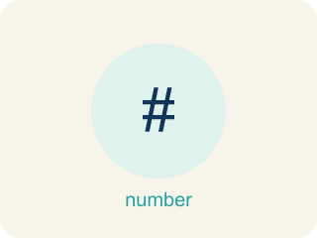
Percents Greater Than 100% and Less Than 1% (Porcentajes mayores que 100% y menores que 1%) — Percents can describe amounts greater than one whole or smaller than one hundredth of a whole.
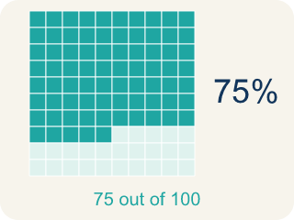
Percent (Porcentaje) — A way to compare a number to 100, shown with the % sign.

Greater than 100% (Mayor que 100%) — A percent bigger than 100%, more than the whole thing.

Less than 1% (Menor que 1%) — A percent smaller than 1%, a very tiny part.
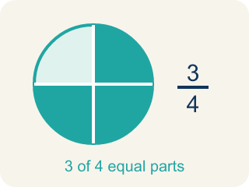
Equivalent (Equivalente) — Having the same value, just written a different way.
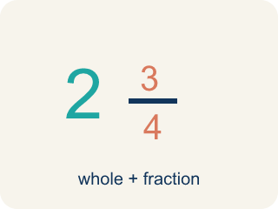
Mixed number (Número mixto) — A whole number plus a fraction, like 2 1/3.

Practice
Show your work. Use the blank space under each problem.
1. A player scored 0.4% of the bonus points. Which decimal represents this percent?
A. 0.4
B. 0.04
C. 0.004
D. 4.0
______________________________________________________________________
2. Spot the Common Mistake
Step 1 (Read the problem): A rare item has a 0.8% drop chance. Write 0.8% as a decimal.
Step 2 (Attempt): The student divides 0.8 by 10 instead of 100, moving the decimal only one place.
Step 3 (Final answer): 0.8% = 0.08
Which step has the mistake? Explain and fix it:
______________________________________________________________________
______________________________________________________________________
______________________________________________________________________
3. Find the Percent Error
Step 1 (Convert 0.6% to a decimal): 0.6%
Step 2 (Move the decimal two places left): 0.6 → 0.06
Step 3 (Final answer): 0.6% = 0.06
Which step has the mistake? Explain and fix it:
______________________________________________________________________
______________________________________________________________________
______________________________________________________________________
4. A game character has 300% of its original health after picking up a power-up. If the original health was 80 points, how many health points does the character have now? A student says 240 points. Another says 380 points. Who is correct and why?
Sentence starter: The student who said ___ is correct because 300% means ___ times the original, so ___ × 80 = ___.
______________________________________________________________________
______________________________________________________________________
______________________________________________________________________
______________________________________________________________________

Answer Key (Teacher)
1. C. 0.004
0.4% = 0.4 ÷ 100 = 0.004. Move the decimal point two places to the left.
Watch for: A common mistake in Percents Greater Than 100% and Less Than 1% is treating every percent-to-decimal conversion the same way regardless of size — for example, writing 150% as 0.15 (as if it were an ordinary under-100% percent) instead of 1.5, or writing 0.5% as 0.5 (forgetting to divide by 100 at all) instead of 0.005. Before finalizing an answer, check that the decimal for any percent over 100% is greater than 1, and the decimal for any percent under 1% is less than 0.01.
2. Spot the Common Mistake
The mistake is in Step 2.
Correct work: To change a percent to a decimal, always divide by 100 — move the decimal point TWO places to the left, not one. 0.8 ÷ 100 = 0.008. So 0.8% = 0.008, which is far less than 1% (0.01), matching the tiny drop chance in the problem.
Watch for: In the Attempt step the student divided by 10 and moved the decimal only one place. Percent to decimal always means dividing by 100, so 0.8 ÷ 100 = 0.008 — a value below 0.01, which matches a drop chance smaller than 1%.
3. Find the Percent Error
The mistake is in Step 2.
Correct work: 0.6% means 0.6 out of 100. Move the decimal two places left: 0.6 → 0.006. The correct answer is 0.6% = 0.006.
Watch for: The step that moves the decimal shifted 0.6 only one place, landing on 0.06 instead of 0.006. Since 0.6% means 0.6 out of 100, the decimal point moves two places left, and the result must be below 0.01 because 0.6% is less than 1%.
4. Open response — answers will vary.
Look for key words: 300%, 3, 240, multiply, greater than 100, whole.

