4.2 Small Group · Group 1 — Homework
Lesson 4-2-group1 • Standard 6.AT.4
Name: ______________________ Period: ______ Date: ____________

Today's Goals
Content: With my small group, I can write equivalent fractions, decimals, and percents for the same value — one step at a time, with support.
Language: I can talk through each step out loud using a sentence frame and the lesson's key words.

Key Words
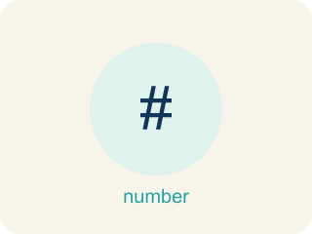
Fractions, Decimals, and Percents (Fracciones, decimales y porcentajes) — Three equivalent ways to name the same part of a whole.
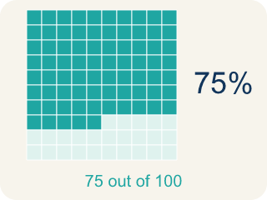
Percent (Porcentaje) — A way to compare a number to 100, shown with the % sign.
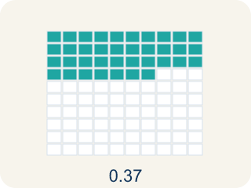
Decimal (Decimal) — A number with a dot, like 0.5, that shows a part less than one.
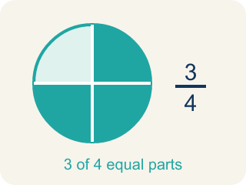
Equivalent (Equivalente) — Having the same value, just written a different way.
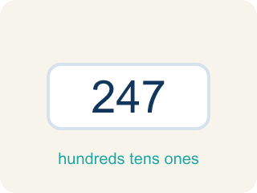
Benchmark (Referencia) — A familiar number you use to guess, like 50% or 1/2.
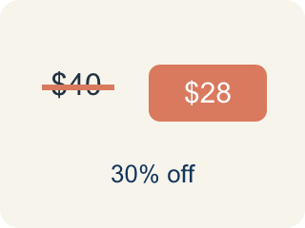
Discount (Descuento) — Money taken off the first price to make it cheaper.

Practice
Show your work. Use the blank space under each problem.
1. Convert 3/5 to a percent.
A. 60%
B. 35%
C. 53%
D. 65%
______________________________________________________________________
2. Convert 7/20 to a percent.
A. 35%
B. 70%
C. 20%
D. 14%
______________________________________________________________________
3. Your arcade scoreboard reads 0.25 of the level cleared. What percent and fraction match this score?
A. 25% and 1/4
B. 2.5% and 1/4
C. 25% and 1/5
D. 250% and 1/40
______________________________________________________________________
4. A player powered up 3/5 of the energy bar. Which decimal and percent name the same amount?
A. 0.6 and 60%
B. 0.35 and 35%
C. 0.6 and 6%
D. 0.65 and 65%
______________________________________________________________________
5. Level 2 Extension — Find the Decimal-to-Percent Mistake
Step 1 (Convert 0.4 to a percent): 0.4
Step 2 (Move the decimal point): 0.4 → 0.04
Step 3 (Write the percent): 0.04 = 4%
Step 4 (Final answer): 0.4 = 4%
Which step has the mistake? Explain and fix it:
______________________________________________________________________
______________________________________________________________________
______________________________________________________________________
6. Find the Conversion Error
Step 1 (Convert 2/3 to a percent): 2/3
Step 2 (Divide numerator by denominator): 2 ÷ 3 = 0.67
Step 3 (Move decimal two places): 0.67 → 67%
Step 4 (Final answer): 2/3 = 67%
Which step has the mistake? Explain and fix it:
______________________________________________________________________
______________________________________________________________________
______________________________________________________________________
7. A student says 3/8 is greater than 40% because 3 and 8 are bigger numbers than 4 and 0. Is the student correct? Convert both values to the same form and explain.
Sentence starter: The student is ___ because 3/8 = ___ = ___%, which is ___ than 40%.
______________________________________________________________________
______________________________________________________________________
______________________________________________________________________
______________________________________________________________________
8. Sort these values — which are greater than 50% and which are less than 50%?
Groups: Greater than 50% | Less than 50%
• 3/4 → __________________
• 0.8 → __________________
• 65% → __________________
• 7/10 → __________________
• 1/3 → __________________
• 0.25 → __________________
• 40% → __________________
• 2/5 → __________________
______________________________________________________________________

Answer Key (Teacher)
1. A. 60%
5 × 20 = 100, so 3 × 20 = 60. That makes 3/5 = 60/100 = 0.6 = 60%.
Watch for: A common mistake in Relate Fractions, Decimals, and Percents is treating the numerator and denominator as the percent's digits — turning 3/5 into "35%" by just reading the 3 and the 5. Percent means out of 100, so the fix is to build an equivalent fraction with denominator 100: 5 × 20 = 100, so multiply the top by 20 too — 3/5 = 60/100 = 60%. A second version of this mistake is scaling only ONE part of the fraction (writing 3/5 = 3/100 or 60/5). Whatever you multiply the denominator by, you must multiply the numerator by the same number. When a denominator will not reach 100 evenly (8, 3, 7), divide the numerator by the denominator instead and then multiply by 100.
2. A. 35%
20 × 5 = 100, so 7 × 5 = 35. That makes 7/20 = 35/100 = 0.35 = 35%.
Watch for: A common mistake in Relate Fractions, Decimals, and Percents is treating the numerator and denominator as the percent's digits — turning 3/5 into "35%" by just reading the 3 and the 5. Percent means out of 100, so the fix is to build an equivalent fraction with denominator 100: 5 × 20 = 100, so multiply the top by 20 too — 3/5 = 60/100 = 60%. A second version of this mistake is scaling only ONE part of the fraction (writing 3/5 = 3/100 or 60/5). Whatever you multiply the denominator by, you must multiply the numerator by the same number. When a denominator will not reach 100 evenly (8, 3, 7), divide the numerator by the denominator instead and then multiply by 100.
3. A. 25% and 1/4
Move the decimal two places: 0.25 = 25%. As a fraction, 0.25 = 25/100 = 1/4.
Watch for: A common mistake in Relate Fractions, Decimals, and Percents is treating the numerator and denominator as the percent's digits — turning 3/5 into "35%" by just reading the 3 and the 5. Percent means out of 100, so the fix is to build an equivalent fraction with denominator 100: 5 × 20 = 100, so multiply the top by 20 too — 3/5 = 60/100 = 60%. A second version of this mistake is scaling only ONE part of the fraction (writing 3/5 = 3/100 or 60/5). Whatever you multiply the denominator by, you must multiply the numerator by the same number. When a denominator will not reach 100 evenly (8, 3, 7), divide the numerator by the denominator instead and then multiply by 100.
4. A. 0.6 and 60%
5 × 20 = 100 and 3 × 20 = 60, so 3/5 = 60/100 = 0.6 = 60%.
Watch for: A common mistake in Relate Fractions, Decimals, and Percents is treating the numerator and denominator as the percent's digits — turning 3/5 into "35%" by just reading the 3 and the 5. Percent means out of 100, so the fix is to build an equivalent fraction with denominator 100: 5 × 20 = 100, so multiply the top by 20 too — 3/5 = 60/100 = 60%. A second version of this mistake is scaling only ONE part of the fraction (writing 3/5 = 3/100 or 60/5). Whatever you multiply the denominator by, you must multiply the numerator by the same number. When a denominator will not reach 100 evenly (8, 3, 7), divide the numerator by the denominator instead and then multiply by 100.
5. Level 2 Extension — Find the Decimal-to-Percent Mistake
The mistake is in Step 2.
Correct work: To change a decimal to a percent, multiply by 100 (move the decimal two places RIGHT): 0.4 × 100 = 40. So 0.4 = 40%, not 4%.
Watch for: Going from a decimal to a percent means multiplying by 100, which moves the decimal point two places to the RIGHT. Moving it left divides instead, which is why 0.4 turned into 0.04. Done correctly, 0.4 × 100 = 40, so 0.4 = 40%.
6. Find the Conversion Error
The mistake is in Step 2.
Correct work: 2 ÷ 3 = 0.666... (repeating). The exact answer is 66.7% or 66⅔%.
Watch for: The division is set up the right way, but 2 ÷ 3 does not end — it gives 0.666... repeating. Writing 0.67 rounds the value, so the percent it produces (67%) is rounded too. The exact answer is 66.7% or 66⅔%.
7. Open response — answers will vary.
Look for key words: not correct, 0.375, 37.5%, less than, convert, compare.
8. Correct groups:
3/4 → Greater than 50%
0.8 → Greater than 50%
65% → Greater than 50%
7/10 → Greater than 50%
1/3 → Less than 50%
0.25 → Less than 50%
40% → Less than 50%
2/5 → Less than 50%

