4.2 Small Group · Group 2 — Homework
Lesson 4-2-group2 • Standard 6.AT.4
Name: ______________________ Period: ______ Date: ____________

Today's Goals
Content: I can write equivalent fractions, decimals, and percents for the same value, explain what each part stands for, and build one for a situation I have not seen before.
Language: I can justify my answer to a skeptic and connect it to a second strategy or representation.

Key Words
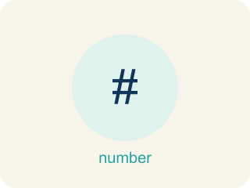
Fractions, Decimals, and Percents (Fracciones, decimales y porcentajes) — Three equivalent ways to name the same part of a whole.
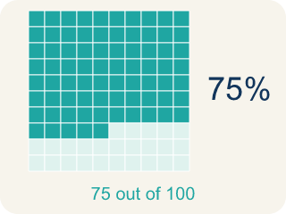
Percent (Porcentaje) — A way to compare a number to 100, shown with the % sign.
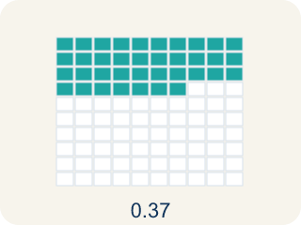
Decimal (Decimal) — A number with a dot, like 0.5, that shows a part less than one.
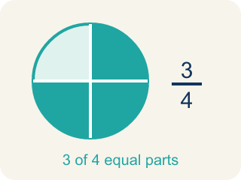
Equivalent (Equivalente) — Having the same value, just written a different way.
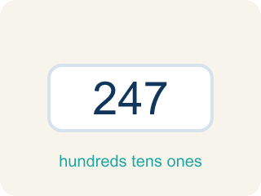
Benchmark (Referencia) — A familiar number you use to guess, like 50% or 1/2.
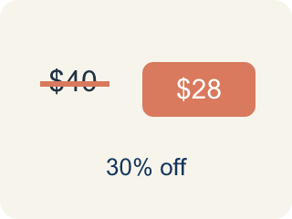
Discount (Descuento) — Money taken off the first price to make it cheaper.

Practice
Show your work. Use the blank space under each problem.
1. A game shows your score as 7/8 complete. What percent is that?
A. 87.5%
B. 78%
C. 75%
D. 88%
______________________________________________________________________
2. Spot the Common Mistake
Step 1 (Convert 5/8 to a percent): 5/8
Step 2 (Divide the bottom by the top): 8 ÷ 5 = 1.6
Step 3 (Multiply by 100): 1.6 × 100 = 160%
Step 4 (Final answer): 5/8 = 160%
Which step has the mistake? Explain and fix it:
______________________________________________________________________
______________________________________________________________________
______________________________________________________________________
3. Find the Conversion Error
Step 1 (Convert 2/3 to a percent): 2/3
Step 2 (Divide numerator by denominator): 2 ÷ 3 = 0.67
Step 3 (Move decimal two places): 0.67 → 67%
Step 4 (Final answer): 2/3 = 67%
Which step has the mistake? Explain and fix it:
______________________________________________________________________
______________________________________________________________________
______________________________________________________________________
4. A student says 3/8 is greater than 40% because 3 and 8 are bigger numbers than 4 and 0. Is the student correct? Convert both values to the same form and explain.
Sentence starter: The student is ___ because 3/8 = ___ = ___%, which is ___ than 40%.
______________________________________________________________________
______________________________________________________________________
______________________________________________________________________
______________________________________________________________________

Answer Key (Teacher)
1. A. 87.5%
8 does not scale to 100 by a whole number, so divide: 7 ÷ 8 = 0.875, and 0.875 × 100 = 87.5%. That is 87.5 out of 100.
Watch for: A common mistake in Relate Fractions, Decimals, and Percents is treating the numerator and denominator as the percent's digits — turning 3/5 into "35%" by just reading the 3 and the 5. Percent means out of 100, so the fix is to build an equivalent fraction with denominator 100: 5 × 20 = 100, so multiply the top by 20 too — 3/5 = 60/100 = 60%. A second version of this mistake is scaling only ONE part of the fraction (writing 3/5 = 3/100 or 60/5). Whatever you multiply the denominator by, you must multiply the numerator by the same number. When a denominator will not reach 100 evenly (8, 3, 7), divide the numerator by the denominator instead and then multiply by 100.
2. Spot the Common Mistake
The mistake is in Step 2.
Correct work: The student divided in the wrong order. To turn a fraction into a decimal, divide the TOP by the bottom: 5 ÷ 8 = 0.625, then × 100 → 62.5%. So 5/8 = 0.625 = 62.5%. (A check: 5/8 is less than 1, so the percent must be under 100%, never 160%.)
Watch for: The fraction bar means numerator ÷ denominator, so this division is upside down. It should be 5 ÷ 8 = 0.625, and 0.625 × 100 = 62.5%. A quick check catches it: 5/8 is less than one whole, so its percent must be under 100% — 160% was impossible.
3. Find the Conversion Error
The mistake is in Step 2.
Correct work: 2 ÷ 3 = 0.666... (repeating). The exact answer is 66.7% or 66⅔%.
Watch for: The division is set up the right way, but 2 ÷ 3 does not end — it gives 0.666... repeating. Writing 0.67 rounds the value, so the percent it produces (67%) is rounded too. The exact answer is 66.7% or 66⅔%.
4. Open response — answers will vary.
Look for key words: not correct, 0.375, 37.5%, less than, convert, compare.

