4.3 Small Group · Group 2 — Homework
Lesson 4-3-group2 • Standard 6.AT.4
Name: ______________________ Period: ______ Date: ____________

Today's Goals
Content: I can estimate the percent of a number using benchmark percents, rounding, and compatible numbers, explain why the method works, and use it on a problem I have not seen before.
Language: I can justify my answer to a skeptic and connect it to a second strategy or representation.

Key Words
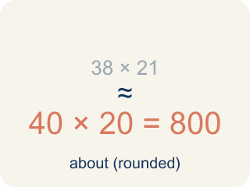
estimate (estimación) — A reasoned answer that is close enough to be useful, found without exact computation.
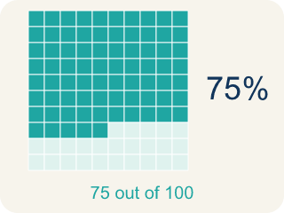
benchmark percent (porcentaje de referencia) — A friendly percent — 1%, 10%, 25%, 50%, 75%, 100% — used as a landmark for estimating.

compatible numbers (números compatibles) — Numbers close to the originals that are easy to compute with mentally.
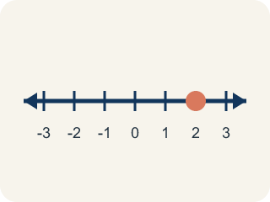
double number line (recta numérica doble) — Two parallel number lines that pair amounts with their percents at the same positions.
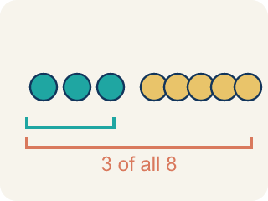
the whole (el todo) — The quantity that counts as 100% in a problem — and it can change between questions.

Practice
Show your work. Use the blank space under each problem.
1. The Green-Team recycled 216 pounds; 8.6% was metal. Using compatible numbers 10% and 200, the estimate is:
A. 20 pounds
B. 2 pounds
C. 208 pounds
D. 86 pounds
______________________________________________________________________
2. Photos use 3.5 GB of the 4 GB of used storage. About what percent of the USED storage is photos?
A. About 87%
B. About 58%
C. About 35%
D. About 99%
______________________________________________________________________
3. Why did the whole change between the two storage questions?
A. The second question asks about the used storage, so 4 GB becomes 100%
B. The phone gained storage between the questions
C. The whole never changes in a percent problem
D. Because photos are more important than mail
______________________________________________________________________
4. Estimate 24% of 81 with benchmarks.
A. About 20
B. About 40
C. About 8
D. About 2
______________________________________________________________________

Answer Key (Teacher)
1. A. 20 pounds
10% of 200 = 0.1 × 200 = 20 pounds of metal.
Watch for: Keeping the same whole for every question — when the problem says 'of the used storage,' the whole changes from 6 GB to 4 GB, and estimates anchored to the old whole are wrong before any arithmetic happens.
2. A. About 87%
The whole is 4 GB here. 75% of 4 is 3 GB and 100% is 4 GB; 3.5 sits midway — about 87%.
Watch for: Keeping the same whole for every question — when the problem says 'of the used storage,' the whole changes from 6 GB to 4 GB, and estimates anchored to the old whole are wrong before any arithmetic happens.
3. A. The second question asks about the used storage, so 4 GB becomes 100%
Each percent question defines its own whole. 'Of the used storage' makes the 4 GB the new 100%.
Watch for: Keeping the same whole for every question — when the problem says 'of the used storage,' the whole changes from 6 GB to 4 GB, and estimates anchored to the old whole are wrong before any arithmetic happens.
4. A. About 20
24% is about 25%, and 81 is about 80. One quarter of 80 is 20.
Watch for: Keeping the same whole for every question — when the problem says 'of the used storage,' the whole changes from 6 GB to 4 GB, and estimates anchored to the old whole are wrong before any arithmetic happens.

