4.4 Small Group · Group 1 — Homework
Lesson 4-4-group1 • Standard 6.AT.4
Name: ______________________ Period: ______ Date: ____________

Today's Goals
Content: With my small group, I can find the percent of a number using an equation or a model — one step at a time, with support.
Language: I can talk through each step out loud using a sentence frame and the lesson's key words.

Key Words
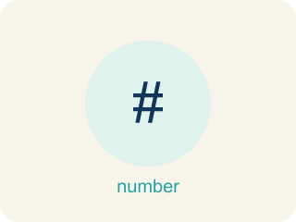
Percent of a Number (Porcentaje de un número) — A part of a number found by multiplying the number by the percent written as a decimal.
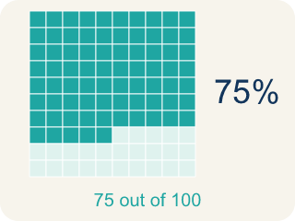
Percent (Porcentaje) — A way to compare a number to 100, shown with the % sign.
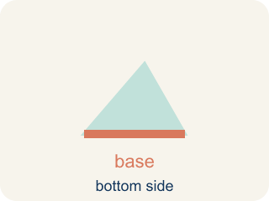
Base (Base) — The whole amount you start with — the number right after the word “of.”
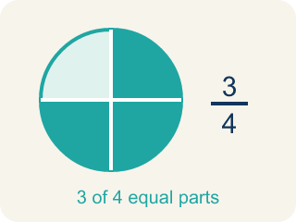
Part (Parte) — How much of the base (the whole) you get. It is your answer.
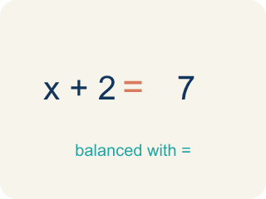
Equation (Ecuación) — A number sentence with an equal sign. The percent one is: part = percent × base.
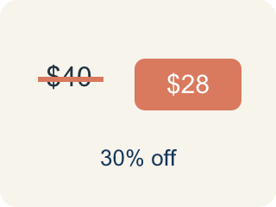
Discount (Descuento) — Money taken off the first price to make it cheaper.

Practice
Show your work. Use the blank space under each problem.
1. What is 20% of 150?
A. 30
B. 20
C. 35
D. 75
______________________________________________________________________
2. What is 50% of 84?
A. 42
B. 50
C. 34
D. 168
______________________________________________________________________
3. A student scored 72 out of 90 on a test. What percent did they score?
A. 80%
B. 72%
C. 75%
D. 90%
______________________________________________________________________
4. The claw machine prize is 80 tickets and today it is 25% off. How many tickets do you save?
A. 20
B. 25
C. 55
D. 16
______________________________________________________________________
5. Your bowling score was 60 points. The bonus round adds 15% more points. How many bonus points is that?
A. 9
B. 15
C. 45
D. 75
______________________________________________________________________
6. A snack at the arcade costs $40. The sales tax is 5%. How many dollars is the tax?
A. $2
B. $5
C. $8
D. $20
______________________________________________________________________
7. Level 2 Extension — Discount Dash Color-by-Code Error
Step 1 (Find 20% of 50): 20% of 50
Step 2 (Use the percent): Use 20 as the part
Step 3 (Write the answer): 20% of 50 = 20
Which step has the mistake? Explain and fix it:
______________________________________________________________________
______________________________________________________________________
______________________________________________________________________
8. Find the Percent Error
Step 1 (Find 30% of 90): 30% of 90
Step 2 (Convert percent to decimal): 30% = 3.0
Step 3 (Multiply): 3.0 × 90 = 270
Step 4 (Final answer): 30% of 90 = 270
Which step has the mistake? Explain and fix it:
______________________________________________________________________
______________________________________________________________________
______________________________________________________________________

Answer Key (Teacher)
1. A. 30
20% = 0.20. Multiply: 0.20 × 150 = 30.
Watch for: A common mistake in Find the Percent of a Number is multiplying by the percent number itself instead of its decimal form — for example, finding 30% of 80 by computing 30 × 80 = 2,400 instead of 0.30 × 80 = 24. Always divide the percent by 100 to get the decimal, then multiply that decimal by the base.
2. A. 42
50% = 0.50. Multiply: 0.50 × 84 = 42. (Or simply divide by 2: 84 ÷ 2 = 42.)
Watch for: A common mistake in Find the Percent of a Number is multiplying by the percent number itself instead of its decimal form — for example, finding 30% of 80 by computing 30 × 80 = 2,400 instead of 0.30 × 80 = 24. Always divide the percent by 100 to get the decimal, then multiply that decimal by the base.
3. A. 80%
72/90 simplifies to 8/10, and 10 × 10 = 100, so 8 × 10 = 80. That makes 72/90 = 80/100 = 80%.
Watch for: A common mistake in Find the Percent of a Number is multiplying by the percent number itself instead of its decimal form — for example, finding 30% of 80 by computing 30 × 80 = 2,400 instead of 0.30 × 80 = 24. Always divide the percent by 100 to get the decimal, then multiply that decimal by the base.
4. A. 20
25% = 0.25. Multiply: 0.25 × 80 = 20 tickets saved.
Watch for: A common mistake in Find the Percent of a Number is multiplying by the percent number itself instead of its decimal form — for example, finding 30% of 80 by computing 30 × 80 = 2,400 instead of 0.30 × 80 = 24. Always divide the percent by 100 to get the decimal, then multiply that decimal by the base.
5. A. 9
15% = 0.15. Multiply: 0.15 × 60 = 9 bonus points.
Watch for: A common mistake in Find the Percent of a Number is multiplying by the percent number itself instead of its decimal form — for example, finding 30% of 80 by computing 30 × 80 = 2,400 instead of 0.30 × 80 = 24. Always divide the percent by 100 to get the decimal, then multiply that decimal by the base.
6. A. $2
5% = 0.05. Multiply: 0.05 × 40 = $2 in tax.
Watch for: A common mistake in Find the Percent of a Number is multiplying by the percent number itself instead of its decimal form — for example, finding 30% of 80 by computing 30 × 80 = 2,400 instead of 0.30 × 80 = 24. Always divide the percent by 100 to get the decimal, then multiply that decimal by the base.
7. Level 2 Extension — Discount Dash Color-by-Code Error
The mistake is in Step 2.
Correct work: First change 20% to a decimal: 20 ÷ 100 = 0.20. Then multiply by the base: 0.20 × 50 = 10. So 20% of 50 = 10, not 20.
Watch for: The work never uses the base at all: it takes 20 straight from '20%' and calls that the part. Percent means per hundred, so 20% = 20 ÷ 100 = 0.20, and the part is 0.20 × 50 = 10.
8. Find the Percent Error
The mistake is in Step 2.
Correct work: 30% = 0.30 (divide by 100, not by 10). 0.30 × 90 = 27. The correct answer is 27.
Watch for: The conversion step is where it goes wrong: the student moved the decimal only one place and wrote 30% = 3.0. A percent is divided by 100, which moves the decimal two places, so 30% = 0.30 and 0.30 × 90 = 27.

