4.4 Small Group · Group 2 — Homework
Lesson 4-4-group2 • Standard 6.AT.4
Name: ______________________ Period: ______ Date: ____________

Today's Goals
Content: I can find the percent of a number using an equation or a model, explain what each part stands for, and build one for a situation I have not seen before.
Language: I can justify my answer to a skeptic and connect it to a second strategy or representation.

Key Words
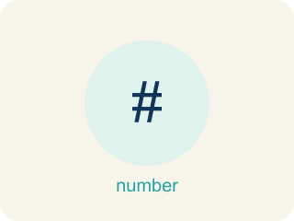
Percent of a Number (Porcentaje de un número) — A part of a number found by multiplying the number by the percent written as a decimal.
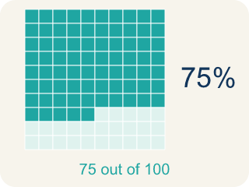
Percent (Porcentaje) — A way to compare a number to 100, shown with the % sign.
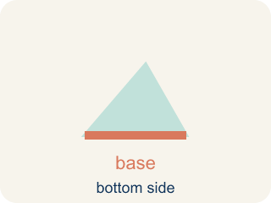
Base (Base) — The whole amount you start with — the number right after the word “of.”
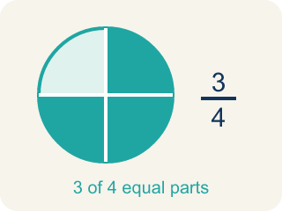
Part (Parte) — How much of the base (the whole) you get. It is your answer.
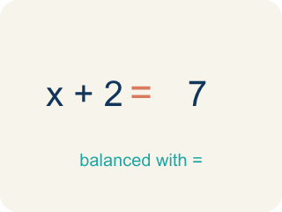
Equation (Ecuación) — A number sentence with an equal sign. The percent one is: part = percent × base.
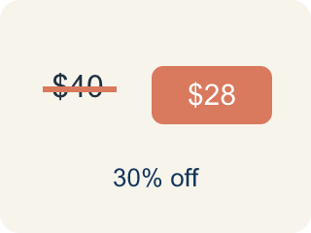
Discount (Descuento) — Money taken off the first price to make it cheaper.

Practice
Show your work. Use the blank space under each problem.
1. An arcade prize costs 240 tickets. If you have a coupon for 15% off, how many tickets do you save?
A. 36 tickets
B. 24 tickets
C. 15 tickets
D. 204 tickets
______________________________________________________________________
2. A student scored 72 out of 90 on a test. What percent did they score?
A. 80%
B. 72%
C. 75%
D. 90%
______________________________________________________________________
3. Spot the Common Mistake
Step 1 (Find 15% of 60): 15% of 60
Step 2 (Change the percent to a decimal): 15% = 0.15
Step 3 (Multiply by the wrong number): 0.15 × 15 = 2.25
Step 4 (Final answer): 15% of 60 = 2.25
Which step has the mistake? Explain and fix it:
______________________________________________________________________
______________________________________________________________________
______________________________________________________________________
4. Find the Percent Error
Step 1 (Find 30% of 90): 30% of 90
Step 2 (Convert percent to decimal): 30% = 3.0
Step 3 (Multiply): 3.0 × 90 = 270
Step 4 (Final answer): 30% of 90 = 270
Which step has the mistake? Explain and fix it:
______________________________________________________________________
______________________________________________________________________
______________________________________________________________________

Answer Key (Teacher)
1. A. 36 tickets
15% of 240 = 0.15 × 240 = 36 tickets saved.
Watch for: A common mistake in Find the Percent of a Number is multiplying by the percent number itself instead of its decimal form — for example, finding 30% of 80 by computing 30 × 80 = 2,400 instead of 0.30 × 80 = 24. Always divide the percent by 100 to get the decimal, then multiply that decimal by the base.
2. A. 80%
72/90 simplifies to 8/10, and 10 × 10 = 100, so 8 × 10 = 80. That makes 72/90 = 80/100 = 80%.
Watch for: A common mistake in Find the Percent of a Number is multiplying by the percent number itself instead of its decimal form — for example, finding 30% of 80 by computing 30 × 80 = 2,400 instead of 0.30 × 80 = 24. Always divide the percent by 100 to get the decimal, then multiply that decimal by the base.
3. Spot the Common Mistake
The mistake is in Step 3.
Correct work: The base is 60, not 15. The word "of" tells you the base: 15% OF 60. Multiply by the base: 0.15 × 60 = 9. So 15% of 60 = 9, not 2.25. The student multiplied by the percent number instead of the base.
Watch for: Converting 15% to 0.15 was right, but then the student multiplied 0.15 by 15, reusing the percent number instead of the base. The word 'of' points to the base, so it is 0.15 × 60 = 9.
4. Find the Percent Error
The mistake is in Step 2.
Correct work: 30% = 0.30 (divide by 100, not by 10). 0.30 × 90 = 27. The correct answer is 27.
Watch for: The conversion step is where it goes wrong: the student moved the decimal only one place and wrote 30% = 3.0. A percent is divided by 100, which moves the decimal two places, so 30% = 0.30 and 0.30 × 90 = 27.

