4.5 Small Group · Group 1 — Homework
Lesson 4-5-group1 • Standard 6.AT.4
Name: ______________________ Period: ______ Date: ____________

Today's Goals
Content: With my small group, I can solve problems involving discounts, markups, tax, and tips using percents — one step at a time, with support.
Language: I can talk through each step out loud using a sentence frame and the lesson's key words.

Key Words
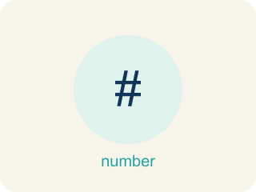
Percent Problem Solving (Resolución de problemas con porcentajes) — Use a percent to find a part, a whole, or a percent change in a real situation.
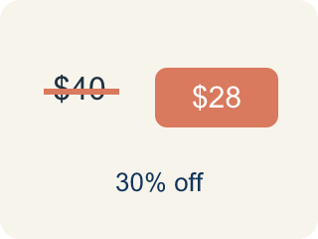
Discount (Descuento) — Money taken off the first price to make it cheaper.
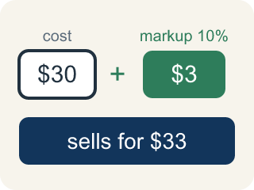
Markup (Recargo (margen)) — The extra amount a store adds to what it paid, found by taking a percent of that cost. Cost + markup = selling price.
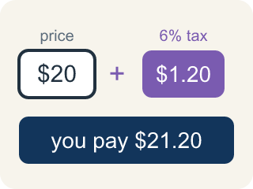
Tax (Impuesto) — Extra money added to the price of a purchase for the government, found by taking a percent of the price. Price + tax = total.
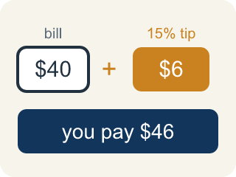
Tip (Propina) — Extra money you add for good service, found by taking a percent of the bill. Bill + tip = total.
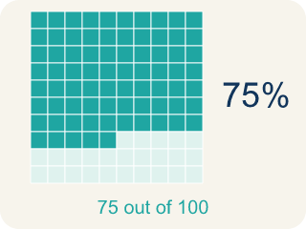
Percent (Porcentaje) — A way to compare a number to 100, shown with the % sign.

Practice
Show your work. Use the blank space under each problem.
1. A prize costs 120 tickets and is 25% off. What is the sale price?
A. 90 tickets
B. 95 tickets
C. 100 tickets
D. 30 tickets
______________________________________________________________________
2. A meal costs $20. You leave a 15% tip. How much is the tip?
A. $3.00
B. $1.50
C. $5.00
D. $0.15
______________________________________________________________________
3. A restaurant bill is $35. You want to leave a 20% tip. What is the total amount you pay?
A. $42.00
B. $40.00
C. $38.50
D. $55.00
______________________________________________________________________
4. Spot the Discount-then-Tax Mistake
Step 1 (Read): A $50 jacket is 20% off, then 5% tax is added. Find the final price.
Step 2 (Find the discount and sale price): 0.20 × 50 = 10 off, so the sale price is 50 − 10 = $40.
Step 3 (Add the tax): Tax = 0.05 × 50 = $2.50, so the total is 40 + 2.50 = $42.50.
Which step has the mistake? Explain and fix it:
______________________________________________________________________
______________________________________________________________________
______________________________________________________________________
5. Store 1 — Sneaker Spot: A pair of sneakers is $60 with 20% off. What is the sale price?
A. $48
B. $40
C. $52
D. $12
______________________________________________________________________
6. Store 2 — Tech Stop: A $25 phone case has 8% sales tax added. What is the total cost?
A. $27
B. $33
C. $25.08
D. $23
______________________________________________________________________
7. Store 3 — Food Court: Your lunch bill is $40. You leave a 15% tip. How much is the tip?
A. $6
B. $4
C. $15
D. $46
______________________________________________________________________
8. Level 2 Extension — Tax-on-Discounted-Price Mistake
Step 1 (A $90 hoodie is 20% off, then 6% tax is added. Find the final price.): $90 hoodie, 20% off, 6% tax
Step 2 (Find the discount and the sale price): 0.20 x 90 = 18, so sale price = 90 - 18 = $72
Step 3 (Add the tax): Tax = 0.06 x 90 = 5.40
Step 4 (Final price): 72 + 5.40 = $77.40
Which step has the mistake? Explain and fix it:
______________________________________________________________________
______________________________________________________________________
______________________________________________________________________

Answer Key (Teacher)
1. A. 90 tickets
25% of 120 = 0.25 × 120 = 30. Sale price: 120 − 30 = 90 tickets.
Watch for: A common mistake in Use Percent to Solve Problems is combining the discount and tax into one single percent change instead of applying them one after another. For a $40 item with a 25% discount and 8% sales tax, a student might compute 40 × (1 − 0.25 + 0.08) = 40 × 0.83 = $33.20, treating the tax as if it applies to the original price. But tax is charged on the discounted price, not the original price: first take 25% off $40 to get $40 × 0.75 = $30, then add 8% tax on that $30: $30 × 1.08 = $32.40. The correct final price is $32.40, not $33.20 — always compute the discount first, then apply tax to the new lower price.
2. A. $3.00
15% of $20 = 0.15 × 20 = $3.00.
Watch for: A common mistake in Use Percent to Solve Problems is combining the discount and tax into one single percent change instead of applying them one after another. For a $40 item with a 25% discount and 8% sales tax, a student might compute 40 × (1 − 0.25 + 0.08) = 40 × 0.83 = $33.20, treating the tax as if it applies to the original price. But tax is charged on the discounted price, not the original price: first take 25% off $40 to get $40 × 0.75 = $30, then add 8% tax on that $30: $30 × 1.08 = $32.40. The correct final price is $32.40, not $33.20 — always compute the discount first, then apply tax to the new lower price.
3. A. $42.00
Tip: 0.20 × $35 = $7.00. Total: $35 + $7 = $42.00.
Watch for: A common mistake in Use Percent to Solve Problems is combining the discount and tax into one single percent change instead of applying them one after another. For a $40 item with a 25% discount and 8% sales tax, a student might compute 40 × (1 − 0.25 + 0.08) = 40 × 0.83 = $33.20, treating the tax as if it applies to the original price. But tax is charged on the discounted price, not the original price: first take 25% off $40 to get $40 × 0.75 = $30, then add 8% tax on that $30: $30 × 1.08 = $32.40. The correct final price is $32.40, not $33.20 — always compute the discount first, then apply tax to the new lower price.
4. Spot the Discount-then-Tax Mistake
The mistake is in Step 3.
Correct work: Tax goes on the price you actually pay ($40), not the original $50. Tax = 0.05 × 40 = $2. Final price = 40 + 2 = $42.
Watch for: The "Add the tax" step charges the 5% on the original $50 instead of on the $40 you actually pay after the discount. Tax is always applied to the current price, so the tax is 0.05 × 40 = $2 and the final price is 40 + 2 = $42, not $42.50.
5. A. $48
Discount: 0.20 x 60 = 12. Sale price: 60 - 12 = $48.
Watch for: A common mistake in Use Percent to Solve Problems is combining the discount and tax into one single percent change instead of applying them one after another. For a $40 item with a 25% discount and 8% sales tax, a student might compute 40 × (1 − 0.25 + 0.08) = 40 × 0.83 = $33.20, treating the tax as if it applies to the original price. But tax is charged on the discounted price, not the original price: first take 25% off $40 to get $40 × 0.75 = $30, then add 8% tax on that $30: $30 × 1.08 = $32.40. The correct final price is $32.40, not $33.20 — always compute the discount first, then apply tax to the new lower price.
6. A. $27
Tax: 0.08 x 25 = 2. Total: 25 + 2 = $27.
Watch for: A common mistake in Use Percent to Solve Problems is combining the discount and tax into one single percent change instead of applying them one after another. For a $40 item with a 25% discount and 8% sales tax, a student might compute 40 × (1 − 0.25 + 0.08) = 40 × 0.83 = $33.20, treating the tax as if it applies to the original price. But tax is charged on the discounted price, not the original price: first take 25% off $40 to get $40 × 0.75 = $30, then add 8% tax on that $30: $30 × 1.08 = $32.40. The correct final price is $32.40, not $33.20 — always compute the discount first, then apply tax to the new lower price.
7. A. $6
Tip: 0.15 x 40 = $6.
Watch for: A common mistake in Use Percent to Solve Problems is combining the discount and tax into one single percent change instead of applying them one after another. For a $40 item with a 25% discount and 8% sales tax, a student might compute 40 × (1 − 0.25 + 0.08) = 40 × 0.83 = $33.20, treating the tax as if it applies to the original price. But tax is charged on the discounted price, not the original price: first take 25% off $40 to get $40 × 0.75 = $30, then add 8% tax on that $30: $30 × 1.08 = $32.40. The correct final price is $32.40, not $33.20 — always compute the discount first, then apply tax to the new lower price.
8. Level 2 Extension — Tax-on-Discounted-Price Mistake
The mistake is in Step 3.
Correct work: Tax must be charged on the price you actually pay ($72), not the original $90. Tax = 0.06 x 72 = 4.32. Final price = 72 + 4.32 = $76.32.
Watch for: The discount was handled correctly, giving a sale price of 90 − 18 = $72. The "Add the tax" step is where it breaks: the 6% was charged on the original $90 instead of on the $72 you actually pay. Tax = 0.06 × 72 = $4.32, so the final price is 72 + 4.32 = $76.32, not $77.40.

