4.5 Small Group · Group 2 — Homework
Lesson 4-5-group2 • Standard 6.AT.4
Name: ______________________ Period: ______ Date: ____________

Today's Goals
Content: I can solve problems involving discounts, markups, tax, and tips using percents, explain why the method works, and use it on a problem I have not seen before.
Language: I can justify my answer to a skeptic and connect it to a second strategy or representation.

Key Words
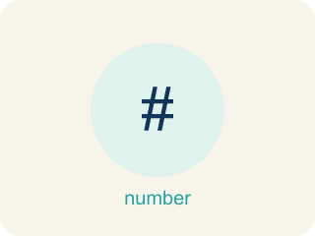
Percent Problem Solving (Resolución de problemas con porcentajes) — Use a percent to find a part, a whole, or a percent change in a real situation.
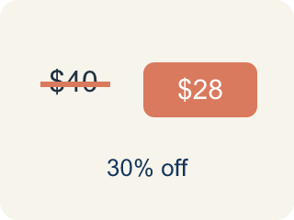
Discount (Descuento) — Money taken off the first price to make it cheaper.
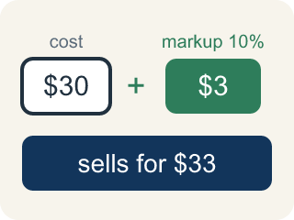
Markup (Recargo (margen)) — The extra amount a store adds to what it paid, found by taking a percent of that cost. Cost + markup = selling price.
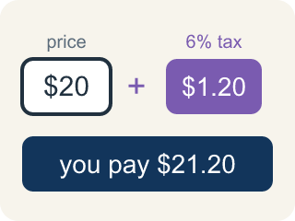
Tax (Impuesto) — Extra money added to the price of a purchase for the government, found by taking a percent of the price. Price + tax = total.
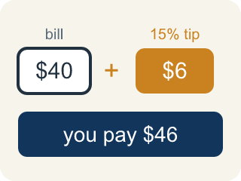
Tip (Propina) — Extra money you add for good service, found by taking a percent of the bill. Bill + tip = total.
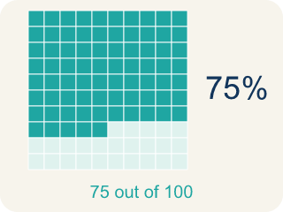
Percent (Porcentaje) — A way to compare a number to 100, shown with the % sign.

Practice
Show your work. Use the blank space under each problem.
1. A store marks up a $30 item by 40%, then a customer gets 10% off. What is the final price?
A. $37.80
B. $39.00
C. $42.00
D. $36.00
______________________________________________________________________
2. A restaurant bill is $35. You want to leave a 20% tip. What is the total amount you pay?
A. $42.00
B. $40.00
C. $38.50
D. $55.00
______________________________________________________________________
3. Spot the Discount-then-Tax Mistake
Step 1 (Read): A $50 jacket is 20% off, then 5% tax is added. Find the final price.
Step 2 (Find the discount and sale price): 0.20 × 50 = 10 off, so the sale price is 50 − 10 = $40.
Step 3 (Add the tax): Tax = 0.05 × 50 = $2.50, so the total is 40 + 2.50 = $42.50.
Which step has the mistake? Explain and fix it:
______________________________________________________________________
______________________________________________________________________
______________________________________________________________________
4. Find the Discount Error
Step 1 (A prize costs 160 tickets at 25% off. Find the sale price.): 160 tickets, 25% off
Step 2 (Find 25% of 160): 25 × 160 = 4,000
Step 3 (Subtract discount): 160 − 4,000 = −3,840
Step 4 (Final answer): Sale price is −3,840 tickets
Which step has the mistake? Explain and fix it:
______________________________________________________________________
______________________________________________________________________
______________________________________________________________________

Answer Key (Teacher)
1. A. $37.80
Markup: $30 × 1.40 = $42. Discount: $42 × 0.10 = $4.20. Final: $42 − $4.20 = $37.80.
Watch for: A common mistake in Use Percent to Solve Problems is combining the discount and tax into one single percent change instead of applying them one after another. For a $40 item with a 25% discount and 8% sales tax, a student might compute 40 × (1 − 0.25 + 0.08) = 40 × 0.83 = $33.20, treating the tax as if it applies to the original price. But tax is charged on the discounted price, not the original price: first take 25% off $40 to get $40 × 0.75 = $30, then add 8% tax on that $30: $30 × 1.08 = $32.40. The correct final price is $32.40, not $33.20 — always compute the discount first, then apply tax to the new lower price.
2. A. $42.00
Tip: 0.20 × $35 = $7.00. Total: $35 + $7 = $42.00.
Watch for: A common mistake in Use Percent to Solve Problems is combining the discount and tax into one single percent change instead of applying them one after another. For a $40 item with a 25% discount and 8% sales tax, a student might compute 40 × (1 − 0.25 + 0.08) = 40 × 0.83 = $33.20, treating the tax as if it applies to the original price. But tax is charged on the discounted price, not the original price: first take 25% off $40 to get $40 × 0.75 = $30, then add 8% tax on that $30: $30 × 1.08 = $32.40. The correct final price is $32.40, not $33.20 — always compute the discount first, then apply tax to the new lower price.
3. Spot the Discount-then-Tax Mistake
The mistake is in Step 3.
Correct work: Tax goes on the price you actually pay ($40), not the original $50. Tax = 0.05 × 40 = $2. Final price = 40 + 2 = $42.
Watch for: The "Add the tax" step charges the 5% on the original $50 instead of on the $40 you actually pay after the discount. Tax is always applied to the current price, so the tax is 0.05 × 40 = $2 and the final price is 40 + 2 = $42, not $42.50.
4. Find the Discount Error
The mistake is in Step 2.
Correct work: 25% = 0.25 (not 25). 0.25 × 160 = 40. Sale price: 160 − 40 = 120 tickets.
Watch for: The "Find 25% of 160" step multiplies by 25 instead of by 0.25, which is 100 times too big. Rewrite the percent as a decimal first: 25% = 0.25, so the discount is 0.25 × 160 = 40 tickets and the sale price is 160 − 40 = 120 tickets. A negative sale price is a signal that the percent was never converted.

