5.1 Small Group · Group 1 — Homework
Lesson 5-1-group1 • Standard 6.GR.1
Name: ______________________ Period: ______ Date: ____________

Today's Goals
Content: With my small group, I can find the area of a parallelogram using base × height — one step at a time, with support.
Language: I can talk through each step out loud using a sentence frame and the lesson's key words.

Key Words
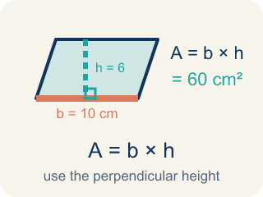
Area of Parallelograms (Área de paralelogramos) — The space inside a parallelogram. Formula: A = b × h, using the perpendicular height.
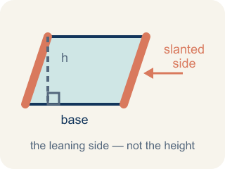
Slanted side (Lado inclinado) — A side that leans instead of going straight up and down. It is not the perpendicular height.
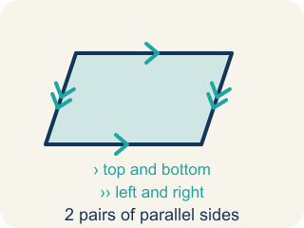
Parallelogram (Paralelogramo) — A four-sided shape with two pairs of parallel sides.
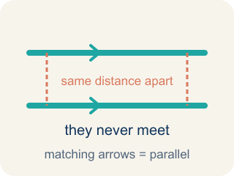
Parallel (Paralelas) — Two lines or sides that stay the same distance apart and never meet.
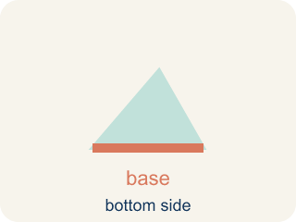
Base (Base) — Any side of a parallelogram can be the base. Once you pick a base, the height must be measured perpendicular (at a 90° angle) to it.
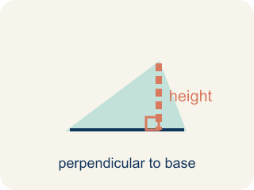
Height (Altura) — The straight-up distance from the base to the top.
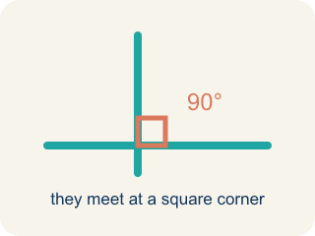
Perpendicular (Perpendicular) — Two lines that meet to make a square corner (90 degrees).
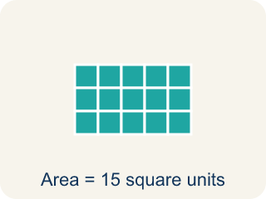
Area (Área) — How much space is inside a flat shape.
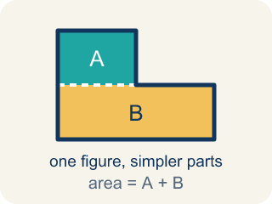
Composite figure (Figura compuesta) — A shape made by putting two or more simple shapes together.
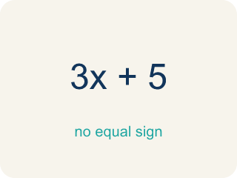
Formula (Fórmula) — A math rule written with symbols.

Practice
Show your work. Use the blank space under each problem.
1. What is the area of a parallelogram with base 10 cm and height 7 cm?
A. 70 sq cm
B. 34 sq cm
C. 17 sq cm
D. 70 cm
______________________________________________________________________
2. A parallelogram has an area of 54 sq ft and a base of 9 ft. What is the height?
A. 6 ft
B. 45 ft
C. 63 ft
D. 27 ft
______________________________________________________________________
3. A blueprint parallelogram has a base of 8 ft, a height of 5 ft, and a slanted side of 7 ft. What is its area?
A. 40 sq ft
B. 56 sq ft
C. 35 sq ft
D. 26 sq ft
______________________________________________________________________
4. Two parallelograms both have base 10 ft and height 6 ft. N is more tilted (slant 9 ft). Compare their areas.
A. Equal: both are 10 x 6 = 60 sq ft because area depends on base and height, not the slant
B. Blueprint N is larger because its slanted side is 9 ft
C. Blueprint M is larger because it is less tilted
D. You cannot compare them without the slanted side of M
______________________________________________________________________
5. Level 2 Extension — The Slanted-Side Slip-Up
Step 1 (Read the blueprint): base = 12 ft, slanted side = 10 ft, height = 7 ft
Step 2 (Write the formula): A = base x height
Step 3 (Substitute the values): A = 12 x 10
Step 4 (Calculate the area): A = 120 sq ft
Which step has the mistake? Explain and fix it:
______________________________________________________________________
______________________________________________________________________
______________________________________________________________________
6. Find the Area Error
Step 1 (Identify base and height): b = 11 m, slant side = 8 m, h = 6 m
Step 2 (Write the formula): A = b × h
Step 3 (Substitute values): A = 11 × 8
Step 4 (Calculate): A = 88 sq m
Which step has the mistake? Explain and fix it:
______________________________________________________________________
______________________________________________________________________
______________________________________________________________________
7. A parallelogram has a base of 12 cm. If you double the height, the area doubles too. Explain why this happens using the formula, and give a specific example with numbers.
Sentence starter: When the height doubles from ___ to ___, the area changes from ___ to ___ because in the formula A = b × h, the base stays at ___ and ___.
______________________________________________________________________
______________________________________________________________________
______________________________________________________________________
______________________________________________________________________
8. Use the formula A = b × h to find the area of each parallelogram.
Parallelogram | Base | Height | Area
Patio X | 6 ft | 4 ft
Patio Y | 11 ft | 3 ft
______________________________________________________________________

Answer Key (Teacher)
1. A. 70 sq cm
A = b × h = 10 × 7 = 70 square centimeters.
Watch for: The most common mistake in Area of Parallelograms is multiplying the base by the slanted side instead of the perpendicular height. For a parallelogram with a base of 16 ft, a perpendicular height of 9 ft, and a slanted side of 11 ft, students compute 16 × 11 = 176 square feet instead of the correct 16 × 9 = 144 square feet. The height must be the straight-up (perpendicular) distance between the base and its opposite side, not the length of the slanted side, even though the slanted side is often the number that 'looks' like it belongs in the formula.
2. A. 6 ft
A = b × h → 54 = 9 × h → h = 54 ÷ 9 = 6 ft.
Watch for: The most common mistake in Area of Parallelograms is multiplying the base by the slanted side instead of the perpendicular height. For a parallelogram with a base of 16 ft, a perpendicular height of 9 ft, and a slanted side of 11 ft, students compute 16 × 11 = 176 square feet instead of the correct 16 × 9 = 144 square feet. The height must be the straight-up (perpendicular) distance between the base and its opposite side, not the length of the slanted side, even though the slanted side is often the number that 'looks' like it belongs in the formula.
3. A. 40 sq ft
Area = base x height = 8 x 5 = 40 sq ft. The 7 ft slanted side is not used; only the perpendicular height belongs in the formula.
Watch for: The most common mistake in Area of Parallelograms is multiplying the base by the slanted side instead of the perpendicular height. For a parallelogram with a base of 16 ft, a perpendicular height of 9 ft, and a slanted side of 11 ft, students compute 16 × 11 = 176 square feet instead of the correct 16 × 9 = 144 square feet. The height must be the straight-up (perpendicular) distance between the base and its opposite side, not the length of the slanted side, even though the slanted side is often the number that 'looks' like it belongs in the formula.
4. A. Equal: both are 10 x 6 = 60 sq ft because area depends on base and height, not the slant
Area = base x height. Both have base 10 ft and height 6 ft, so both areas are 10 x 6 = 60 sq ft. Tilting the shape changes the slanted side but not the perpendicular height, so the area stays the same.
Watch for: The most common mistake in Area of Parallelograms is multiplying the base by the slanted side instead of the perpendicular height. For a parallelogram with a base of 16 ft, a perpendicular height of 9 ft, and a slanted side of 11 ft, students compute 16 × 11 = 176 square feet instead of the correct 16 × 9 = 144 square feet. The height must be the straight-up (perpendicular) distance between the base and its opposite side, not the length of the slanted side, even though the slanted side is often the number that 'looks' like it belongs in the formula.
5. Level 2 Extension — The Slanted-Side Slip-Up
The mistake is in Step 3.
Correct work: The height is 7 ft, not the slanted side of 10 ft. Substitute the perpendicular height: A = 12 x 7 = 84 sq ft. Only the straight-up height belongs in A = base x height.
Watch for: The blueprint lists three numbers, and the substitution step grabs the 10 ft slanted side instead of the 7 ft height. Since A = base × height only accepts the perpendicular measurement, the real area is A = 12 × 7 = 84 sq ft.
6. Find the Area Error
The mistake is in Step 3.
Correct work: The height is 6 m, not the slant side of 8 m. A = 11 × 6 = 66 sq m. Always use the perpendicular height, not the slanted side.
Watch for: The Substitute step plugs in the 8 m slant side for h, but the first step already labeled the height as 6 m. The slant side is longer than the true straight-up distance, so the correct area is A = 11 × 6 = 66 sq m.
7. Open response — answers will vary.
Look for key words: formula, base, height, double, multiply, proportional.
8. Use the formula A = b × h to find the area of each parallelogram.
Patio X — Area: 24 sq ft
Patio Y — Area: 33 sq ft

