5.1 Small Group · Group 2 — Homework
Lesson 5-1-group2 • Standard 6.GR.1
Name: ______________________ Period: ______ Date: ____________

Today's Goals
Content: I can find the area of a parallelogram using base × height, explain why the method works, and use it on a problem I have not seen before.
Language: I can justify my answer to a skeptic and connect it to a second strategy or representation.

Key Words
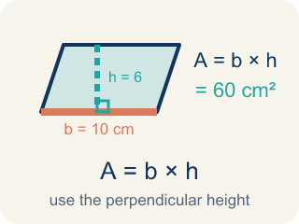
Area of Parallelograms (Área de paralelogramos) — The space inside a parallelogram. Formula: A = b × h, using the perpendicular height.
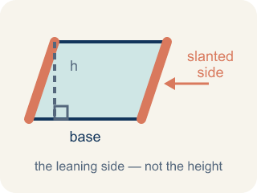
Slanted side (Lado inclinado) — A side that leans instead of going straight up and down. It is not the perpendicular height.
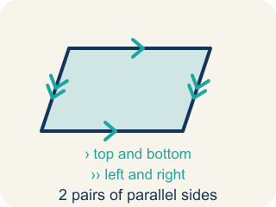
Parallelogram (Paralelogramo) — A four-sided shape with two pairs of parallel sides.
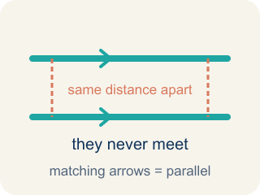
Parallel (Paralelas) — Two lines or sides that stay the same distance apart and never meet.
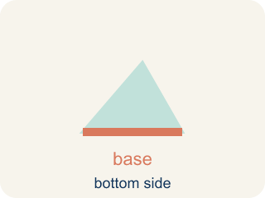
Base (Base) — Any side of a parallelogram can be the base. Once you pick a base, the height must be measured perpendicular (at a 90° angle) to it.
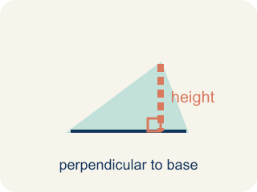
Height (Altura) — The straight-up distance from the base to the top.
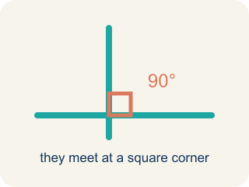
Perpendicular (Perpendicular) — Two lines that meet to make a square corner (90 degrees).
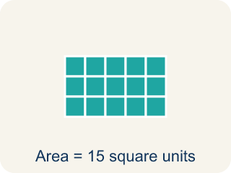
Area (Área) — How much space is inside a flat shape.
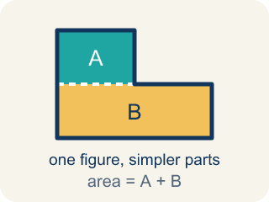
Composite figure (Figura compuesta) — A shape made by putting two or more simple shapes together.
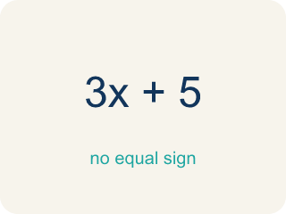
Formula (Fórmula) — A math rule written with symbols.

Practice
Show your work. Use the blank space under each problem.
1. Spot the Common Mistake
Step 1 (Read the parallelogram): base = 9 cm, slanted side = 10 cm, height = 6 cm
Step 2 (Write the formula): A = base × height
Step 3 (Substitute the values): A = 9 × 10
Step 4 (Calculate the area): A = 90 sq cm
Which step has the mistake? Explain and fix it:
______________________________________________________________________
______________________________________________________________________
______________________________________________________________________
2. Find the Area Error
Step 1 (Identify base and height): b = 11 m, slant side = 8 m, h = 6 m
Step 2 (Write the formula): A = b × h
Step 3 (Substitute values): A = 11 × 8
Step 4 (Calculate): A = 88 sq m
Which step has the mistake? Explain and fix it:
______________________________________________________________________
______________________________________________________________________
______________________________________________________________________
3. A parallelogram has a base of 12 cm. If you double the height, the area doubles too. Explain why this happens using the formula, and give a specific example with numbers.
Sentence starter: When the height doubles from ___ to ___, the area changes from ___ to ___ because in the formula A = b × h, the base stays at ___ and ___.
______________________________________________________________________
______________________________________________________________________
______________________________________________________________________
______________________________________________________________________
4. Cut the slanted end off a parallelogram and slide it to the other side. What shape forms, and why does that show A = base × height?
A. A rectangle with the same base and height, so its area equals base x height
B. A bigger parallelogram, so the area gets larger
C. A triangle, so the area is cut in half
D. A square, so all four sides must be equal
______________________________________________________________________

Answer Key (Teacher)
1. Spot the Common Mistake
The mistake is in Step 3.
Correct work: The height is 6 cm, not the slanted side of 10 cm. Substitute the perpendicular height: A = 9 × 6 = 54 sq cm. Only the straight-up height belongs in A = base × height.
Watch for: The substitution step uses 10 cm, which is the slanted side, instead of the 6 cm height listed in the first step. Only the perpendicular height belongs in A = base × height, so A = 9 × 6 = 54 sq cm.
2. Find the Area Error
The mistake is in Step 3.
Correct work: The height is 6 m, not the slant side of 8 m. A = 11 × 6 = 66 sq m. Always use the perpendicular height, not the slanted side.
Watch for: The Substitute step plugs in the 8 m slant side for h, but the first step already labeled the height as 6 m. The slant side is longer than the true straight-up distance, so the correct area is A = 11 × 6 = 66 sq m.
3. Open response — answers will vary.
Look for key words: formula, base, height, double, multiply, proportional.
4. A. A rectangle with the same base and height, so its area equals base x height
Sliding the cut triangle turns the parallelogram into a rectangle that keeps the same base and height. A rectangle's area is base x height, so the parallelogram's area is base x height too.
Watch for: The most common mistake in Area of Parallelograms is multiplying the base by the slanted side instead of the perpendicular height. For a parallelogram with a base of 16 ft, a perpendicular height of 9 ft, and a slanted side of 11 ft, students compute 16 × 11 = 176 square feet instead of the correct 16 × 9 = 144 square feet. The height must be the straight-up (perpendicular) distance between the base and its opposite side, not the length of the slanted side, even though the slanted side is often the number that 'looks' like it belongs in the formula.

