5.10 Small Group · Group 1 — Homework
Lesson 5-10-group1 • Standard 6.GR.2
Name: ______________________ Period: ______ Date: ____________

Today's Goals
Content: With my small group, I can find the volume of a rectangular prism, including ones with fractional edge lengths, using base area × height — one step at a time, with support.
Language: I can talk through each step out loud using a sentence frame and the lesson's key words.

Key Words
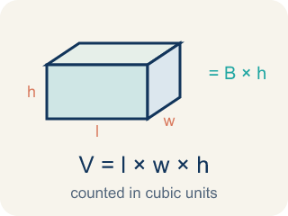
Volume of Rectangular Prisms (Volumen de prismas rectangulares) — The space inside a rectangular prism. Formula: V = Bh = l × w × h.

Volume (Volumen) — How much space is inside a solid shape.
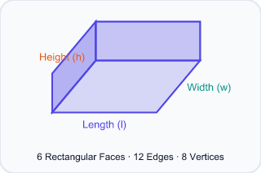
Rectangular prism (Prisma rectangular) — A solid box shape with six flat rectangle sides.
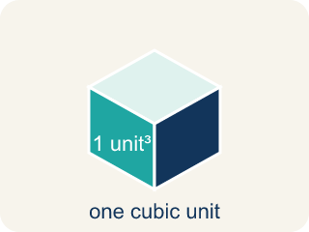
Cubic units (Unidades cúbicas) — The units used to measure space inside, like cubic inches.
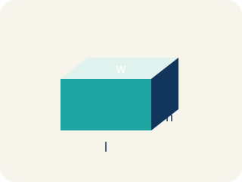
Dimensions (Dimensiones) — How long, how wide, and how tall a shape is.
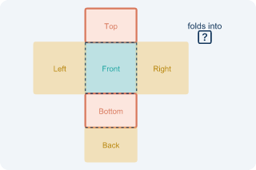
Net (Plantilla (desarrollo plano)) — A flat shape that folds up into a solid.
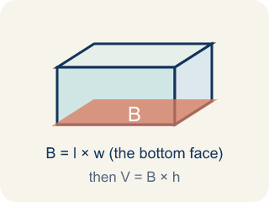
Base area (Área de la base) — The area of the bottom of a solid. Volume = base area × height.

Practice
Show your work. Use the blank space under each problem.
1. What is the volume of a rectangular prism with l = 4 in, w = 3 in, h = 5 in?
A. 60 in³
B. 12 in³
C. 60 in²
D. 24 in³
______________________________________________________________________
2. A box has a volume of 36 cm³. Its length is 6 cm and width is 3 cm. What is the height?
A. 2 cm
B. 6 cm
C. 3 cm
D. 12 cm
______________________________________________________________________
3. A cube has an edge length of 5 cm. What is its volume?
A. 125 cm³
B. 15 cm³
C. 25 cm³
D. 75 cm³
______________________________________________________________________
4. A time-capsule box measures 6 in long, 4 in wide, and 3 in tall. What is its volume?
A. 72 cubic in
B. 13 cubic in
C. 24 cubic in
D. 72 square in
______________________________________________________________________
5. Two storage boxes are ready to pack. Box A is 5 × 5 × 2 inches and Box B is 4 × 4 × 3 inches. Which box holds more?
A. Box A, because 50 cubic in is more than 48 cubic in
B. Box B, because 48 cubic in is more than 50 cubic in
C. They hold the same amount
D. Box B, because it is taller
______________________________________________________________________
6. A keepsake box is 4 in long, 3 in wide, and 1½ in tall. What is its volume?
A. 18 cubic in
B. 8.5 cubic in
C. 12 cubic in
D. 36 cubic in
______________________________________________________________________
7. Level 2 Extension — Catch the Packing Mistake
Step 1 (Dimensions): A box is 7 in long, 3 in wide, and 2 in tall.
Step 2 (Formula): V = length × width × height
Step 3 (Calculate): V = 7 × 3 = 21 cubic in
Step 4 (Answer): Volume = 21 cubic in
Which step has the mistake? Explain and fix it:
______________________________________________________________________
______________________________________________________________________
______________________________________________________________________
8. Find the Volume Error
Step 1 (Dimensions): l = 5 m, w = 3 m, h = 2.5 m
Step 2 (Formula): V = l × w × h
Step 3 (Calculate): V = 5 × 3 × 2.5 = 5 × 5.5 = 27.5 m³
Step 4 (Answer): Volume = 27.5 m³
Which step has the mistake? Explain and fix it:
______________________________________________________________________
______________________________________________________________________
______________________________________________________________________

Answer Key (Teacher)
1. A. 60 in³
V = l × w × h = 4 × 3 × 5 = 60 cubic inches.
Watch for: A common mistake in Volume of Rectangular Prisms is rounding a fractional edge length to the nearest whole number before multiplying, instead of using the exact fraction or decimal. For a box that is 2 ft × 1.5 ft × 1 ft, a student might round 1.5 down to 1 and compute 2 × 1 × 1 = 2 ft³, but the correct volume uses the exact edge length: 2 × 1.5 × 1 = 3 ft³ — a full cubic foot larger. Before you submit, ask: 'Did I multiply using the exact fractional or decimal edge length, or did I round it off first?'
2. A. 2 cm
V = l × w × h → 36 = 6 × 3 × h → 36 = 18h → h = 2 cm.
Watch for: A common mistake in Volume of Rectangular Prisms is rounding a fractional edge length to the nearest whole number before multiplying, instead of using the exact fraction or decimal. For a box that is 2 ft × 1.5 ft × 1 ft, a student might round 1.5 down to 1 and compute 2 × 1 × 1 = 2 ft³, but the correct volume uses the exact edge length: 2 × 1.5 × 1 = 3 ft³ — a full cubic foot larger. Before you submit, ask: 'Did I multiply using the exact fractional or decimal edge length, or did I round it off first?'
3. A. 125 cm³
A cube's volume is edge³ = 5 × 5 × 5 = 125 cm³.
Watch for: A common mistake in Volume of Rectangular Prisms is rounding a fractional edge length to the nearest whole number before multiplying, instead of using the exact fraction or decimal. For a box that is 2 ft × 1.5 ft × 1 ft, a student might round 1.5 down to 1 and compute 2 × 1 × 1 = 2 ft³, but the correct volume uses the exact edge length: 2 × 1.5 × 1 = 3 ft³ — a full cubic foot larger. Before you submit, ask: 'Did I multiply using the exact fractional or decimal edge length, or did I round it off first?'
4. A. 72 cubic in
V = length × width × height = 6 × 4 × 3 = 72 cubic in. Volume uses cubic units.
Watch for: A common mistake in Volume of Rectangular Prisms is rounding a fractional edge length to the nearest whole number before multiplying, instead of using the exact fraction or decimal. For a box that is 2 ft × 1.5 ft × 1 ft, a student might round 1.5 down to 1 and compute 2 × 1 × 1 = 2 ft³, but the correct volume uses the exact edge length: 2 × 1.5 × 1 = 3 ft³ — a full cubic foot larger. Before you submit, ask: 'Did I multiply using the exact fractional or decimal edge length, or did I round it off first?'
5. A. Box A, because 50 cubic in is more than 48 cubic in
Box A: 5 × 5 × 2 = 50 cubic in. Box B: 4 × 4 × 3 = 48 cubic in. 50 > 48, so Box A holds more.
Watch for: A common mistake in Volume of Rectangular Prisms is rounding a fractional edge length to the nearest whole number before multiplying, instead of using the exact fraction or decimal. For a box that is 2 ft × 1.5 ft × 1 ft, a student might round 1.5 down to 1 and compute 2 × 1 × 1 = 2 ft³, but the correct volume uses the exact edge length: 2 × 1.5 × 1 = 3 ft³ — a full cubic foot larger. Before you submit, ask: 'Did I multiply using the exact fractional or decimal edge length, or did I round it off first?'
6. A. 18 cubic in
V = 4 × 3 × 1.5 = 12 × 1.5 = 18 cubic in. A fractional edge does not change the steps.
Watch for: A common mistake in Volume of Rectangular Prisms is rounding a fractional edge length to the nearest whole number before multiplying, instead of using the exact fraction or decimal. For a box that is 2 ft × 1.5 ft × 1 ft, a student might round 1.5 down to 1 and compute 2 × 1 × 1 = 2 ft³, but the correct volume uses the exact edge length: 2 × 1.5 × 1 = 3 ft³ — a full cubic foot larger. Before you submit, ask: 'Did I multiply using the exact fractional or decimal edge length, or did I round it off first?'
7. Level 2 Extension — Catch the Packing Mistake
The mistake is in Step 3.
Correct work: The student only multiplied length × width and forgot the height. V = 7 × 3 × 2 = 21 × 2 = 42 cubic in.
Watch for: The Calculate step used only the length and width and never brought in the 2 in height — that is area thinking, not volume. All three edges must multiply: V = 7 × 3 × 2 = 21 × 2 = 42 cubic in.
8. Find the Volume Error
The mistake is in Step 3.
Correct work: 3 × 2.5 = 7.5, not 5.5. Correct: V = 5 × 7.5 = 37.5 m³.
Watch for: In the Calculate step, 3 × 2.5 was written as 5.5, which is what you get by adding 3 + 2.5 instead of multiplying. Three groups of 2.5 make 7.5, so V = 5 × 7.5 = 37.5 m³.

