5.10 Small Group · Group 2 — Homework
Lesson 5-10-group2 • Standard 6.GR.2
Name: ______________________ Period: ______ Date: ____________

Today's Goals
Content: I can find the volume of a rectangular prism, including ones with fractional edge lengths, using base area × height, explain why the method works, and use it on a problem I have not seen before.
Language: I can justify my answer to a skeptic and connect it to a second strategy or representation.

Key Words
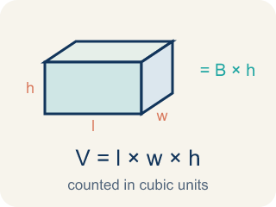
Volume of Rectangular Prisms (Volumen de prismas rectangulares) — The space inside a rectangular prism. Formula: V = Bh = l × w × h.

Volume (Volumen) — How much space is inside a solid shape.
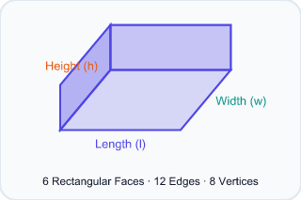
Rectangular prism (Prisma rectangular) — A solid box shape with six flat rectangle sides.
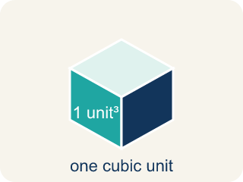
Cubic units (Unidades cúbicas) — The units used to measure space inside, like cubic inches.
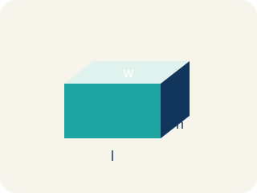
Dimensions (Dimensiones) — How long, how wide, and how tall a shape is.
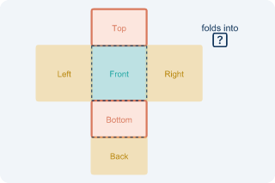
Net (Plantilla (desarrollo plano)) — A flat shape that folds up into a solid.
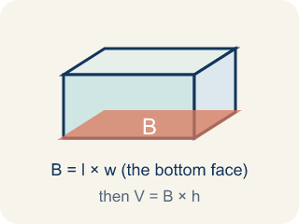
Base area (Área de la base) — The area of the bottom of a solid. Volume = base area × height.

Practice
Show your work. Use the blank space under each problem.
1. Two boxes: Box A is 10 × 5 × 4 inches. Box B is 8 × 6 × 5 inches. Which has more volume and by how much?
A. Box B by 40 in³
B. Box A by 40 in³
C. Box B by 60 in³
D. They're equal
______________________________________________________________________
2. Spot the Common Mistake
Step 1 (Dimensions): A box is 6 in long, 4 in wide, and 1/2 in tall.
Step 2 (Formula): V = length × width × height
Step 3 (Calculate): V = 6 × 4 × 1/2, and the student dropped the 1/2: V = 6 × 4 = 24 cubic in
Step 4 (Answer): Volume = 24 cubic in
Which step has the mistake? Explain and fix it:
______________________________________________________________________
______________________________________________________________________
______________________________________________________________________
3. What is the volume of a prism with edge lengths 1/2 m, 3 m, and 4 m?
A. 7.5 m³
B. 12 m³
C. 6 m³
D. 3 m³
______________________________________________________________________
4. A cube has an edge length of 5 cm. What is its volume?
A. 125 cm³
B. 15 cm³
C. 25 cm³
D. 75 cm³
______________________________________________________________________

Answer Key (Teacher)
1. A. Box B by 40 in³
Box A: 10 × 5 × 4 = 200 in³. Box B: 8 × 6 × 5 = 240 in³. Box B is bigger by 40 in³.
Watch for: A common mistake in Volume of Rectangular Prisms is rounding a fractional edge length to the nearest whole number before multiplying, instead of using the exact fraction or decimal. For a box that is 2 ft × 1.5 ft × 1 ft, a student might round 1.5 down to 1 and compute 2 × 1 × 1 = 2 ft³, but the correct volume uses the exact edge length: 2 × 1.5 × 1 = 3 ft³ — a full cubic foot larger. Before you submit, ask: 'Did I multiply using the exact fractional or decimal edge length, or did I round it off first?'
2. Spot the Common Mistake
The mistake is in Step 3.
Correct work: The student ignored the fractional edge of 1/2 in. A fractional edge still counts: V = 6 × 4 × 1/2 = 24 × 1/2 = 12 cubic in.
Watch for: The Calculate step threw away the 1/2 in height, but a fractional edge is still an edge. Multiply all three: V = 6 × 4 × 1/2 = 24 × 1/2 = 12 cubic in. A half-inch height makes the volume half of 24, not equal to it.
3. C. 6 m³
V = 1/2 × 3 × 4 = 6 m³.
Watch for: A common mistake in Volume of Rectangular Prisms is rounding a fractional edge length to the nearest whole number before multiplying, instead of using the exact fraction or decimal. For a box that is 2 ft × 1.5 ft × 1 ft, a student might round 1.5 down to 1 and compute 2 × 1 × 1 = 2 ft³, but the correct volume uses the exact edge length: 2 × 1.5 × 1 = 3 ft³ — a full cubic foot larger. Before you submit, ask: 'Did I multiply using the exact fractional or decimal edge length, or did I round it off first?'
4. A. 125 cm³
A cube's volume is edge³ = 5 × 5 × 5 = 125 cm³.
Watch for: A common mistake in Volume of Rectangular Prisms is rounding a fractional edge length to the nearest whole number before multiplying, instead of using the exact fraction or decimal. For a box that is 2 ft × 1.5 ft × 1 ft, a student might round 1.5 down to 1 and compute 2 × 1 × 1 = 2 ft³, but the correct volume uses the exact edge length: 2 × 1.5 × 1 = 3 ft³ — a full cubic foot larger. Before you submit, ask: 'Did I multiply using the exact fractional or decimal edge length, or did I round it off first?'

