5.2 Small Group · Group 1 — Homework
Lesson 5-2-group1 • Standard 6.GR.1
Name: ______________________ Period: ______ Date: ____________

Today's Goals
Content: With my small group, I can find the area of a triangle using the formula A = ½ × base × height — one step at a time, with support.
Language: I can talk through each step out loud using a sentence frame and the lesson's key words.

Key Words
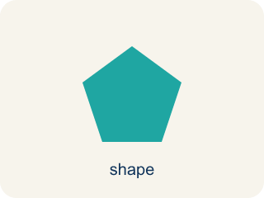
Area of a Triangle (Área de un triángulo) — The space inside a triangle. A triangle is half of a rectangle with the same base and height, so A = ½ × b × h.
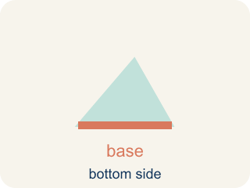
Base (Base) — Any side of a triangle can be the base. Once you pick a base, the height must be measured perpendicular (at a 90° angle) to it.
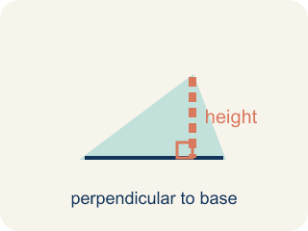
Height (Altura) — The straight-up distance from the base to the top corner.
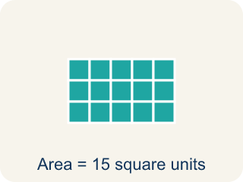
Area (Área) — How much space is inside a flat shape.
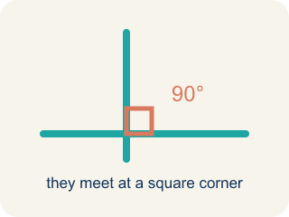
Perpendicular (Perpendicular) — Two lines that meet to make a square corner (90 degrees).
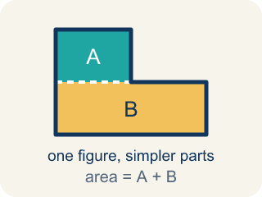
Composite figure (Figura compuesta) — A shape made by putting two or more simple shapes together.
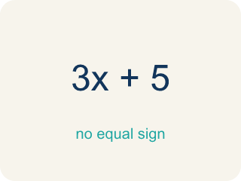
Formula (Fórmula) — A math rule written with symbols.
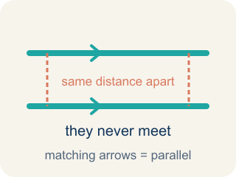
Parallel (Paralelas) — Two lines or sides that stay the same distance apart and never meet.

Practice
Show your work. Use the blank space under each problem.
1. What is the area of a triangle with base 10 cm and height 6 cm?
A. 30 sq cm
B. 60 sq cm
C. 16 sq cm
D. 30 cm
______________________________________________________________________
2. A triangle has an area of 24 sq ft and a base of 8 ft. What is the height?
A. 6 ft
B. 3 ft
C. 16 ft
D. 12 ft
______________________________________________________________________
3. A triangular roof panel on the blueprint has a base of 7 ft and a height of 4 ft. What is its area?
A. 14 sq ft
B. 28 sq ft
C. 11 sq ft
D. 22 sq ft
______________________________________________________________________
4. On the blueprint, a triangular garden bed has a base of 11 ft and a height of 6 ft. What is its area?
A. 33 sq ft
B. 66 sq ft
C. 17 sq ft
D. 30 sq ft
______________________________________________________________________
5. Level 2 Extension — Find the Half-Area Mistake
Step 1 (Identify base and height): base = 16 ft, height = 9 ft
Step 2 (Write the formula): A = ½ × base × height
Step 3 (Multiply base × height): 16 × 9 = 144
Step 4 (Final answer): A = 144 sq ft
Which step has the mistake? Explain and fix it:
______________________________________________________________________
______________________________________________________________________
______________________________________________________________________
6. Find the Area Error
Step 1 (Identify base and height): b = 14 m, h = 9 m
Step 2 (Write the formula): A = ½ × b × h
Step 3 (Substitute values): A = ½ × 14 × 9
Step 4 (Calculate): A = ½ × 23 = 11.5 sq m
Which step has the mistake? Explain and fix it:
______________________________________________________________________
______________________________________________________________________
______________________________________________________________________
7. A rectangle is 12 ft by 8 ft. A diagonal line cuts it into two triangles. What is the area of each triangle? Explain how the triangle area formula relates to the rectangle area formula.
Sentence starter: The rectangle's area is ___ because ___. Each triangle's area is ___ because a diagonal splits a rectangle into ___ equal triangles, so A = ½ × ___ × ___ = ___.
______________________________________________________________________
______________________________________________________________________
______________________________________________________________________
______________________________________________________________________
8. Use the formula A = ½ × b × h to find the area of each triangle.
Triangle | Base | Height | Area
Sail A | 6 ft | 8 ft
Sail B | 10 ft | 5 ft
______________________________________________________________________

Answer Key (Teacher)
1. A. 30 sq cm
A = ½ × b × h = ½ × 10 × 6 = 30 square centimeters.
Watch for: A common mistake in Area of Triangles is forgetting the ½ — students multiply base × height like a rectangle and stop there, or they use the triangle's slanted side instead of the perpendicular height that's already given. Always check: did I take half, and did I use the straight-up height, not the slanted side?
2. A. 6 ft
A = ½ × b × h → 24 = ½ × 8 × h → 24 = 4h → h = 6 ft.
Watch for: A common mistake in Area of Triangles is forgetting the ½ — students multiply base × height like a rectangle and stop there, or they use the triangle's slanted side instead of the perpendicular height that's already given. Always check: did I take half, and did I use the straight-up height, not the slanted side?
3. A. 14 sq ft
A = ½ × base × height = ½ × 7 × 4 = ½ × 28 = 14 sq ft. Multiply base × height first (28), then take half (14).
Watch for: A common mistake in Area of Triangles is forgetting the ½ — students multiply base × height like a rectangle and stop there, or they use the triangle's slanted side instead of the perpendicular height that's already given. Always check: did I take half, and did I use the straight-up height, not the slanted side?
4. A. 33 sq ft
A = ½ × base × height = ½ × 11 × 6 = ½ × 66 = 33 sq ft.
Watch for: A common mistake in Area of Triangles is forgetting the ½ — students multiply base × height like a rectangle and stop there, or they use the triangle's slanted side instead of the perpendicular height that's already given. Always check: did I take half, and did I use the straight-up height, not the slanted side?
5. Level 2 Extension — Find the Half-Area Mistake
The mistake is in Step 4.
Correct work: The intern stopped at base × height = 16 × 9 = 144, but that is the area of the whole rectangle. A triangle is only half of that rectangle, so you must still take half: ½ × 144 = 72 sq ft.
Watch for: Multiplying 16 × 9 = 144 is only half the job — that product is the area of the rectangle that surrounds the triangle. The formula still has a ½ waiting to be used, so the triangular wall is ½ × 144 = 72 sq ft.
6. Find the Area Error
The mistake is in Step 4.
Correct work: 14 × 9 = 126, then ½ × 126 = 63 sq m. The student added 14 + 9 = 23 instead of multiplying 14 × 9 = 126.
Watch for: The setup A = ½ × 14 × 9 is written correctly, but the calculation added 14 + 9 = 23 instead of multiplying. Base and height must be multiplied: 14 × 9 = 126, and then ½ × 126 = 63 sq m.
7. Open response — answers will vary.
Look for key words: rectangle, triangle, half, diagonal, base, height, formula.
8. Use the formula A = ½ × b × h to find the area of each triangle.
Sail A — Area: 24 sq ft
Sail B — Area: 25 sq ft

