5.2 Small Group · Group 2 — Homework
Lesson 5-2-group2 • Standard 6.GR.1
Name: ______________________ Period: ______ Date: ____________

Today's Goals
Content: I can find the area of a triangle using the formula A = ½ × base × height, explain why the method works, and use it on a problem I have not seen before.
Language: I can justify my answer to a skeptic and connect it to a second strategy or representation.

Key Words
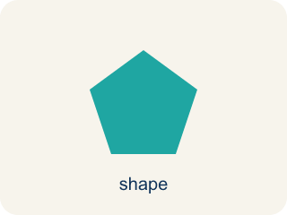
Area of a Triangle (Área de un triángulo) — The space inside a triangle. A triangle is half of a rectangle with the same base and height, so A = ½ × b × h.
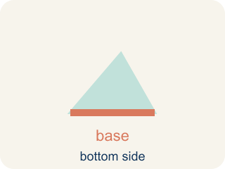
Base (Base) — Any side of a triangle can be the base. Once you pick a base, the height must be measured perpendicular (at a 90° angle) to it.
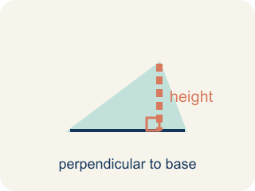
Height (Altura) — The straight-up distance from the base to the top corner.
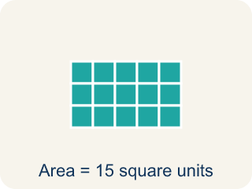
Area (Área) — How much space is inside a flat shape.
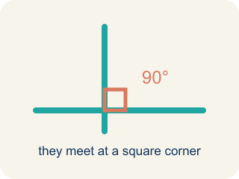
Perpendicular (Perpendicular) — Two lines that meet to make a square corner (90 degrees).
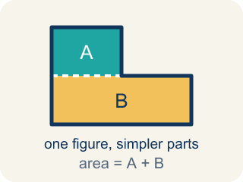
Composite figure (Figura compuesta) — A shape made by putting two or more simple shapes together.
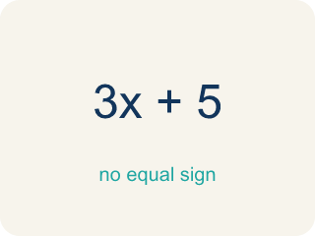
Formula (Fórmula) — A math rule written with symbols.
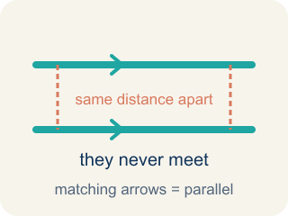
Parallel (Paralelas) — Two lines or sides that stay the same distance apart and never meet.

Practice
Show your work. Use the blank space under each problem.
1. Spot the Common Mistake
Step 1 (Identify base and height): base = 12 ft, height = 7 ft
Step 2 (Write the formula): A = ½ × base × height
Step 3 (Substitute values): A = ½ × 12 × 7
Step 4 (Calculate): A = (½ × 12) × (½ × 7) = 6 × 3.5 = 21 sq ft
Which step has the mistake? Explain and fix it:
______________________________________________________________________
______________________________________________________________________
______________________________________________________________________
2. Find the Area Error
Step 1 (Identify base and height): b = 14 m, h = 9 m
Step 2 (Write the formula): A = ½ × b × h
Step 3 (Substitute values): A = ½ × 14 × 9
Step 4 (Calculate): A = ½ × 23 = 11.5 sq m
Which step has the mistake? Explain and fix it:
______________________________________________________________________
______________________________________________________________________
______________________________________________________________________
3. A rectangle is 12 ft by 8 ft. A diagonal line cuts it into two triangles. What is the area of each triangle? Explain how the triangle area formula relates to the rectangle area formula.
Sentence starter: The rectangle's area is ___ because ___. Each triangle's area is ___ because a diagonal splits a rectangle into ___ equal triangles, so A = ½ × ___ × ___ = ___.
______________________________________________________________________
______________________________________________________________________
______________________________________________________________________
______________________________________________________________________
4. A triangular window in the firm's lobby has a base of 10 ft and a height of 6 ft. What is its area?
A. 30 sq ft
B. 60 sq ft
C. 16 sq ft
D. 32 sq ft
______________________________________________________________________

Answer Key (Teacher)
1. Spot the Common Mistake
The mistake is in Step 4.
Correct work: There is only ONE ½ in the formula, not two. The student halved both the base and the height. Multiply base × height first, then take half just once: 12 × 7 = 84, then ½ × 84 = 42 sq ft.
Watch for: There is only ONE ½ in A = ½ × base × height, but the calculation halved the base and the height separately. Multiply first, then halve a single time: 12 × 7 = 84, and ½ × 84 = 42 sq ft. Halving twice cuts the area to a quarter of the rectangle, which is why 21 came out as exactly half of the true answer.
2. Find the Area Error
The mistake is in Step 4.
Correct work: 14 × 9 = 126, then ½ × 126 = 63 sq m. The student added 14 + 9 = 23 instead of multiplying 14 × 9 = 126.
Watch for: The setup A = ½ × 14 × 9 is written correctly, but the calculation added 14 + 9 = 23 instead of multiplying. Base and height must be multiplied: 14 × 9 = 126, and then ½ × 126 = 63 sq m.
3. Open response — answers will vary.
Look for key words: rectangle, triangle, half, diagonal, base, height, formula.
4. A. 30 sq ft
A = ½ × base × height = ½ × 10 × 6 = ½ × 60 = 30 sq ft. The triangle is half of the 10 × 6 = 60 rectangle it fits inside.
Watch for: A common mistake in Area of Triangles is forgetting the ½ — students multiply base × height like a rectangle and stop there, or they use the triangle's slanted side instead of the perpendicular height that's already given. Always check: did I take half, and did I use the straight-up height, not the slanted side?

