5.3 Small Group · Group 1 — Homework
Lesson 5-3-group1 • Standard 6.GR.1
Name: ______________________ Period: ______ Date: ____________

Today's Goals
Content: With my small group, I can find the area of a trapezoid using the formula A = ½(b1 + b2) × h — one step at a time, with support.
Language: I can talk through each step out loud using a sentence frame and the lesson's key words.

Key Words
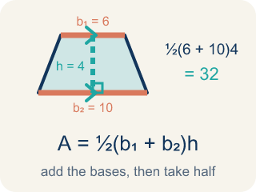
Area of Trapezoids (Área de trapecios) — The space inside a trapezoid. Formula: A = 1/2(b₁ + b₂)h.
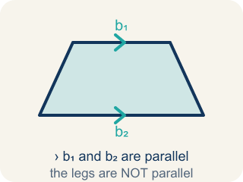
Trapezoid (Trapecio) — A four-sided shape with just one pair of parallel sides.
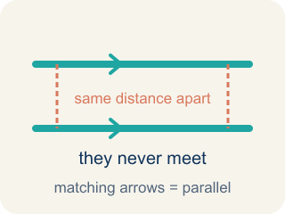
Parallel (Paralelas) — Two lines or sides that stay the same distance apart and never meet.
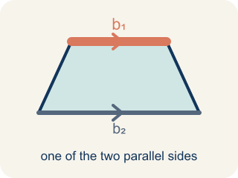
Base 1 (b1) (Base 1 (b1)) — One of the two parallel sides of a trapezoid.
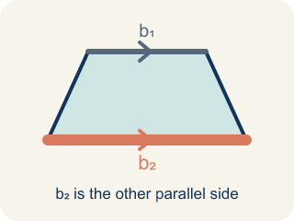
Base 2 (b2) (Base 2 (b2)) — The other parallel side of a trapezoid.
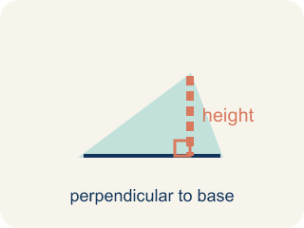
Height (Altura) — The straight-up distance between the two parallel sides.
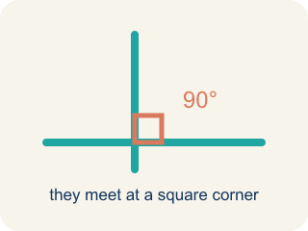
Perpendicular (Perpendicular) — Two lines that meet to make a square corner (90 degrees).
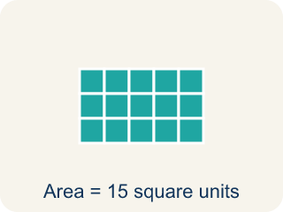
Area (Área) — How much space is inside a flat shape.

Practice
Show your work. Use the blank space under each problem.
1. What is the area of a trapezoid with bases 6 cm and 10 cm, and height 4 cm?
A. 32 sq cm
B. 64 sq cm
C. 24 sq cm
D. 40 sq cm
______________________________________________________________________
2. A trapezoid has an area of 45 sq ft, bases of 7 ft and 11 ft. What is the height?
A. 5 ft
B. 9 ft
C. 3 ft
D. 10 ft
______________________________________________________________________
3. Blueprint 1: A trapezoidal lobby window has bases of 6 ft and 10 ft and a height of 4 ft. What is its area for the glass order?
A. 32 sq ft
B. 40 sq ft
C. 16 sq ft
D. 60 sq ft
______________________________________________________________________
4. Blueprint 2: A trapezoidal skylight has bases of 9 ft and 7 ft and a height of 6 ft. What is its area?
A. 48 sq ft
B. 96 sq ft
C. 63 sq ft
D. 44 sq ft
______________________________________________________________________
5. Two equal trapezoid windows join to form a parallelogram with area 96 sq ft. What is the area of ONE trapezoid?
A. 48 sq ft
B. 96 sq ft
C. 16 sq ft
D. 192 sq ft
______________________________________________________________________
6. Level 2 Extension — The Missing Half
Step 1 (Read the blueprint): Trapezoid window: b1 = 6 ft, b2 = 10 ft, h = 4 ft
Step 2 (Write the formula): A = ½ × (b1 + b2) × h
Step 3 (Add the bases, then multiply by height): (6 + 10) × 4 = 16 × 4 = 64
Step 4 (State the area for the glass order): A = 64 sq ft
Which step has the mistake? Explain and fix it:
______________________________________________________________________
______________________________________________________________________
______________________________________________________________________
7. Find the Area Error
Step 1 (Identify the bases and height): b₁ = 10 m, b₂ = 6 m, h = 7 m
Step 2 (Write the formula): A = ½ × (b₁ + b₂) × h
Step 3 (Substitute values): A = ½ × (10 + 6) × 7
Step 4 (Calculate): A = (10 + 6) × 7 = 112 sq m
Which step has the mistake? Explain and fix it:
______________________________________________________________________
______________________________________________________________________
______________________________________________________________________
8. A trapezoid and a parallelogram both have a height of 8 ft. The trapezoid has bases of 5 ft and 11 ft. The parallelogram has a base of 7 ft. Which shape has the greater area? Explain your reasoning using the formulas.
Sentence starter: The trapezoid's area is ___ because ½ × (___ + ___) × ___ = ___. The parallelogram's area is ___ because ___ × ___ = ___. The ___ has a greater area by ___ sq ft.
______________________________________________________________________
______________________________________________________________________
______________________________________________________________________
______________________________________________________________________

Answer Key (Teacher)
1. A. 32 sq cm
A = ½ × (b₁ + b₂) × h = ½ × (6 + 10) × 4 = ½ × 16 × 4 = 32 sq cm.
Watch for: A common mistake in Area of Trapezoids is forgetting the ½ in A = ½ × (b1 + b2) × h. After adding the bases and multiplying by the height, students stop there instead of taking half — for example, with bases 6 ft and 10 ft and a height of 4 ft, they compute (6 + 10) × 4 = 64 sq ft instead of taking half to get the correct 32 sq ft. That unhalved number is really the area of the parallelogram made from two trapezoids, not the area of one trapezoid. Before you submit, always ask: "Did I take half of my last answer?"
2. A. 5 ft
A = ½ × (b₁ + b₂) × h → 45 = ½ × 18 × h → 45 = 9h → h = 5 ft.
Watch for: A common mistake in Area of Trapezoids is forgetting the ½ in A = ½ × (b1 + b2) × h. After adding the bases and multiplying by the height, students stop there instead of taking half — for example, with bases 6 ft and 10 ft and a height of 4 ft, they compute (6 + 10) × 4 = 64 sq ft instead of taking half to get the correct 32 sq ft. That unhalved number is really the area of the parallelogram made from two trapezoids, not the area of one trapezoid. Before you submit, always ask: "Did I take half of my last answer?"
3. A. 32 sq ft
Use A = ½ × (b1 + b2) × h = ½ × (6 + 10) × 4 = ½ × 16 × 4 = 32 sq ft.
Watch for: A common mistake in Area of Trapezoids is forgetting the ½ in A = ½ × (b1 + b2) × h. After adding the bases and multiplying by the height, students stop there instead of taking half — for example, with bases 6 ft and 10 ft and a height of 4 ft, they compute (6 + 10) × 4 = 64 sq ft instead of taking half to get the correct 32 sq ft. That unhalved number is really the area of the parallelogram made from two trapezoids, not the area of one trapezoid. Before you submit, always ask: "Did I take half of my last answer?"
4. A. 48 sq ft
A = ½ × (9 + 7) × 6 = ½ × 16 × 6 = ½ × 96 = 48 sq ft.
Watch for: A common mistake in Area of Trapezoids is forgetting the ½ in A = ½ × (b1 + b2) × h. After adding the bases and multiplying by the height, students stop there instead of taking half — for example, with bases 6 ft and 10 ft and a height of 4 ft, they compute (6 + 10) × 4 = 64 sq ft instead of taking half to get the correct 32 sq ft. That unhalved number is really the area of the parallelogram made from two trapezoids, not the area of one trapezoid. Before you submit, always ask: "Did I take half of my last answer?"
5. A. 48 sq ft
One trapezoid is half the parallelogram: 96 ÷ 2 = 48 sq ft. This matches A = ½ × (5 + 11) × 6 = ½ × 16 × 6 = 48 sq ft — the ½ comes from the trapezoid being half of the parallelogram.
Watch for: A common mistake in Area of Trapezoids is forgetting the ½ in A = ½ × (b1 + b2) × h. After adding the bases and multiplying by the height, students stop there instead of taking half — for example, with bases 6 ft and 10 ft and a height of 4 ft, they compute (6 + 10) × 4 = 64 sq ft instead of taking half to get the correct 32 sq ft. That unhalved number is really the area of the parallelogram made from two trapezoids, not the area of one trapezoid. Before you submit, always ask: "Did I take half of my last answer?"
6. Level 2 Extension — The Missing Half
The mistake is in Step 4.
Correct work: The student forgot to multiply by ½, so they ordered double the glass. The correct area is A = ½ × (6 + 10) × 4 = ½ × 64 = 32 sq ft, not 64 sq ft.
Watch for: The work computed (6 + 10) × 4 = 64 and stopped, never applying the ½. That 64 is the parallelogram made from two copies of this window, so the glass order should be half of it: A = ½ × 64 = 32 sq ft. Ordering 64 sq ft would buy double the glass needed.
7. Find the Area Error
The mistake is in Step 4.
Correct work: The student forgot to multiply by ½. A = ½ × 16 × 7 = ½ × 112 = 56 sq m.
Watch for: The ½ appears in the formula and in the substitution, then disappears in the final calculation. Keeping it gives A = ½ × 16 × 7 = ½ × 112 = 56 sq m, which is exactly half of the 112 that was reported.
8. Open response — answers will vary.
Look for key words: trapezoid, parallelogram, formula, compare, area, height, base.

