5.3 Small Group · Group 2 — Homework
Lesson 5-3-group2 • Standard 6.GR.1
Name: ______________________ Period: ______ Date: ____________

Today's Goals
Content: I can find the area of a trapezoid using the formula A = ½(b1 + b2) × h, explain why the method works, and use it on a problem I have not seen before.
Language: I can justify my answer to a skeptic and connect it to a second strategy or representation.

Key Words
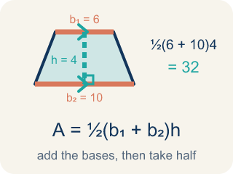
Area of Trapezoids (Área de trapecios) — The space inside a trapezoid. Formula: A = 1/2(b₁ + b₂)h.
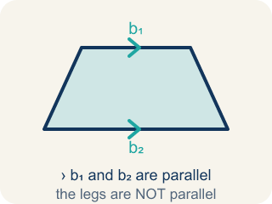
Trapezoid (Trapecio) — A four-sided shape with just one pair of parallel sides.
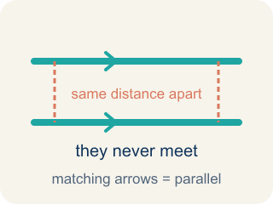
Parallel (Paralelas) — Two lines or sides that stay the same distance apart and never meet.
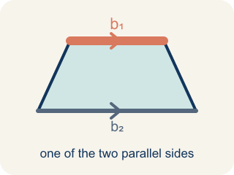
Base 1 (b1) (Base 1 (b1)) — One of the two parallel sides of a trapezoid.
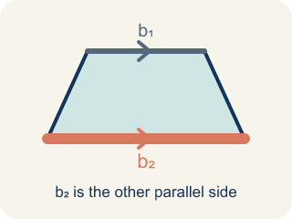
Base 2 (b2) (Base 2 (b2)) — The other parallel side of a trapezoid.
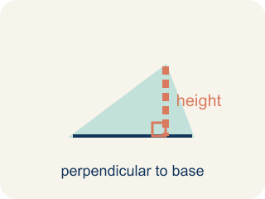
Height (Altura) — The straight-up distance between the two parallel sides.
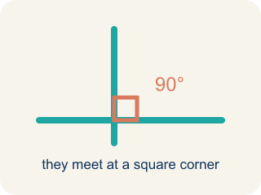
Perpendicular (Perpendicular) — Two lines that meet to make a square corner (90 degrees).
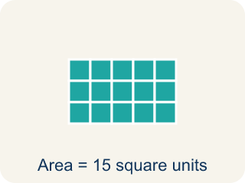
Area (Área) — How much space is inside a flat shape.

Practice
Show your work. Use the blank space under each problem.
1. Using the Wrong Height
Step 1 (Read the blueprint): A trapezoid window has b1 = 7 ft and b2 = 13 ft. The slanted side measures 10 ft, and the straight-up height between the bases is 6 ft.
Step 2 (Write the formula): A = ½ × (b1 + b2) × h
Step 3 (Substitute values): A = ½ × (7 + 13) × 10
Step 4 (Calculate): A = ½ × 20 × 10 = 100 sq ft
Which step has the mistake? Explain and fix it:
______________________________________________________________________
______________________________________________________________________
______________________________________________________________________
2. Find the Area Error
Step 1 (Identify the bases and height): b₁ = 10 m, b₂ = 6 m, h = 7 m
Step 2 (Write the formula): A = ½ × (b₁ + b₂) × h
Step 3 (Substitute values): A = ½ × (10 + 6) × 7
Step 4 (Calculate): A = (10 + 6) × 7 = 112 sq m
Which step has the mistake? Explain and fix it:
______________________________________________________________________
______________________________________________________________________
______________________________________________________________________
3. A trapezoid and a parallelogram both have a height of 8 ft. The trapezoid has bases of 5 ft and 11 ft. The parallelogram has a base of 7 ft. Which shape has the greater area? Explain your reasoning using the formulas.
Sentence starter: The trapezoid's area is ___ because ½ × (___ + ___) × ___ = ___. The parallelogram's area is ___ because ___ × ___ = ___. The ___ has a greater area by ___ sq ft.
______________________________________________________________________
______________________________________________________________________
______________________________________________________________________
______________________________________________________________________
4. Blueprint 1: A trapezoidal lobby window has bases of 6 ft and 10 ft and a height of 4 ft. What is its area for the glass order?
A. 32 sq ft
B. 40 sq ft
C. 16 sq ft
D. 60 sq ft
______________________________________________________________________

Answer Key (Teacher)
1. Using the Wrong Height
The mistake is in Step 4.
Correct work: The student used the slanted side (10 ft) as the height instead of the true perpendicular height (6 ft). The height in the trapezoid formula must be measured straight up between the two bases, not along the slanted side. The correct area is A = ½ × (7 + 13) × 6 = ½ × 20 × 6 = 60 sq ft, not 100 sq ft.
Watch for: The 10 ft slanted side was substituted for the height, but the height of a trapezoid is the straight-up perpendicular distance between the two bases, which is 6 ft here. Using the true height gives A = ½ × (7 + 13) × 6 = ½ × 20 × 6 = 60 sq ft; the slant is always longer, which is why 100 sq ft came out too big.
2. Find the Area Error
The mistake is in Step 4.
Correct work: The student forgot to multiply by ½. A = ½ × 16 × 7 = ½ × 112 = 56 sq m.
Watch for: The ½ appears in the formula and in the substitution, then disappears in the final calculation. Keeping it gives A = ½ × 16 × 7 = ½ × 112 = 56 sq m, which is exactly half of the 112 that was reported.
3. Open response — answers will vary.
Look for key words: trapezoid, parallelogram, formula, compare, area, height, base.
4. A. 32 sq ft
Use A = ½ × (b1 + b2) × h = ½ × (6 + 10) × 4 = ½ × 16 × 4 = 32 sq ft.
Watch for: A common mistake in Area of Trapezoids is forgetting the ½ in A = ½ × (b1 + b2) × h. After adding the bases and multiplying by the height, students stop there instead of taking half — for example, with bases 6 ft and 10 ft and a height of 4 ft, they compute (6 + 10) × 4 = 64 sq ft instead of taking half to get the correct 32 sq ft. That unhalved number is really the area of the parallelogram made from two trapezoids, not the area of one trapezoid. Before you submit, always ask: "Did I take half of my last answer?"

