5.4–5.5 Catch-Up — Homework
Lesson 5-4-catchup • Standard 6.GR.1
Name: ______________________ Period: ______ Date: ____________

Today's Goals
Content: I can show I am caught up on Lessons 5.4–5.5 by using each lesson's big idea in mixed practice.
Language: I can explain which lesson's big idea I used and how, using key vocabulary from Lessons 5.4–5.5.

Key Words
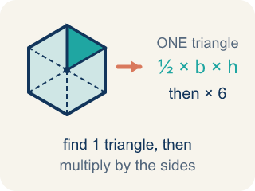
Area of Regular Polygons (Área de polígonos regulares) — The total space a regular polygon covers, found by splitting it into congruent triangles from the center. Formula: A = (½bh) × n — one triangle's area times the number of triangles.
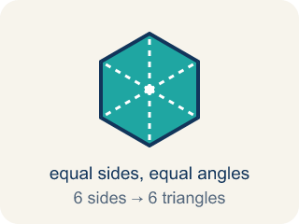
Regular Polygon (Polígono regular) — A closed flat shape made of straight sides, where every side is the same length and every angle is the same size.
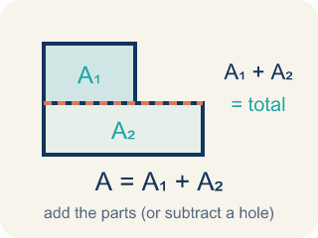
Area of Composite Figures (Área de figuras compuestas) — The total space inside a figure made of basic shapes. Formula: A = A₁ + A₂ — add the parts (or subtract a missing piece).
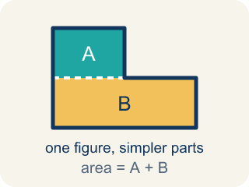
Composite Figure (Figura compuesta) — A shape made by putting two or more simple shapes together.
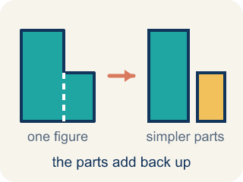
Decompose (Descomponer) — To break a shape into smaller, simpler shapes.

Practice
Show your work. Use the blank space under each problem.
1. (Lesson 5.4) A regular hexagon is divided into 6 equal triangles from the center. Each triangle has a base of 6 ft and a height of 5.2 ft. What is the area of one triangle?
A. 15.6 sq ft
B. 31.2 sq ft
C. 11.2 sq ft
D. 15.6 ft
______________________________________________________________________
2. (Lesson 5.4) Using the triangle from the previous question, what is the total area of the hexagonal skylight?
A. 93.6 sq ft
B. 15.6 sq ft
C. 187.2 sq ft
D. 62.4 sq ft
______________________________________________________________________
3. (Lesson 5.4) Spot the Common Mistake
Step 1 (Decompose the pentagon): A regular pentagon = 5 congruent triangles
Step 2 (Identify one triangle): base = 6 ft, height = 4 ft
Step 3 (Find the area of one triangle): A = 6 × 4 = 24 sq ft
Step 4 (Find total area): Total area = 5 × 24 = 120 sq ft
Which step has the mistake? Explain and fix it:
______________________________________________________________________
______________________________________________________________________
______________________________________________________________________
4. Complete the table.
Polygon | Number of Triangles | Triangle Base | Triangle Height | Area of One Triangle | Total Area
Hexagon | 6 | 6 ft | 5.2 ft
Pentagon | 5 | 8 ft | 5.5 ft
Square | 4 | 5 ft | 4 ft
Octagon | 8 | 4 ft | 4.8 ft
______________________________________________________________________
5. (Lesson 5.5) Spot the Common Mistake
Step 1 (Identify the shapes): A 16 ft × 9 ft floor has a 4 ft × 5 ft supply closet cut out of one corner. Find the usable floor area.
Step 2 (Find the large rectangle area): A = 16 × 9 = 144 sq ft.
Step 3 (Find the cutout area): A = 4 × 5 = 20 sq ft.
Step 4 (Find the usable area): Usable area = 144 + 20 = 164 sq ft.
Which step has the mistake? Explain and fix it:
______________________________________________________________________
______________________________________________________________________
______________________________________________________________________
6. Complete the table.
Figure | Shape 1 Area | Shape 2 Area | Operation | Total Area
L-shaped deck | 48 sq ft | 20 sq ft | Add
Floor with alcove | 90 sq ft | 15 sq ft | Add
Wall with window cutout | 120 sq ft | 18 sq ft | Subtract
Courtyard with fountain cutout | 200 sq ft | 36 sq ft | Subtract
______________________________________________________________________
7. (Lesson 5.4) A regular hexagonal floor tile splits from its center into 6 congruent triangles, each with an area of 12 cm². What is the total area of the tile?
A. 72 cm²
B. 12 cm²
C. 36 cm²
D. 18 cm²
______________________________________________________________________
8. (Lesson 5.5) A 7 ft by 5 ft rectangle has a triangle (base 7 ft, height 4 ft) on top. Add the two areas. What is the total area?
A. 49 sq ft
B. 35 sq ft
C. 14 sq ft
D. 63 sq ft
______________________________________________________________________

Answer Key (Teacher)
1. A. 15.6 sq ft
A = ½ × b × h = ½ × 6 × 5.2 = 15.6 square feet.
Watch for: A common mistake in Area of Composite Figures is adding every piece even when a piece has been cut out of the figure. For a 10 ft by 8 ft rectangle with a 3 ft by 2 ft rectangular notch cut from one corner, students compute the full rectangle 10 × 8 = 80 sq ft and stop, or they add the notch instead of removing it (80 + 6 = 86 sq ft) instead of subtracting it: 80 − (3 × 2) = 80 − 6 = 74 sq ft. Before submitting, check whether each piece is part of the figure (add it) or missing from the figure (subtract it).
2. A. 93.6 sq ft
Total area = 6 triangles × 15.6 sq ft = 93.6 square feet.
Watch for: A common mistake in Area of Composite Figures is adding every piece even when a piece has been cut out of the figure. For a 10 ft by 8 ft rectangle with a 3 ft by 2 ft rectangular notch cut from one corner, students compute the full rectangle 10 × 8 = 80 sq ft and stop, or they add the notch instead of removing it (80 + 6 = 86 sq ft) instead of subtracting it: 80 − (3 × 2) = 80 − 6 = 74 sq ft. Before submitting, check whether each piece is part of the figure (add it) or missing from the figure (subtract it).
3. (Lesson 5.4) Spot the Common Mistake
The mistake is in Step 3.
Correct work: The student forgot to multiply by ½ when finding the triangle's area. A = ½ × 6 × 4 = 12 sq ft, so Total = 5 × 12 = 60 sq ft.
Watch for: In the step that finds one triangle's area, the student used 6 × 4 = 24 and left out the ½. A triangle is half of the rectangle with the same base and height, so A = ½ × 6 × 4 = 12 sq ft and the pentagon's total is 5 × 12 = 60 sq ft.
4. Table
Hexagon — Area of One Triangle: 15.6 sq ft
Hexagon — Total Area: 93.6 sq ft
Pentagon — Area of One Triangle: 22 sq ft
Pentagon — Total Area: 110 sq ft
Square — Area of One Triangle: 10 sq ft
Square — Total Area: 40 sq ft
Octagon — Area of One Triangle: 9.6 sq ft
Octagon — Total Area: 76.8 sq ft

5. (Lesson 5.5) Spot the Common Mistake
The mistake is in Step 4.
Correct work: The closet is cut out, so subtract its area instead of adding it. Usable area = 144 − 20 = 124 sq ft.
Watch for: Both areas are found correctly, 144 sq ft and 20 sq ft, but the final step adds them. The closet was cut out of the floor, so its 20 sq ft is not usable space — subtract it: 144 − 20 = 124 sq ft. An answer of 164 sq ft should also look wrong, since usable floor can never exceed the whole 144 sq ft floor.
6. Table
L-shaped deck — Total Area: 68 sq ft
Floor with alcove — Total Area: 105 sq ft
Wall with window cutout — Total Area: 102 sq ft
Courtyard with fountain cutout — Total Area: 164 sq ft

7. A. 72 cm²
A hexagon has 6 sides, so it splits into 6 equal triangles. Total = 6 × 12 = 72 cm².
Watch for: A common mistake in Area of Composite Figures is adding every piece even when a piece has been cut out of the figure. For a 10 ft by 8 ft rectangle with a 3 ft by 2 ft rectangular notch cut from one corner, students compute the full rectangle 10 × 8 = 80 sq ft and stop, or they add the notch instead of removing it (80 + 6 = 86 sq ft) instead of subtracting it: 80 − (3 × 2) = 80 − 6 = 74 sq ft. Before submitting, check whether each piece is part of the figure (add it) or missing from the figure (subtract it).
8. A. 49 sq ft
Rectangle = 7 x 5 = 35 sq ft. Triangle = 1/2 x 7 x 4 = 14 sq ft. The pieces are joined, so add: 35 + 14 = 49 sq ft.
Watch for: A common mistake in Area of Composite Figures is adding every piece even when a piece has been cut out of the figure. For a 10 ft by 8 ft rectangle with a 3 ft by 2 ft rectangular notch cut from one corner, students compute the full rectangle 10 × 8 = 80 sq ft and stop, or they add the notch instead of removing it (80 + 6 = 86 sq ft) instead of subtracting it: 80 − (3 × 2) = 80 − 6 = 74 sq ft. Before submitting, check whether each piece is part of the figure (add it) or missing from the figure (subtract it).

