5.4 Small Group · Group 1 — Homework
Lesson 5-4-group1 • Standard 6.GR.1
Name: ______________________ Period: ______ Date: ____________

Today's Goals
Content: With my small group, I can find the area of a composite figure by adding or subtracting the areas of basic shapes — one step at a time, with support.
Language: I can talk through each step out loud using a sentence frame and the lesson's key words.

Key Words
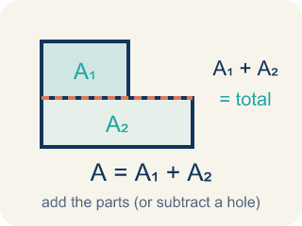
Area of Composite Figures (Área de figuras compuestas) — The total space inside a figure made of basic shapes. Formula: A = A₁ + A₂ — add the parts (or subtract a missing piece).
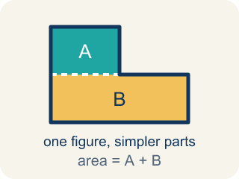
Composite Figure (Figura compuesta) — A shape made by putting two or more simple shapes together.
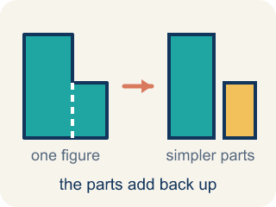
Decompose (Descomponer) — To break a shape into smaller, simpler shapes.
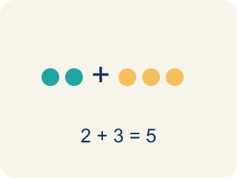
Add (Sumar) — Add up the areas of the smaller shapes to get the total.
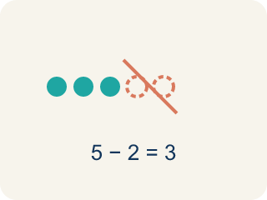
Subtract (Restar) — Take away the area of a missing piece from a bigger shape.
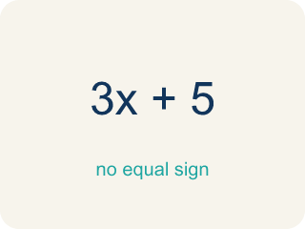
Formula (Fórmula) — A math rule written with symbols.

Practice
Show your work. Use the blank space under each problem.
1. An L-shaped room is made of two rectangles: 10 ft × 6 ft and 4 ft × 3 ft. What is the total area?
A. 72 sq ft
B. 60 sq ft
C. 12 sq ft
D. 72 ft
______________________________________________________________________
2. A rectangular patio is 15 ft × 10 ft with a 5 ft × 4 ft rectangular flower bed cut out. What is the remaining area?
A. 130 sq ft
B. 150 sq ft
C. 20 sq ft
D. 170 sq ft
______________________________________________________________________
3. Plan 2 — L-shaped lobby: decompose the L into two rectangles, one 9 ft by 6 ft and one 7 ft by 3 ft, then ADD. What is the total floor area?
A. 75 sq ft
B. 63 sq ft
C. 54 sq ft
D. 21 sq ft
______________________________________________________________________
4. Plan 4 — Design studio: the floor is a 16 ft by 12 ft rectangle, but a 5 ft by 4 ft storage closet is cut out of one corner. Find the usable floor area.
A. 172 sq ft
B. 192 sq ft
C. 212 sq ft
D. 20 sq ft
______________________________________________________________________
5. Level 2 Extension — Catch the Architect's Area Mistake
Step 1 (Identify the shapes): A clubhouse wall is a 18 ft by 11 ft rectangle with a triangular gable (base 18 ft, height 6 ft) joined on top.
Step 2 (Find the rectangle area): A = 18 x 11 = 198 sq ft
Step 3 (Find the triangle area): A = 1/2 x 18 x 6 = 54 sq ft
Step 4 (Add the areas for the total): Total = 198 + 198 + 54 = 450 sq ft
Which step has the mistake? Explain and fix it:
______________________________________________________________________
______________________________________________________________________
______________________________________________________________________
6. Find the Area Error
Step 1 (Identify the shapes): Rectangle: 16 ft × 10 ft, with a 4 ft × 6 ft piece cut from the corner
Step 2 (Find the large rectangle area): A = 16 × 10 = 160 sq ft
Step 3 (Find the cutout area): A = 4 × 6 = 24 sq ft
Step 4 (Find total area): Total = 160 + 24 = 184 sq ft
Which step has the mistake? Explain and fix it:
______________________________________________________________________
______________________________________________________________________
______________________________________________________________________
7. A T-shaped room can be decomposed in two different ways. Show both ways and prove they give the same total area. Use a T-shape where the top is 14 ft × 4 ft and the stem is 6 ft × 10 ft.
Sentence starter: Way 1: I split it into ___ and ___. Areas: ___ + ___ = ___. Way 2: I used a ___ rectangle and subtracted ___. Areas: ___ − ___ = ___. Both give ___ sq ft.
______________________________________________________________________
______________________________________________________________________
______________________________________________________________________
______________________________________________________________________
8. Sort each composite figure by whether you ADD or SUBTRACT the areas to find the total.
Groups: Add the areas | Subtract the areas
• L-shaped hallway (two rectangles joined) → __________________
• Wall with a window cut out → __________________
• T-shaped stage (two rectangles joined) → __________________
• Floor with a trapdoor removed → __________________
• U-shaped pool (rectangle with center removed) → __________________
• Plus-sign shape (rectangles joined) → __________________
______________________________________________________________________

Answer Key (Teacher)
1. A. 72 sq ft
Area 1 = 10 × 6 = 60 sq ft. Area 2 = 4 × 3 = 12 sq ft. Total = 60 + 12 = 72 sq ft.
Watch for: A common mistake in Area of Composite Figures is adding every piece even when a piece has been cut out of the figure. For a 10 ft by 8 ft rectangle with a 3 ft by 2 ft rectangular notch cut from one corner, students compute the full rectangle 10 × 8 = 80 sq ft and stop, or they add the notch instead of removing it (80 + 6 = 86 sq ft) instead of subtracting it: 80 − (3 × 2) = 80 − 6 = 74 sq ft. Before submitting, check whether each piece is part of the figure (add it) or missing from the figure (subtract it).
2. A. 130 sq ft
Patio = 15 × 10 = 150 sq ft. Cutout = 5 × 4 = 20 sq ft. Remaining = 150 − 20 = 130 sq ft.
Watch for: A common mistake in Area of Composite Figures is adding every piece even when a piece has been cut out of the figure. For a 10 ft by 8 ft rectangle with a 3 ft by 2 ft rectangular notch cut from one corner, students compute the full rectangle 10 × 8 = 80 sq ft and stop, or they add the notch instead of removing it (80 + 6 = 86 sq ft) instead of subtracting it: 80 − (3 × 2) = 80 − 6 = 74 sq ft. Before submitting, check whether each piece is part of the figure (add it) or missing from the figure (subtract it).
3. A. 75 sq ft
First rectangle = 9 x 6 = 54 sq ft. Second rectangle = 7 x 3 = 21 sq ft. Joined L-shape, so add: 54 + 21 = 75 sq ft.
Watch for: A common mistake in Area of Composite Figures is adding every piece even when a piece has been cut out of the figure. For a 10 ft by 8 ft rectangle with a 3 ft by 2 ft rectangular notch cut from one corner, students compute the full rectangle 10 × 8 = 80 sq ft and stop, or they add the notch instead of removing it (80 + 6 = 86 sq ft) instead of subtracting it: 80 − (3 × 2) = 80 − 6 = 74 sq ft. Before submitting, check whether each piece is part of the figure (add it) or missing from the figure (subtract it).
4. A. 172 sq ft
Large rectangle = 16 x 12 = 192 sq ft. Cutout closet = 5 x 4 = 20 sq ft. A piece is removed, so subtract: 192 - 20 = 172 sq ft.
Watch for: A common mistake in Area of Composite Figures is adding every piece even when a piece has been cut out of the figure. For a 10 ft by 8 ft rectangle with a 3 ft by 2 ft rectangular notch cut from one corner, students compute the full rectangle 10 × 8 = 80 sq ft and stop, or they add the notch instead of removing it (80 + 6 = 86 sq ft) instead of subtracting it: 80 − (3 × 2) = 80 − 6 = 74 sq ft. Before submitting, check whether each piece is part of the figure (add it) or missing from the figure (subtract it).
5. Level 2 Extension — Catch the Architect's Area Mistake
The mistake is in Step 4.
Correct work: The architect used the rectangle's area twice (198 + 198). Each region's area is counted only once. Total = 198 + 54 = 252 sq ft.
Watch for: The figure has only two regions, the 198 sq ft rectangle and the 54 sq ft gable, but the final step adds 198 twice. Each region's area is counted exactly once, so the total is 198 + 54 = 252 sq ft.
6. Find the Area Error
The mistake is in Step 4.
Correct work: Since the piece is cut out, subtract: 160 − 24 = 136 sq ft. When a piece is removed, subtract its area from the larger shape.
Watch for: The problem says a 4 ft × 6 ft piece was cut from the corner, so its 24 sq ft is missing from the figure, not added to it. The total should be 160 − 24 = 136 sq ft, which is smaller than the original rectangle — the 184 sq ft answer is larger, which is a signal the operation was backwards.
7. Open response — answers will vary.
Look for key words: decompose, add, subtract, rectangle, composite, equivalent, same area.
8. Correct groups:
L-shaped hallway (two rectangles joined) → Add the areas
Wall with a window cut out → Subtract the areas
T-shaped stage (two rectangles joined) → Add the areas
Floor with a trapdoor removed → Subtract the areas
U-shaped pool (rectangle with center removed) → Subtract the areas
Plus-sign shape (rectangles joined) → Add the areas

