5.4 Small Group · Group 2 — Homework
Lesson 5-4-group2 • Standard 6.GR.1
Name: ______________________ Period: ______ Date: ____________

Today's Goals
Content: I can find the area of a composite figure by adding or subtracting the areas of basic shapes, explain why the method works, and use it on a problem I have not seen before.
Language: I can justify my answer to a skeptic and connect it to a second strategy or representation.

Key Words
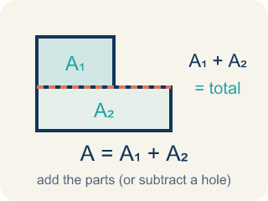
Area of Composite Figures (Área de figuras compuestas) — The total space inside a figure made of basic shapes. Formula: A = A₁ + A₂ — add the parts (or subtract a missing piece).
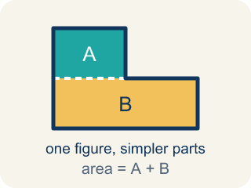
Composite Figure (Figura compuesta) — A shape made by putting two or more simple shapes together.
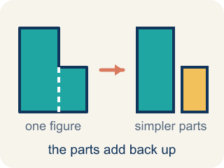
Decompose (Descomponer) — To break a shape into smaller, simpler shapes.
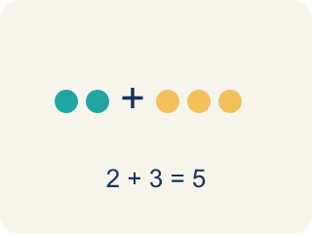
Add (Sumar) — Add up the areas of the smaller shapes to get the total.
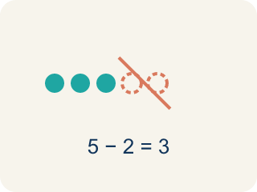
Subtract (Restar) — Take away the area of a missing piece from a bigger shape.
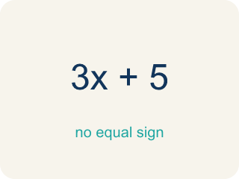
Formula (Fórmula) — A math rule written with symbols.

Practice
Show your work. Use the blank space under each problem.
1. Spot the Common Mistake
Step 1 (Identify the shapes): A 16 ft × 9 ft floor has a 4 ft × 5 ft supply closet cut out of one corner. Find the usable floor area.
Step 2 (Find the large rectangle area): A = 16 × 9 = 144 sq ft.
Step 3 (Find the cutout area): A = 4 × 5 = 20 sq ft.
Step 4 (Find the usable area): Usable area = 144 + 20 = 164 sq ft.
Which step has the mistake? Explain and fix it:
______________________________________________________________________
______________________________________________________________________
______________________________________________________________________
2. Find the Area Error
Step 1 (Identify the shapes): Rectangle: 16 ft × 10 ft, with a 4 ft × 6 ft piece cut from the corner
Step 2 (Find the large rectangle area): A = 16 × 10 = 160 sq ft
Step 3 (Find the cutout area): A = 4 × 6 = 24 sq ft
Step 4 (Find total area): Total = 160 + 24 = 184 sq ft
Which step has the mistake? Explain and fix it:
______________________________________________________________________
______________________________________________________________________
______________________________________________________________________
3. A T-shaped room can be decomposed in two different ways. Show both ways and prove they give the same total area. Use a T-shape where the top is 14 ft × 4 ft and the stem is 6 ft × 10 ft.
Sentence starter: Way 1: I split it into ___ and ___. Areas: ___ + ___ = ___. Way 2: I used a ___ rectangle and subtracted ___. Areas: ___ − ___ = ___. Both give ___ sq ft.
______________________________________________________________________
______________________________________________________________________
______________________________________________________________________
______________________________________________________________________
4. A 7 ft by 5 ft rectangle has a triangle (base 7 ft, height 4 ft) on top. Add the two areas. What is the total area?
A. 49 sq ft
B. 35 sq ft
C. 14 sq ft
D. 63 sq ft
______________________________________________________________________

Answer Key (Teacher)
1. Spot the Common Mistake
The mistake is in Step 4.
Correct work: The closet is cut out, so subtract its area instead of adding it. Usable area = 144 − 20 = 124 sq ft.
Watch for: Both areas are found correctly, 144 sq ft and 20 sq ft, but the final step adds them. The closet was cut out of the floor, so its 20 sq ft is not usable space — subtract it: 144 − 20 = 124 sq ft. An answer of 164 sq ft should also look wrong, since usable floor can never exceed the whole 144 sq ft floor.
2. Find the Area Error
The mistake is in Step 4.
Correct work: Since the piece is cut out, subtract: 160 − 24 = 136 sq ft. When a piece is removed, subtract its area from the larger shape.
Watch for: The problem says a 4 ft × 6 ft piece was cut from the corner, so its 24 sq ft is missing from the figure, not added to it. The total should be 160 − 24 = 136 sq ft, which is smaller than the original rectangle — the 184 sq ft answer is larger, which is a signal the operation was backwards.
3. Open response — answers will vary.
Look for key words: decompose, add, subtract, rectangle, composite, equivalent, same area.
4. A. 49 sq ft
Rectangle = 7 x 5 = 35 sq ft. Triangle = 1/2 x 7 x 4 = 14 sq ft. The pieces are joined, so add: 35 + 14 = 49 sq ft.
Watch for: A common mistake in Area of Composite Figures is adding every piece even when a piece has been cut out of the figure. For a 10 ft by 8 ft rectangle with a 3 ft by 2 ft rectangular notch cut from one corner, students compute the full rectangle 10 × 8 = 80 sq ft and stop, or they add the notch instead of removing it (80 + 6 = 86 sq ft) instead of subtracting it: 80 − (3 × 2) = 80 − 6 = 74 sq ft. Before submitting, check whether each piece is part of the figure (add it) or missing from the figure (subtract it).

