5.5 Small Group · Group 1 — Homework
Lesson 5-5-group1 • Standard 6.GR.2
Name: ______________________ Period: ______ Date: ____________

Today's Goals
Content: With my small group, I can find the volume of a rectangular prism with whole-number edges using length × width × height — one step at a time, with support.
Language: I can talk through each step out loud using a sentence frame and the lesson's key words.

Key Words
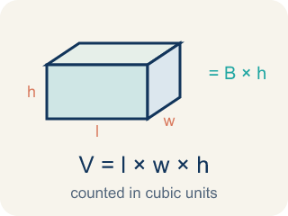
Volume with Whole-Number Edges (Volumen con aristas de números enteros) — The number of unit cubes inside a rectangular prism. Formula: V = l × w × h.

Volume (Volumen) — How much space is inside a solid shape.
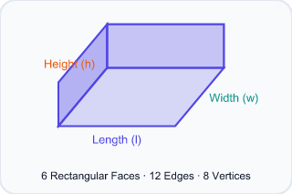
Rectangular prism (Prisma rectangular) — A solid box shape with six flat rectangle sides.
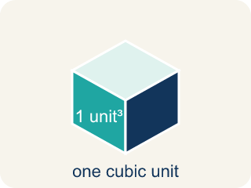
Cubic units (Unidades cúbicas) — The units used to measure space inside, like cubic inches.
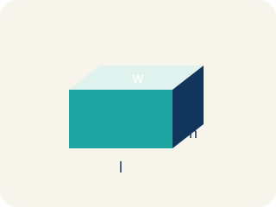
Length, width, height (Largo, ancho, altura) — How long, how wide, and how tall a box is.
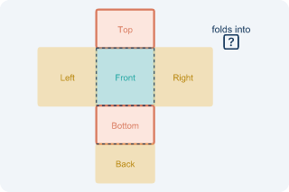
Net (Plantilla (desarrollo plano)) — A flat shape that folds up into a solid.
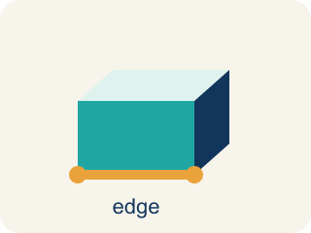
Edge (Arista) — The line where two flat sides of a solid meet.

Practice
Show your work. Use the blank space under each problem.
1. What is the volume of a rectangular prism with l = 7 in, w = 3 in, h = 4 in?
A. 84 in³
B. 14 in³
C. 84 in²
D. 42 in³
______________________________________________________________________
2. A time capsule box has a volume of 120 cm³. Its length is 10 cm and width is 4 cm. What is its height?
A. 3 cm
B. 6 cm
C. 4 cm
D. 12 cm
______________________________________________________________________
3. A rectangular prism has length 8 cm, width 5 cm, and height 4 cm. What is its volume?
A. 17 cm³
B. 160 cm³
C. 80 cm³
D. 120 cm³
______________________________________________________________________
4. A box has a volume of 72 in³. Its base is 6 in by 4 in. What is its height?
A. 3 in
B. 12 in
C. 2 in
D. 18 in
______________________________________________________________________
5. A time capsule box is 5 units long, 3 units wide, and 2 units tall. How many unit cubes fill it?
A. 30 cubic units
B. 10 cubic units
C. 15 cubic units
D. 25 cubic units
______________________________________________________________________
6. You stack unit cubes in a capsule: each layer has 6 cubes, and there are 4 layers. What is the volume?
A. 24 cubic units
B. 10 cubic units
C. 12 cubic units
D. 18 cubic units
______________________________________________________________________
7. Level 2 Extension — Cube Stack Mistake
Step 1 (Dimensions): A capsule is 5 long, 3 wide, and 4 tall
Step 2 (Formula): V = length × width × height
Step 3 (Calculate): V = 5 + 3 + 4 = 12 cubic units
Step 4 (Answer): Volume = 12 cubic units
Which step has the mistake? Explain and fix it:
______________________________________________________________________
______________________________________________________________________
______________________________________________________________________
8. Find the Volume Error
Step 1 (Dimensions): l = 9 ft, w = 4 ft, h = 6 ft
Step 2 (Formula): V = l × w × h
Step 3 (Calculate): V = 9 × 4 × 6 = 9 × 10 = 90 ft³
Step 4 (Answer): Volume = 90 ft³
Which step has the mistake? Explain and fix it:
______________________________________________________________________
______________________________________________________________________
______________________________________________________________________

Answer Key (Teacher)
1. A. 84 in³
V = l × w × h = 7 × 3 × 4 = 84 cubic inches.
Watch for: A common mistake in Volume with Whole Number Edges is multiplying only two of the three edges and stopping there — for example, seeing a box that is 6 in long, 4 in wide, and 3 in tall, multiplying just 6 × 4 = 24, and calling that the volume, when 24 is only the area of the bottom face (in square inches), not the volume of the whole box. The height must also be multiplied in: V = 6 × 4 × 3 = 72 cubic inches. A second common mistake is adding the three edges instead of multiplying them (6 + 4 + 3 = 13 instead of 6 × 4 × 3 = 72 cubic inches). Volume always MULTIPLIES all three edges, and the answer is always labeled in cubic units (in³), never square units (in²) or plain units (in).
2. A. 3 cm
V = l × w × h → 120 = 10 × 4 × h → 120 = 40h → h = 3 cm.
Watch for: A common mistake in Volume with Whole Number Edges is multiplying only two of the three edges and stopping there — for example, seeing a box that is 6 in long, 4 in wide, and 3 in tall, multiplying just 6 × 4 = 24, and calling that the volume, when 24 is only the area of the bottom face (in square inches), not the volume of the whole box. The height must also be multiplied in: V = 6 × 4 × 3 = 72 cubic inches. A second common mistake is adding the three edges instead of multiplying them (6 + 4 + 3 = 13 instead of 6 × 4 × 3 = 72 cubic inches). Volume always MULTIPLIES all three edges, and the answer is always labeled in cubic units (in³), never square units (in²) or plain units (in).
3. B. 160 cm³
V = l × w × h = 8 × 5 × 4 = 160 cm³.
Watch for: A common mistake in Volume with Whole Number Edges is multiplying only two of the three edges and stopping there — for example, seeing a box that is 6 in long, 4 in wide, and 3 in tall, multiplying just 6 × 4 = 24, and calling that the volume, when 24 is only the area of the bottom face (in square inches), not the volume of the whole box. The height must also be multiplied in: V = 6 × 4 × 3 = 72 cubic inches. A second common mistake is adding the three edges instead of multiplying them (6 + 4 + 3 = 13 instead of 6 × 4 × 3 = 72 cubic inches). Volume always MULTIPLIES all three edges, and the answer is always labeled in cubic units (in³), never square units (in²) or plain units (in).
4. A. 3 in
Height = V ÷ (l × w) = 72 ÷ (6 × 4) = 72 ÷ 24 = 3 in.
Watch for: A common mistake in Volume with Whole Number Edges is multiplying only two of the three edges and stopping there — for example, seeing a box that is 6 in long, 4 in wide, and 3 in tall, multiplying just 6 × 4 = 24, and calling that the volume, when 24 is only the area of the bottom face (in square inches), not the volume of the whole box. The height must also be multiplied in: V = 6 × 4 × 3 = 72 cubic inches. A second common mistake is adding the three edges instead of multiplying them (6 + 4 + 3 = 13 instead of 6 × 4 × 3 = 72 cubic inches). Volume always MULTIPLIES all three edges, and the answer is always labeled in cubic units (in³), never square units (in²) or plain units (in).
5. A. 30 cubic units
V = length × width × height = 5 × 3 × 2 = 30 cubic units.
Watch for: A common mistake in Volume with Whole Number Edges is multiplying only two of the three edges and stopping there — for example, seeing a box that is 6 in long, 4 in wide, and 3 in tall, multiplying just 6 × 4 = 24, and calling that the volume, when 24 is only the area of the bottom face (in square inches), not the volume of the whole box. The height must also be multiplied in: V = 6 × 4 × 3 = 72 cubic inches. A second common mistake is adding the three edges instead of multiplying them (6 + 4 + 3 = 13 instead of 6 × 4 × 3 = 72 cubic inches). Volume always MULTIPLIES all three edges, and the answer is always labeled in cubic units (in³), never square units (in²) or plain units (in).
6. A. 24 cubic units
Each layer has 6 cubes and there are 4 layers, so 6 × 4 = 24 cubic units. This is the same as length × width × height with one factor being the number of layers.
Watch for: A common mistake in Volume with Whole Number Edges is multiplying only two of the three edges and stopping there — for example, seeing a box that is 6 in long, 4 in wide, and 3 in tall, multiplying just 6 × 4 = 24, and calling that the volume, when 24 is only the area of the bottom face (in square inches), not the volume of the whole box. The height must also be multiplied in: V = 6 × 4 × 3 = 72 cubic inches. A second common mistake is adding the three edges instead of multiplying them (6 + 4 + 3 = 13 instead of 6 × 4 × 3 = 72 cubic inches). Volume always MULTIPLIES all three edges, and the answer is always labeled in cubic units (in³), never square units (in²) or plain units (in).
7. Level 2 Extension — Cube Stack Mistake
The mistake is in Step 3.
Correct work: The student added the edges instead of multiplying. Volume = 5 × 3 × 4 = 60 cubic units. Adding the edges (5 + 3 + 4 = 12) does not count the cubes that fill the box.
Watch for: In the Calculate step the student wrote 5 + 3 + 4 = 12, adding the edges instead of multiplying them. Adding only walks along three edges; filling the box takes 5 × 3 × 4 = 60 cubic units.
8. Find the Volume Error
The mistake is in Step 3.
Correct work: 4 × 6 = 24, not 10. The student added instead of multiplied. Correct: V = 9 × 24 = 216 ft³.
Watch for: Inside the Calculate step the student replaced 4 × 6 with 10, which is 4 + 6. Multiplying gives 4 × 6 = 24, so the volume is V = 9 × 24 = 216 ft³, not 90 ft³.

