5.5 Small Group · Group 2 — Homework
Lesson 5-5-group2 • Standard 6.GR.2
Name: ______________________ Period: ______ Date: ____________

Today's Goals
Content: I can find the volume of a rectangular prism with whole-number edges using length × width × height, explain why the method works, and use it on a problem I have not seen before.
Language: I can justify my answer to a skeptic and connect it to a second strategy or representation.

Key Words
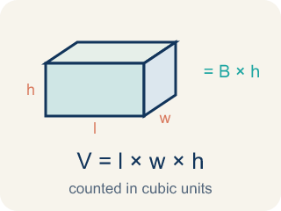
Volume with Whole-Number Edges (Volumen con aristas de números enteros) — The number of unit cubes inside a rectangular prism. Formula: V = l × w × h.

Volume (Volumen) — How much space is inside a solid shape.
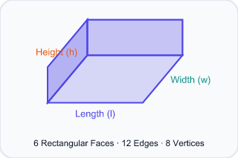
Rectangular prism (Prisma rectangular) — A solid box shape with six flat rectangle sides.
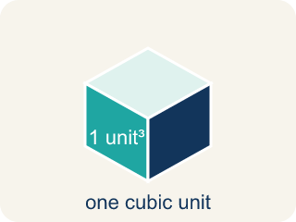
Cubic units (Unidades cúbicas) — The units used to measure space inside, like cubic inches.
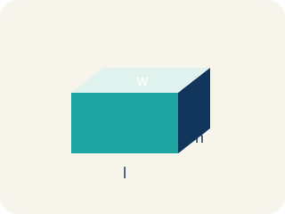
Length, width, height (Largo, ancho, altura) — How long, how wide, and how tall a box is.
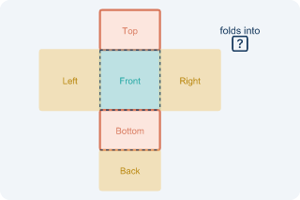
Net (Plantilla (desarrollo plano)) — A flat shape that folds up into a solid.
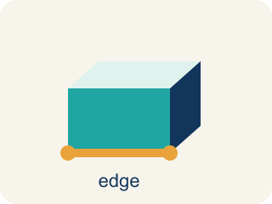
Edge (Arista) — The line where two flat sides of a solid meet.

Practice
Show your work. Use the blank space under each problem.
1. Two storage bins: Bin A is 8 × 6 × 5 inches. Bin B is 9 × 4 × 7 inches. Which holds more and by how much?
A. Bin B by 12 in³
B. Bin A by 12 in³
C. Bin B by 24 in³
D. They hold the same
______________________________________________________________________
2. Added the Last Edge
Step 1 (Dimensions): A capsule is 6 long, 5 wide, and 3 tall
Step 2 (Formula): V = length × width × height
Step 3 (Calculate): V = 6 × 5 + 3 = 33 cubic units
Step 4 (Answer): Volume = 33 cubic units
Which step has the mistake? Explain and fix it:
______________________________________________________________________
______________________________________________________________________
______________________________________________________________________
3. A rectangular prism has length 8 cm, width 5 cm, and height 4 cm. What is its volume?
A. 17 cm³
B. 160 cm³
C. 80 cm³
D. 120 cm³
______________________________________________________________________
4. A box has a volume of 72 in³. Its base is 6 in by 4 in. What is its height?
A. 3 in
B. 12 in
C. 2 in
D. 18 in
______________________________________________________________________

Answer Key (Teacher)
1. A. Bin B by 12 in³
Bin A: 8 × 6 × 5 = 240 in³. Bin B: 9 × 4 × 7 = 252 in³. Bin B holds 12 in³ more.
Watch for: A common mistake in Volume with Whole Number Edges is multiplying only two of the three edges and stopping there — for example, seeing a box that is 6 in long, 4 in wide, and 3 in tall, multiplying just 6 × 4 = 24, and calling that the volume, when 24 is only the area of the bottom face (in square inches), not the volume of the whole box. The height must also be multiplied in: V = 6 × 4 × 3 = 72 cubic inches. A second common mistake is adding the three edges instead of multiplying them (6 + 4 + 3 = 13 instead of 6 × 4 × 3 = 72 cubic inches). Volume always MULTIPLIES all three edges, and the answer is always labeled in cubic units (in³), never square units (in²) or plain units (in).
2. Added the Last Edge
The mistake is in Step 3.
Correct work: The student multiplied the first two edges correctly (6 × 5 = 30) but then added the height instead of multiplying it. Every edge must be multiplied: V = 6 × 5 × 3 = 90 cubic units.
Watch for: The Calculate step starts fine with 6 × 5 = 30, but then the student writes + 3 instead of × 3, landing on 33. Volume multiplies every edge, so the correct work is V = 6 × 5 × 3 = 90 cubic units.
3. B. 160 cm³
V = l × w × h = 8 × 5 × 4 = 160 cm³.
Watch for: A common mistake in Volume with Whole Number Edges is multiplying only two of the three edges and stopping there — for example, seeing a box that is 6 in long, 4 in wide, and 3 in tall, multiplying just 6 × 4 = 24, and calling that the volume, when 24 is only the area of the bottom face (in square inches), not the volume of the whole box. The height must also be multiplied in: V = 6 × 4 × 3 = 72 cubic inches. A second common mistake is adding the three edges instead of multiplying them (6 + 4 + 3 = 13 instead of 6 × 4 × 3 = 72 cubic inches). Volume always MULTIPLIES all three edges, and the answer is always labeled in cubic units (in³), never square units (in²) or plain units (in).
4. A. 3 in
Height = V ÷ (l × w) = 72 ÷ (6 × 4) = 72 ÷ 24 = 3 in.
Watch for: A common mistake in Volume with Whole Number Edges is multiplying only two of the three edges and stopping there — for example, seeing a box that is 6 in long, 4 in wide, and 3 in tall, multiplying just 6 × 4 = 24, and calling that the volume, when 24 is only the area of the bottom face (in square inches), not the volume of the whole box. The height must also be multiplied in: V = 6 × 4 × 3 = 72 cubic inches. A second common mistake is adding the three edges instead of multiplying them (6 + 4 + 3 = 13 instead of 6 × 4 × 3 = 72 cubic inches). Volume always MULTIPLIES all three edges, and the answer is always labeled in cubic units (in³), never square units (in²) or plain units (in).

