10.1–10.3 Catch-Up — Homework
Lesson 5-6-catchup • Standard 6.GR.4
Name: ______________________ Period: ______ Date: ____________

Today's Goals
Content: I can show I am caught up on Lessons 10.1–10.3 by using each lesson's big idea in mixed practice.
Language: I can explain which lesson's big idea I used and how, using key vocabulary from Lessons 10.1–10.3.

Key Words
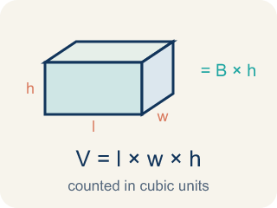
Volume with Whole-Number Edges (Volumen con aristas de números enteros) — The number of unit cubes inside a rectangular prism. Formula: V = l × w × h.

Volume (Volumen) — How much space is inside a solid shape.

Volume of Rectangular Prisms (Volumen de prismas rectangulares) — The space inside a rectangular prism. Formula: V = Bh = l × w × h.
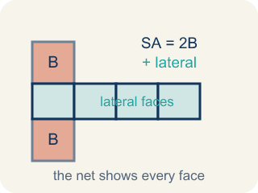
Surface Area Using Nets (Área de superficie usando redes) — The total area of every face of a three-dimensional figure, found by adding the faces shown in its net. Formula: SA = the sum of the areas of all the faces.
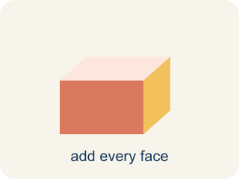
Surface area (Área de superficie) — The total area of all the flat sides of a solid.
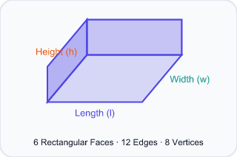
Rectangular prism (Prisma rectangular) — A solid box shape with six flat rectangle sides.
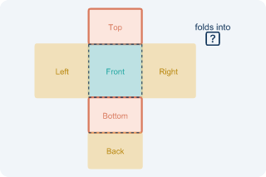
Net (Plantilla (desarrollo plano)) — A flat shape that folds up into a solid.

Practice
Show your work. Use the blank space under each problem.
1. (Lesson 10.1) What is the volume of a rectangular prism with l = 7 in, w = 3 in, h = 4 in?
A. 84 in³
B. 14 in³
C. 84 in²
D. 42 in³
______________________________________________________________________
2. (Lesson 10.1) A time capsule box has a volume of 120 cm³. Its length is 10 cm and width is 4 cm. What is its height?
A. 3 cm
B. 6 cm
C. 4 cm
D. 12 cm
______________________________________________________________________
3. (Lesson 10.1) Two storage bins: Bin A is 8 × 6 × 5 inches. Bin B is 9 × 4 × 7 inches. Which holds more and by how much?
A. Bin B by 12 in³
B. Bin A by 12 in³
C. Bin B by 24 in³
D. They hold the same
______________________________________________________________________
4. (Lesson 10.1) Added the Last Edge
Step 1 (Dimensions): A capsule is 6 long, 5 wide, and 3 tall
Step 2 (Formula): V = length × width × height
Step 3 (Calculate): V = 6 × 5 + 3 = 33 cubic units
Step 4 (Answer): Volume = 33 cubic units
Which step has the mistake? Explain and fix it:
______________________________________________________________________
______________________________________________________________________
______________________________________________________________________
5. (Lesson 10.2) Two boxes: Box A is 10 × 5 × 4 inches. Box B is 8 × 6 × 5 inches. Which has more volume and by how much?
A. Box B by 40 in³
B. Box A by 40 in³
C. Box B by 60 in³
D. They're equal
______________________________________________________________________
6. (Lesson 10.2) Spot the Common Mistake
Step 1 (Dimensions): A box is 6 in long, 4 in wide, and 1/2 in tall.
Step 2 (Formula): V = length × width × height
Step 3 (Calculate): V = 6 × 4 × 1/2, and the student dropped the 1/2: V = 6 × 4 = 24 cubic in
Step 4 (Answer): Volume = 24 cubic in
Which step has the mistake? Explain and fix it:
______________________________________________________________________
______________________________________________________________________
______________________________________________________________________
7. (Lesson 10.3) A cube has edges of 5 cm. What is its surface area?
A. 150 cm²
B. 125 cm²
C. 150 cm³
D. 30 cm²
______________________________________________________________________
8. (Lesson 10.3) Spot the Mistake — One Pair Was Not Doubled
Step 1 (Read): A time capsule box from the net is l = 7 in, w = 5 in, h = 4 in. Find the surface area.
Step 2 (Find each face pair): Top/Bottom: 7×5 = 35, Front/Back: 7×4 = 28, Left/Right: 5×4 = 20
Step 3 (Apply the formula): SA = 2(35) + 2(28) + 20 = 70 + 56 + 20 = 146 in² (left/right pair not doubled)
Step 4 (Answer): Surface Area = 146 in²
Which step has the mistake? Explain and fix it:
______________________________________________________________________
______________________________________________________________________
______________________________________________________________________
9. (Lesson 10.1) A time capsule box is 5 units long, 3 units wide, and 2 units tall. How many unit cubes fill it?
A. 30 cubic units
B. 10 cubic units
C. 15 cubic units
D. 25 cubic units
______________________________________________________________________
10. (Lesson 10.2) A time-capsule box measures 6 in long, 4 in wide, and 3 in tall. What is its volume?
A. 72 cubic in
B. 13 cubic in
C. 24 cubic in
D. 72 square in
______________________________________________________________________

Answer Key (Teacher)
1. A. 84 in³
V = l × w × h = 7 × 3 × 4 = 84 cubic inches.
Watch for: A common mistake in Surface Area Using Nets is finding the area of only one face from each of the 3 matching pairs and forgetting to double it, instead of counting all 6 faces. For a box that is 9 in × 4 in × 5 in, a student might add just one face from each pair: (9×4) + (9×5) + (4×5) = 36 + 45 + 20 = 101 in², but the net actually has two of each face, so the correct total is 2(36) + 2(45) + 2(20) = 72 + 90 + 40 = 202 in² — exactly double. Before you submit, ask: 'Did I count both matching faces in each pair, or only one from each pair?'
2. A. 3 cm
V = l × w × h → 120 = 10 × 4 × h → 120 = 40h → h = 3 cm.
Watch for: A common mistake in Surface Area Using Nets is finding the area of only one face from each of the 3 matching pairs and forgetting to double it, instead of counting all 6 faces. For a box that is 9 in × 4 in × 5 in, a student might add just one face from each pair: (9×4) + (9×5) + (4×5) = 36 + 45 + 20 = 101 in², but the net actually has two of each face, so the correct total is 2(36) + 2(45) + 2(20) = 72 + 90 + 40 = 202 in² — exactly double. Before you submit, ask: 'Did I count both matching faces in each pair, or only one from each pair?'
3. A. Bin B by 12 in³
Bin A: 8 × 6 × 5 = 240 in³. Bin B: 9 × 4 × 7 = 252 in³. Bin B holds 12 in³ more.
Watch for: A common mistake in Surface Area Using Nets is finding the area of only one face from each of the 3 matching pairs and forgetting to double it, instead of counting all 6 faces. For a box that is 9 in × 4 in × 5 in, a student might add just one face from each pair: (9×4) + (9×5) + (4×5) = 36 + 45 + 20 = 101 in², but the net actually has two of each face, so the correct total is 2(36) + 2(45) + 2(20) = 72 + 90 + 40 = 202 in² — exactly double. Before you submit, ask: 'Did I count both matching faces in each pair, or only one from each pair?'
4. (Lesson 10.1) Added the Last Edge
The mistake is in Step 3.
Correct work: The student multiplied the first two edges correctly (6 × 5 = 30) but then added the height instead of multiplying it. Every edge must be multiplied: V = 6 × 5 × 3 = 90 cubic units.
Watch for: The Calculate step starts fine with 6 × 5 = 30, but then the student writes + 3 instead of × 3, landing on 33. Volume multiplies every edge, so the correct work is V = 6 × 5 × 3 = 90 cubic units.
5. A. Box B by 40 in³
Box A: 10 × 5 × 4 = 200 in³. Box B: 8 × 6 × 5 = 240 in³. Box B is bigger by 40 in³.
Watch for: A common mistake in Surface Area Using Nets is finding the area of only one face from each of the 3 matching pairs and forgetting to double it, instead of counting all 6 faces. For a box that is 9 in × 4 in × 5 in, a student might add just one face from each pair: (9×4) + (9×5) + (4×5) = 36 + 45 + 20 = 101 in², but the net actually has two of each face, so the correct total is 2(36) + 2(45) + 2(20) = 72 + 90 + 40 = 202 in² — exactly double. Before you submit, ask: 'Did I count both matching faces in each pair, or only one from each pair?'
6. (Lesson 10.2) Spot the Common Mistake
The mistake is in Step 3.
Correct work: The student ignored the fractional edge of 1/2 in. A fractional edge still counts: V = 6 × 4 × 1/2 = 24 × 1/2 = 12 cubic in.
Watch for: The Calculate step threw away the 1/2 in height, but a fractional edge is still an edge. Multiply all three: V = 6 × 4 × 1/2 = 24 × 1/2 = 12 cubic in. A half-inch height makes the volume half of 24, not equal to it.
7. A. 150 cm²
A cube has 6 identical faces. Each face: 5 × 5 = 25 cm². Total SA = 6 × 25 = 150 cm².
Watch for: A common mistake in Surface Area Using Nets is finding the area of only one face from each of the 3 matching pairs and forgetting to double it, instead of counting all 6 faces. For a box that is 9 in × 4 in × 5 in, a student might add just one face from each pair: (9×4) + (9×5) + (4×5) = 36 + 45 + 20 = 101 in², but the net actually has two of each face, so the correct total is 2(36) + 2(45) + 2(20) = 72 + 90 + 40 = 202 in² — exactly double. Before you submit, ask: 'Did I count both matching faces in each pair, or only one from each pair?'
8. (Lesson 10.3) Spot the Mistake — One Pair Was Not Doubled
The mistake is in Step 3.
Correct work: The student doubled the first two pairs but forgot to double the left/right pair. There are two 20 in² faces, so it should be 2(20) = 40, not 20. Correct: SA = 70 + 56 + 40 = 166 in².
Watch for: The three face areas are right, but the formula line doubles only the first two pairs. The left and right faces are each 5 × 4 = 20 in², so that pair contributes 2(20) = 40 in², not 20 in². The correct total is SA = 70 + 56 + 40 = 166 in².
9. A. 30 cubic units
V = length × width × height = 5 × 3 × 2 = 30 cubic units.
Watch for: A common mistake in Surface Area Using Nets is finding the area of only one face from each of the 3 matching pairs and forgetting to double it, instead of counting all 6 faces. For a box that is 9 in × 4 in × 5 in, a student might add just one face from each pair: (9×4) + (9×5) + (4×5) = 36 + 45 + 20 = 101 in², but the net actually has two of each face, so the correct total is 2(36) + 2(45) + 2(20) = 72 + 90 + 40 = 202 in² — exactly double. Before you submit, ask: 'Did I count both matching faces in each pair, or only one from each pair?'
10. A. 72 cubic in
V = length × width × height = 6 × 4 × 3 = 72 cubic in. Volume uses cubic units.
Watch for: A common mistake in Surface Area Using Nets is finding the area of only one face from each of the 3 matching pairs and forgetting to double it, instead of counting all 6 faces. For a box that is 9 in × 4 in × 5 in, a student might add just one face from each pair: (9×4) + (9×5) + (4×5) = 36 + 45 + 20 = 101 in², but the net actually has two of each face, so the correct total is 2(36) + 2(45) + 2(20) = 72 + 90 + 40 = 202 in² — exactly double. Before you submit, ask: 'Did I count both matching faces in each pair, or only one from each pair?'

