5.6 Small Group · Group 1 — Homework
Lesson 5-6-group1 • Standard 6.GR.4
Name: ______________________ Period: ______ Date: ____________

Today's Goals
Content: With my small group, I can find the surface area of a solid by using its net — one step at a time, with support.
Language: I can talk through each step out loud using a sentence frame and the lesson's key words.

Key Words
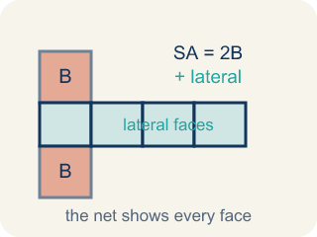
Surface Area Using Nets (Área de superficie usando redes) — The total area of every face of a three-dimensional figure, found by adding the faces shown in its net. Formula: SA = the sum of the areas of all the faces.
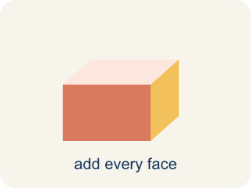
Surface area (Área de superficie) — The total area of all the flat sides of a solid.
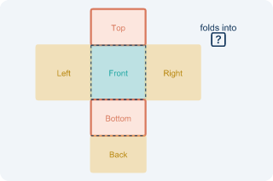
Net (Plantilla (desarrollo plano)) — A flat shape that folds up into a solid.
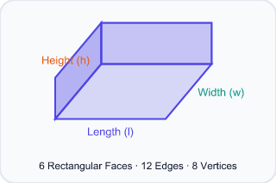
Face (Cara) — One flat side of a solid shape.
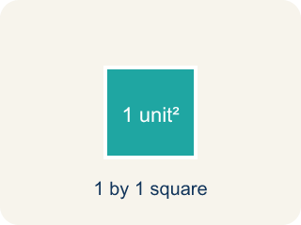
Two-dimensional (Bidimensional) — A flat shape with length and width, but no thickness.
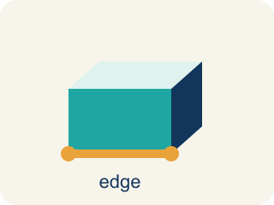
Edge (Arista) — The line where two flat sides of a solid meet.

Practice
Show your work. Use the blank space under each problem.
1. A rectangular prism has l = 6 in, w = 4 in, h = 2 in. What is its surface area?
A. 88 in²
B. 48 in²
C. 88 in³
D. 44 in²
______________________________________________________________________
2. How many faces does a rectangular prism have?
A. 6
B. 4
C. 8
D. 12
______________________________________________________________________
3. You unfold a time capsule that is a cube. Its net shows 6 equal squares, and each square has an area of 4 cm². What is the cube's total surface area?
A. 24 cm²
B. 10 cm²
C. 16 cm²
D. 12 cm²
______________________________________________________________________
4. Your team unfolds a rectangular time capsule box into a flat net. How many faces (flat sides) will the net show in all?
A. 6
B. 4
C. 5
D. 8
______________________________________________________________________
5. A time capsule box measures 2 in × 3 in × 4 in. Using its net, you add up all six faces. What is the total surface area?
A. 52 in²
B. 24 in²
C. 26 in²
D. 48 in²
______________________________________________________________________
6. Level 2 Extension — The Missing Back Face
Step 1 (Box from the net): A time capsule box: l = 8 in, w = 3 in, h = 2 in
Step 2 (Label the faces): Top/Bottom: 8×3 = 24, Front/Back: 8×2 = 16, Left/Right: 3×2 = 6
Step 3 (Add the faces): SA = 24 + 24 + 16 + 6 + 6 = 76 in² (only one front face counted)
Step 4 (Answer): Surface Area = 76 in²
Which step has the mistake? Explain and fix it:
______________________________________________________________________
______________________________________________________________________
______________________________________________________________________
7. Find the Surface Area Error
Step 1 (Dimensions): l = 10 in, w = 4 in, h = 3 in
Step 2 (Formula): SA = 2lw + 2lh + 2wh
Step 3 (Calculate): SA = 2(10×4) + 2(10×3) + (4×3) = 80 + 60 + 12 = 152 in²
Step 4 (Answer): Surface Area = 152 in²
Which step has the mistake? Explain and fix it:
______________________________________________________________________
______________________________________________________________________
______________________________________________________________________
8. Two boxes have the same volume of 60 in³. Box A is 5 × 4 × 3. Box B is 10 × 6 × 1. Which box uses less wrapping paper (has less surface area)? Show your calculations and explain why a more cube-like shape might use less material.
Sentence starter: Box A: SA = 2(___) + 2(___) + 2(___) = ___ in². Box B: SA = 2(___) + 2(___) + 2(___) = ___ in². Box ___ uses less wrapping paper because ___.
______________________________________________________________________
______________________________________________________________________
______________________________________________________________________
______________________________________________________________________

Answer Key (Teacher)
1. A. 88 in²
SA = 2(6×4) + 2(6×2) + 2(4×2) = 48 + 24 + 16 = 88 in².
Watch for: A common mistake in Surface Area Using Nets is finding the area of only one face from each of the 3 matching pairs and forgetting to double it, instead of counting all 6 faces. For a box that is 9 in × 4 in × 5 in, a student might add just one face from each pair: (9×4) + (9×5) + (4×5) = 36 + 45 + 20 = 101 in², but the net actually has two of each face, so the correct total is 2(36) + 2(45) + 2(20) = 72 + 90 + 40 = 202 in² — exactly double. Before you submit, ask: 'Did I count both matching faces in each pair, or only one from each pair?'
2. A. 6
A rectangular prism has 6 faces: top, bottom, front, back, left, and right.
Watch for: A common mistake in Surface Area Using Nets is finding the area of only one face from each of the 3 matching pairs and forgetting to double it, instead of counting all 6 faces. For a box that is 9 in × 4 in × 5 in, a student might add just one face from each pair: (9×4) + (9×5) + (4×5) = 36 + 45 + 20 = 101 in², but the net actually has two of each face, so the correct total is 2(36) + 2(45) + 2(20) = 72 + 90 + 40 = 202 in² — exactly double. Before you submit, ask: 'Did I count both matching faces in each pair, or only one from each pair?'
3. A. 24 cm²
A cube net has 6 equal square faces. With each face 4 cm², the surface area is 6 × 4 = 24 cm².
Watch for: A common mistake in Surface Area Using Nets is finding the area of only one face from each of the 3 matching pairs and forgetting to double it, instead of counting all 6 faces. For a box that is 9 in × 4 in × 5 in, a student might add just one face from each pair: (9×4) + (9×5) + (4×5) = 36 + 45 + 20 = 101 in², but the net actually has two of each face, so the correct total is 2(36) + 2(45) + 2(20) = 72 + 90 + 40 = 202 in² — exactly double. Before you submit, ask: 'Did I count both matching faces in each pair, or only one from each pair?'
4. A. 6
A rectangular prism has 6 faces — top, bottom, front, back, left, and right — so its net shows 6 faces.
Watch for: A common mistake in Surface Area Using Nets is finding the area of only one face from each of the 3 matching pairs and forgetting to double it, instead of counting all 6 faces. For a box that is 9 in × 4 in × 5 in, a student might add just one face from each pair: (9×4) + (9×5) + (4×5) = 36 + 45 + 20 = 101 in², but the net actually has two of each face, so the correct total is 2(36) + 2(45) + 2(20) = 72 + 90 + 40 = 202 in² — exactly double. Before you submit, ask: 'Did I count both matching faces in each pair, or only one from each pair?'
5. A. 52 in²
From the net: SA = 2(2×3) + 2(2×4) + 2(3×4) = 12 + 16 + 24 = 52 in².
Watch for: A common mistake in Surface Area Using Nets is finding the area of only one face from each of the 3 matching pairs and forgetting to double it, instead of counting all 6 faces. For a box that is 9 in × 4 in × 5 in, a student might add just one face from each pair: (9×4) + (9×5) + (4×5) = 36 + 45 + 20 = 101 in², but the net actually has two of each face, so the correct total is 2(36) + 2(45) + 2(20) = 72 + 90 + 40 = 202 in² — exactly double. Before you submit, ask: 'Did I count both matching faces in each pair, or only one from each pair?'
6. Level 2 Extension — The Missing Back Face
The mistake is in Step 3.
Correct work: The student forgot the back face. On the net the front AND back each measure 8×2 = 16, so both must be added. Correct: SA = 24 + 24 + 16 + 16 + 6 + 6 = 92 in².
Watch for: The three face areas are correct, but the addition line uses only one 8×2 = 16 in² face. A closed box has a front AND a back, so both 16 in² faces belong in the sum. Counting all six faces gives SA = 24 + 24 + 16 + 16 + 6 + 6 = 92 in², not 76 in².
7. Find the Surface Area Error
The mistake is in Step 3.
Correct work: The student forgot to multiply the last face pair by 2. It should be 2(4×3) = 24, not 12. Correct: SA = 80 + 60 + 24 = 164 in².
Watch for: The formula SA = 2lw + 2lh + 2wh is written correctly, but in the calculation the last face pair loses its 2. The left and right faces are each 4 × 3 = 12 in², so they contribute 2(12) = 24 in². The correct total is SA = 80 + 60 + 24 = 164 in².
8. Open response — answers will vary.
Look for key words: surface area, volume, same, less, cube, efficient, wrapping paper, 94, 152.

