5.6 Small Group · Group 2 — Homework
Lesson 5-6-group2 • Standard 6.GR.4
Name: ______________________ Period: ______ Date: ____________

Today's Goals
Content: I can find the surface area of a solid by using its net, explain why the method works, and use it on a problem I have not seen before.
Language: I can justify my answer to a skeptic and connect it to a second strategy or representation.

Key Words
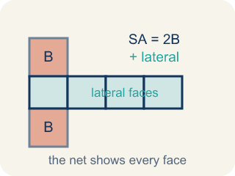
Surface Area Using Nets (Área de superficie usando redes) — The total area of every face of a three-dimensional figure, found by adding the faces shown in its net. Formula: SA = the sum of the areas of all the faces.
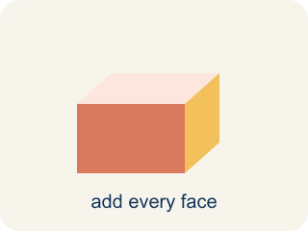
Surface area (Área de superficie) — The total area of all the flat sides of a solid.
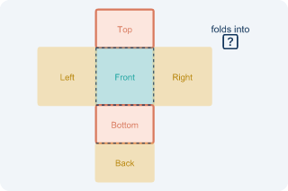
Net (Plantilla (desarrollo plano)) — A flat shape that folds up into a solid.
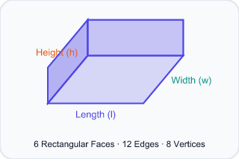
Face (Cara) — One flat side of a solid shape.
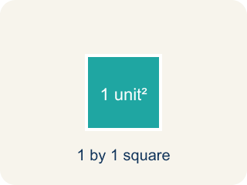
Two-dimensional (Bidimensional) — A flat shape with length and width, but no thickness.
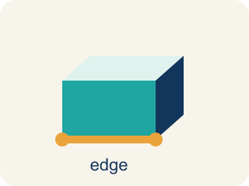
Edge (Arista) — The line where two flat sides of a solid meet.

Practice
Show your work. Use the blank space under each problem.
1. A cube has edges of 5 cm. What is its surface area?
A. 150 cm²
B. 125 cm²
C. 150 cm³
D. 30 cm²
______________________________________________________________________
2. Spot the Mistake — One Pair Was Not Doubled
Step 1 (Read): A time capsule box from the net is l = 7 in, w = 5 in, h = 4 in. Find the surface area.
Step 2 (Find each face pair): Top/Bottom: 7×5 = 35, Front/Back: 7×4 = 28, Left/Right: 5×4 = 20
Step 3 (Apply the formula): SA = 2(35) + 2(28) + 20 = 70 + 56 + 20 = 146 in² (left/right pair not doubled)
Step 4 (Answer): Surface Area = 146 in²
Which step has the mistake? Explain and fix it:
______________________________________________________________________
______________________________________________________________________
______________________________________________________________________
3. Find the Surface Area Error
Step 1 (Dimensions): l = 10 in, w = 4 in, h = 3 in
Step 2 (Formula): SA = 2lw + 2lh + 2wh
Step 3 (Calculate): SA = 2(10×4) + 2(10×3) + (4×3) = 80 + 60 + 12 = 152 in²
Step 4 (Answer): Surface Area = 152 in²
Which step has the mistake? Explain and fix it:
______________________________________________________________________
______________________________________________________________________
______________________________________________________________________
4. Two boxes have the same volume of 60 in³. Box A is 5 × 4 × 3. Box B is 10 × 6 × 1. Which box uses less wrapping paper (has less surface area)? Show your calculations and explain why a more cube-like shape might use less material.
Sentence starter: Box A: SA = 2(___) + 2(___) + 2(___) = ___ in². Box B: SA = 2(___) + 2(___) + 2(___) = ___ in². Box ___ uses less wrapping paper because ___.
______________________________________________________________________
______________________________________________________________________
______________________________________________________________________
______________________________________________________________________

Answer Key (Teacher)
1. A. 150 cm²
A cube has 6 identical faces. Each face: 5 × 5 = 25 cm². Total SA = 6 × 25 = 150 cm².
Watch for: A common mistake in Surface Area Using Nets is finding the area of only one face from each of the 3 matching pairs and forgetting to double it, instead of counting all 6 faces. For a box that is 9 in × 4 in × 5 in, a student might add just one face from each pair: (9×4) + (9×5) + (4×5) = 36 + 45 + 20 = 101 in², but the net actually has two of each face, so the correct total is 2(36) + 2(45) + 2(20) = 72 + 90 + 40 = 202 in² — exactly double. Before you submit, ask: 'Did I count both matching faces in each pair, or only one from each pair?'
2. Spot the Mistake — One Pair Was Not Doubled
The mistake is in Step 3.
Correct work: The student doubled the first two pairs but forgot to double the left/right pair. There are two 20 in² faces, so it should be 2(20) = 40, not 20. Correct: SA = 70 + 56 + 40 = 166 in².
Watch for: The three face areas are right, but the formula line doubles only the first two pairs. The left and right faces are each 5 × 4 = 20 in², so that pair contributes 2(20) = 40 in², not 20 in². The correct total is SA = 70 + 56 + 40 = 166 in².
3. Find the Surface Area Error
The mistake is in Step 3.
Correct work: The student forgot to multiply the last face pair by 2. It should be 2(4×3) = 24, not 12. Correct: SA = 80 + 60 + 24 = 164 in².
Watch for: The formula SA = 2lw + 2lh + 2wh is written correctly, but in the calculation the last face pair loses its 2. The left and right faces are each 4 × 3 = 12 in², so they contribute 2(12) = 24 in². The correct total is SA = 80 + 60 + 24 = 164 in².
4. Open response — answers will vary.
Look for key words: surface area, volume, same, less, cube, efficient, wrapping paper, 94, 152.

