Represent Three-Dimensional Figures in Two Dimensions — Homework
Lesson 5-6 • Standard 6.GR.4
Name: ______________________ Period: ______ Date: ____________

Today's Goals
Content: I can find the surface area of a solid by using its net.
Language: I can explain my work using the words surface area, net, face, and two-dimensional.

Key Words
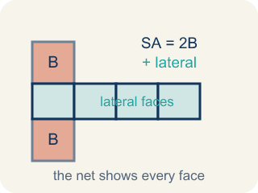
Surface Area Using Nets (Área de superficie usando redes) — The total area of all the faces of a solid. A net unfolds the solid flat so you can see every face and add their areas.
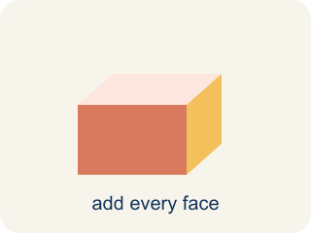
Surface area (Área de superficie) — The total area of all the flat sides of a solid.
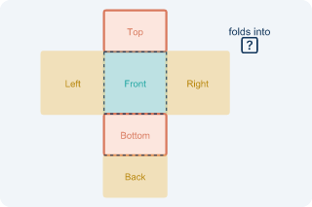
Net (Plantilla (desarrollo plano)) — A flat shape that folds up into a solid.
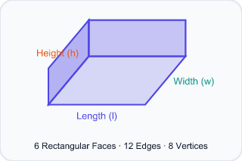
Face (Cara) — One flat side of a solid shape.
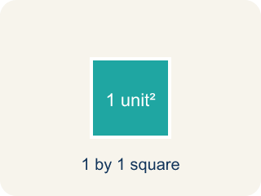
Two-dimensional (Bidimensional) — A flat shape with length and width, but no thickness.
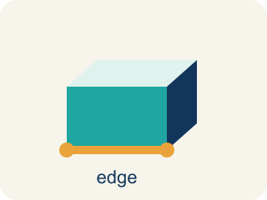
Edge (Arista) — The line where two flat sides of a solid meet.

Practice
Show your work. Use the blank space under each problem.
1. A rectangular prism has l = 6 in, w = 4 in, h = 2 in. What is its surface area?
A. 88 in²
B. 48 in²
C. 88 in³
D. 44 in²
______________________________________________________________________
2. How many faces does a rectangular prism have?
A. 6
B. 4
C. 8
D. 12
______________________________________________________________________
3. Find the surface area of each time capsule box using its net.
Box | Length | Width | Height | Surface Area
Box A | 10 in | 6 in | 4 in
Box B | 7 cm | 7 cm | 3 cm
Box C | 12 ft | 5 ft | 2 ft
______________________________________________________________________
4. A cube has edges of 5 cm. What is its surface area?
A. 150 cm²
B. 125 cm²
C. 150 cm³
D. 30 cm²
______________________________________________________________________
5. Sort each item into the correct group.
• undefined → __________________
• undefined → __________________
• undefined → __________________
• undefined → __________________
• undefined → __________________
______________________________________________________________________
6. Spot the Mistake — One Pair Was Not Doubled
Step 1 (Read): A time capsule box from the net is l = 7 in, w = 5 in, h = 4 in. Find the surface area.
Step 2 (Find each face pair): Top/Bottom: 7×5 = 35, Front/Back: 7×4 = 28, Left/Right: 5×4 = 20
Step 3 (Apply the formula): SA = 2(35) + 2(28) + 20 = 70 + 56 + 20 = 146 in² (left/right pair not doubled)
Step 4 (Answer): Surface Area = 146 in²
Which step has the mistake? Explain and fix it:
______________________________________________________________________
______________________________________________________________________
______________________________________________________________________
7. You unfold a time capsule that is a cube. Its net shows 6 equal squares, and each square has an area of 4 cm². What is the cube's total surface area?
A. 24 cm²
B. 10 cm²
C. 16 cm²
D. 12 cm²
______________________________________________________________________
8. Your team unfolds a rectangular time capsule box into a flat net. How many faces (flat sides) will the net show in all?
A. 6
B. 4
C. 5
D. 8
______________________________________________________________________
9. Match each solid to the net it folds up from.
Item | Answer choices
____ Cube | F. How surface area is measured
____ Rectangular prism | E. 6 faces
____ Triangular prism | D. Net of 1 square and 4 triangles
____ Square pyramid | C. Net of 2 triangles and 3 rectangles
____ Faces on any rectangular prism | B. Net of 6 rectangles (3 matching pairs)
____ Square units (in², cm²) | A. Net of 6 equal squares
______________________________________________________________________
10. Sort each flat shape: is it a valid net that folds into a closed time capsule box, or not a complete net?
Groups: Valid net (folds into a closed box) | Not a complete net
• Six rectangles arranged in a cross shape → __________________
• Six rectangles in a T shape (3 matching pairs) → __________________
• Four rectangles in a straight row (top and bottom missing) → __________________
• A single rectangle by itself → __________________
• Two squares and four rectangles for a box → __________________
• Seven rectangles (one extra face) → __________________
______________________________________________________________________

Answer Key (Teacher)
1. A. 88 in²
SA = 2(6×4) + 2(6×2) + 2(4×2) = 48 + 24 + 16 = 88 in².
Watch for: A common mistake in Surface Area Using Nets is finding the area of only one face from each of the 3 matching pairs and forgetting to double it, instead of counting all 6 faces. For a box that is 9 in × 4 in × 5 in, a student might add just one face from each pair: (9×4) + (9×5) + (4×5) = 36 + 45 + 20 = 101 in², but the net actually has two of each face, so the correct total is 2(36) + 2(45) + 2(20) = 72 + 90 + 40 = 202 in² — exactly double. Before you submit, ask: 'Did I count both matching faces in each pair, or only one from each pair?'
2. A. 6
A rectangular prism has 6 faces: top, bottom, front, back, left, and right.
Watch for: A common mistake in Surface Area Using Nets is finding the area of only one face from each of the 3 matching pairs and forgetting to double it, instead of counting all 6 faces. For a box that is 9 in × 4 in × 5 in, a student might add just one face from each pair: (9×4) + (9×5) + (4×5) = 36 + 45 + 20 = 101 in², but the net actually has two of each face, so the correct total is 2(36) + 2(45) + 2(20) = 72 + 90 + 40 = 202 in² — exactly double. Before you submit, ask: 'Did I count both matching faces in each pair, or only one from each pair?'
3. Find the surface area of each time capsule box using its net.
Box A — Surface Area: 248 in²
Box B — Surface Area: 182 cm²
Box C — Surface Area: 188 ft²

4. A. 150 cm²
A cube has 6 identical faces. Each face: 5 × 5 = 25 cm². Total SA = 6 × 25 = 150 cm².
Watch for: A common mistake in Surface Area Using Nets is finding the area of only one face from each of the 3 matching pairs and forgetting to double it, instead of counting all 6 faces. For a box that is 9 in × 4 in × 5 in, a student might add just one face from each pair: (9×4) + (9×5) + (4×5) = 36 + 45 + 20 = 101 in², but the net actually has two of each face, so the correct total is 2(36) + 2(45) + 2(20) = 72 + 90 + 40 = 202 in² — exactly double. Before you submit, ask: 'Did I count both matching faces in each pair, or only one from each pair?'
5. Correct groups:
undefined → undefined
undefined → undefined
undefined → undefined
undefined → undefined
undefined → undefined

6. Spot the Mistake — One Pair Was Not Doubled
The mistake is in Step 3.
Correct work: The student doubled the first two pairs but forgot to double the left/right pair. There are two 20 in² faces, so it should be 2(20) = 40, not 20. Correct: SA = 70 + 56 + 40 = 166 in².
Watch for: The three face areas are right, but the formula line doubles only the first two pairs. The left and right faces are each 5 × 4 = 20 in², so that pair contributes 2(20) = 40 in², not 20 in². The correct total is SA = 70 + 56 + 40 = 166 in².
7. A. 24 cm²
A cube net has 6 equal square faces. With each face 4 cm², the surface area is 6 × 4 = 24 cm².
Watch for: A common mistake in Surface Area Using Nets is finding the area of only one face from each of the 3 matching pairs and forgetting to double it, instead of counting all 6 faces. For a box that is 9 in × 4 in × 5 in, a student might add just one face from each pair: (9×4) + (9×5) + (4×5) = 36 + 45 + 20 = 101 in², but the net actually has two of each face, so the correct total is 2(36) + 2(45) + 2(20) = 72 + 90 + 40 = 202 in² — exactly double. Before you submit, ask: 'Did I count both matching faces in each pair, or only one from each pair?'
8. A. 6
A rectangular prism has 6 faces — top, bottom, front, back, left, and right — so its net shows 6 faces.
Watch for: A common mistake in Surface Area Using Nets is finding the area of only one face from each of the 3 matching pairs and forgetting to double it, instead of counting all 6 faces. For a box that is 9 in × 4 in × 5 in, a student might add just one face from each pair: (9×4) + (9×5) + (4×5) = 36 + 45 + 20 = 101 in², but the net actually has two of each face, so the correct total is 2(36) + 2(45) + 2(20) = 72 + 90 + 40 = 202 in² — exactly double. Before you submit, ask: 'Did I count both matching faces in each pair, or only one from each pair?'
9. Matches:
Cube → Net of 6 equal squares
Rectangular prism → Net of 6 rectangles (3 matching pairs)
Triangular prism → Net of 2 triangles and 3 rectangles
Square pyramid → Net of 1 square and 4 triangles
Faces on any rectangular prism → 6 faces
Square units (in², cm²) → How surface area is measured

10. Correct groups:
Six rectangles arranged in a cross shape → Valid net (folds into a closed box)
Six rectangles in a T shape (3 matching pairs) → Valid net (folds into a closed box)
Four rectangles in a straight row (top and bottom missing) → Not a complete net
A single rectangle by itself → Not a complete net
Two squares and four rectangles for a box → Valid net (folds into a closed box)
Seven rectangles (one extra face) → Not a complete net

