5.7 Small Group · Group 1 — Homework
Lesson 5-7-group1 • Standard 6.GR.4
Name: ______________________ Period: ______ Date: ____________

Today's Goals
Content: With my small group, I can find the surface area of rectangular and triangular prisms — one step at a time, with support.
Language: I can talk through each step out loud using a sentence frame and the lesson's key words.

Key Words
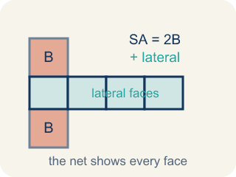
Surface Area of Prisms (Área de superficie de prismas) — The total area of all bases and lateral faces of a prism. Formula: SA = 2B + lateral area.
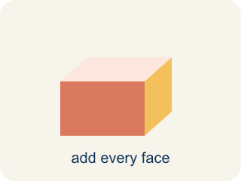
Surface area (Área de superficie) — The total area of all the flat sides of a solid.
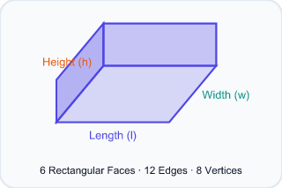
Rectangular prism (Prisma rectangular) — A solid box shape with six flat rectangle sides.

Triangular prism (Prisma triangular) — A solid with two triangle ends and three flat rectangle sides.

Face (Cara) — One flat side of a solid shape.
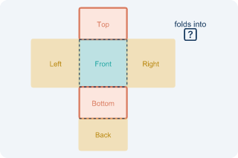
Net (Plantilla (desarrollo plano)) — A flat shape that folds up into a solid.

Lateral face (Cara lateral) — The side faces of a solid, not the top or bottom.

Practice
Show your work. Use the blank space under each problem.
1. What is the surface area of a rectangular prism with l = 5 cm, w = 4 cm, h = 3 cm?
A. 94 cm²
B. 60 cm²
C. 94 cm³
D. 47 cm²
______________________________________________________________________
2. How many faces does a triangular prism have?
A. 5
B. 4
C. 6
D. 3
______________________________________________________________________
3. A rectangular time capsule box measures 3 in by 4 in by 5 in. How much wrapping paper covers its surface (no overlap)?
A. 94 in²
B. 60 in²
C. 47 in²
D. 94 in³
______________________________________________________________________
4. A rectangular capsule crate is 6 cm long, 5 cm wide, and 4 cm tall. How much cardboard is needed to cover all its faces?
A. 148 cm²
B. 120 cm²
C. 74 cm²
D. 148 cm³
______________________________________________________________________
5. A triangular prism is 10 in long. Its triangle ends have base 8 in, height 6 in, and sides 8, 6, and 10 in. Find its surface area.
A. 288 in²
B. 240 in²
C. 48 in²
D. 288 in³
______________________________________________________________________
6. Level 2 Extension — Wrapping Paper Mix-Up
Step 1 (Dimensions): Rectangular capsule: l = 4 in, w = 3 in, h = 2 in. Find the wrapping paper (surface area).
Step 2 (Formula): Surface area means adding the area of all 6 faces: SA = 2lw + 2lh + 2wh.
Step 3 (Calculate): The student multiplied the three dimensions: 4 × 3 × 2 = 24, so they wrote SA = 24 in².
Step 4 (Answer): Wrapping paper needed = 24 in²
Which step has the mistake? Explain and fix it:
______________________________________________________________________
______________________________________________________________________
______________________________________________________________________
7. Find the Surface Area Error
Step 1 (Dimensions): Rectangular prism: l = 12 cm, w = 7 cm, h = 5 cm
Step 2 (Formula): SA = 2lw + 2lh + 2wh
Step 3 (Calculate): SA = 2(12×7) + 2(12×5) + 2(7×5) = 168 + 120 + 35 = 323 cm²
Step 4 (Answer): Surface Area = 323 cm²
Which step has the mistake? Explain and fix it:
______________________________________________________________________
______________________________________________________________________
______________________________________________________________________
8. A company ships products in two container options: a rectangular prism (8 × 6 × 4 in) or a triangular prism (triangle base 8 in, triangle height 6 in, prism length 8 in, slant sides 6.3 in each). Both must be wrapped in protective film. Which shape uses LESS film? Show your work.
Sentence starter: Rectangular prism SA = 2(___) + 2(___) + 2(___) = ___ in². Triangular prism SA = 2(___) + ___ + ___ + ___ = ___ in². The ___ uses less film because ___.
______________________________________________________________________
______________________________________________________________________
______________________________________________________________________
______________________________________________________________________

Answer Key (Teacher)
1. A. 94 cm²
SA = 2(5×4) + 2(5×3) + 2(4×3) = 40 + 30 + 24 = 94 cm².
Watch for: A common mistake in Surface Area of Prisms is confusing surface area with volume — multiplying l × w × h (which finds the space INSIDE the prism, in cubic units) instead of adding the areas of all the faces (SA = 2lw + 2lh + 2wh, in square units). A second common slip is forgetting to double one face pair, like writing 2(l×w) + 2(l×h) + (w×h) instead of + 2(w×h) — always count all 6 faces (or all 5 for a triangular prism) before you submit.
2. A. 5
A triangular prism has 5 faces: 2 triangular bases and 3 rectangular lateral faces.
Watch for: A common mistake in Surface Area of Prisms is confusing surface area with volume — multiplying l × w × h (which finds the space INSIDE the prism, in cubic units) instead of adding the areas of all the faces (SA = 2lw + 2lh + 2wh, in square units). A second common slip is forgetting to double one face pair, like writing 2(l×w) + 2(l×h) + (w×h) instead of + 2(w×h) — always count all 6 faces (or all 5 for a triangular prism) before you submit.
3. A. 94 in²
SA = 2(lw + lh + wh) = 2(3×4 + 3×5 + 4×5) = 2(12 + 15 + 20) = 2(47) = 94 in².
Watch for: A common mistake in Surface Area of Prisms is confusing surface area with volume — multiplying l × w × h (which finds the space INSIDE the prism, in cubic units) instead of adding the areas of all the faces (SA = 2lw + 2lh + 2wh, in square units). A second common slip is forgetting to double one face pair, like writing 2(l×w) + 2(l×h) + (w×h) instead of + 2(w×h) — always count all 6 faces (or all 5 for a triangular prism) before you submit.
4. A. 148 cm²
SA = 2(6×5) + 2(6×4) + 2(5×4) = 60 + 48 + 40 = 148 cm².
Watch for: A common mistake in Surface Area of Prisms is confusing surface area with volume — multiplying l × w × h (which finds the space INSIDE the prism, in cubic units) instead of adding the areas of all the faces (SA = 2lw + 2lh + 2wh, in square units). A second common slip is forgetting to double one face pair, like writing 2(l×w) + 2(l×h) + (w×h) instead of + 2(w×h) — always count all 6 faces (or all 5 for a triangular prism) before you submit.
5. A. 288 in²
Two triangle ends: 2 × (½ × 8 × 6) = 48 in². Three rectangles: (8 + 6 + 10) × 10 = 24 × 10 = 240 in². SA = 48 + 240 = 288 in².
Watch for: A common mistake in Surface Area of Prisms is confusing surface area with volume — multiplying l × w × h (which finds the space INSIDE the prism, in cubic units) instead of adding the areas of all the faces (SA = 2lw + 2lh + 2wh, in square units). A second common slip is forgetting to double one face pair, like writing 2(l×w) + 2(l×h) + (w×h) instead of + 2(w×h) — always count all 6 faces (or all 5 for a triangular prism) before you submit.
6. Level 2 Extension — Wrapping Paper Mix-Up
The mistake is in Step 3.
Correct work: Multiplying l × w × h gives the VOLUME (24 in³), not the surface area. To wrap the box you must add all six faces: SA = 2(4×3) + 2(4×2) + 2(3×2) = 24 + 16 + 12 = 52 in².
Watch for: In the Calculate step the student multiplied 4 × 3 × 2, which measures how much fits inside — the volume, 24 in³. Wrapping paper covers the outside faces, so add all six: 2(4×3) + 2(4×2) + 2(3×2) = 24 + 16 + 12 = 52 in².
7. Find the Surface Area Error
The mistake is in Step 3.
Correct work: The student forgot to multiply 7 × 5 by 2. It should be 2(7×5) = 2(35) = 70, not 35. Correct: SA = 168 + 120 + 70 = 358 cm².
Watch for: The Calculate step doubled 12×7 and 12×5 but left 7 × 5 as a single 35, so one whole face was left out. That pair should be 2(7×5) = 70, which makes SA = 168 + 120 + 70 = 358 cm².
8. Open response — answers will vary.
Look for key words: surface area, rectangular, triangular, compare, less, film, face, area.

