5.7 Small Group · Group 2 — Homework
Lesson 5-7-group2 • Standard 6.GR.4
Name: ______________________ Period: ______ Date: ____________

Today's Goals
Content: I can find the surface area of rectangular and triangular prisms, explain why the method works, and use it on a problem I have not seen before.
Language: I can justify my answer to a skeptic and connect it to a second strategy or representation.

Key Words
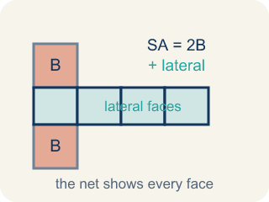
Surface Area of Prisms (Área de superficie de prismas) — The total area of all bases and lateral faces of a prism. Formula: SA = 2B + lateral area.
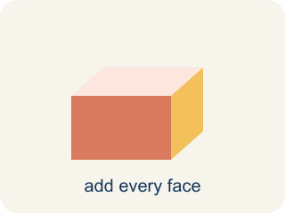
Surface area (Área de superficie) — The total area of all the flat sides of a solid.
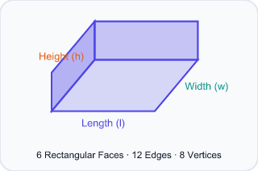
Rectangular prism (Prisma rectangular) — A solid box shape with six flat rectangle sides.

Triangular prism (Prisma triangular) — A solid with two triangle ends and three flat rectangle sides.

Face (Cara) — One flat side of a solid shape.
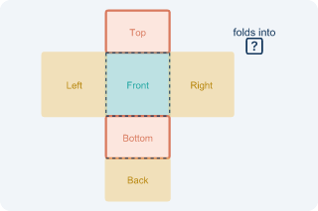
Net (Plantilla (desarrollo plano)) — A flat shape that folds up into a solid.

Lateral face (Cara lateral) — The side faces of a solid, not the top or bottom.

Practice
Show your work. Use the blank space under each problem.
1. A triangular prism has triangular bases with base 6 in and height 4 in. The prism is 10 in long and the two slant sides of the triangle are each 5 in. What is the surface area?
A. 184 in²
B. 160 in²
C. 124 in²
D. 184 in³
______________________________________________________________________
2. Spot the Common Mistake — Surface Area or Volume?
Step 1 (Dimensions): Rectangular prism time capsule: l = 7 in, w = 4 in, h = 3 in. Find the surface area.
Step 2 (Formula): Surface area adds all 6 faces: SA = 2lw + 2lh + 2wh.
Step 3 (Calculate): The student multiplied the three dimensions: 7 × 4 × 3 = 84, so they wrote SA = 84 in².
Which step has the mistake? Explain and fix it:
______________________________________________________________________
______________________________________________________________________
______________________________________________________________________
3. Find the Surface Area Error
Step 1 (Dimensions): Rectangular prism: l = 12 cm, w = 7 cm, h = 5 cm
Step 2 (Formula): SA = 2lw + 2lh + 2wh
Step 3 (Calculate): SA = 2(12×7) + 2(12×5) + 2(7×5) = 168 + 120 + 35 = 323 cm²
Step 4 (Answer): Surface Area = 323 cm²
Which step has the mistake? Explain and fix it:
______________________________________________________________________
______________________________________________________________________
______________________________________________________________________
4. A company ships products in two container options: a rectangular prism (8 × 6 × 4 in) or a triangular prism (triangle base 8 in, triangle height 6 in, prism length 8 in, slant sides 6.3 in each). Both must be wrapped in protective film. Which shape uses LESS film? Show your work.
Sentence starter: Rectangular prism SA = 2(___) + 2(___) + 2(___) = ___ in². Triangular prism SA = 2(___) + ___ + ___ + ___ = ___ in². The ___ uses less film because ___.
______________________________________________________________________
______________________________________________________________________
______________________________________________________________________
______________________________________________________________________

Answer Key (Teacher)
1. A. 184 in²
Triangular bases: 2 × (½ × 6 × 4) = 24 in². Three rectangular faces: 6(10) + 5(10) + 5(10) = 60 + 50 + 50 = 160 in². SA = 24 + 160 = 184 in².
Watch for: A common mistake in Surface Area of Prisms is confusing surface area with volume — multiplying l × w × h (which finds the space INSIDE the prism, in cubic units) instead of adding the areas of all the faces (SA = 2lw + 2lh + 2wh, in square units). A second common slip is forgetting to double one face pair, like writing 2(l×w) + 2(l×h) + (w×h) instead of + 2(w×h) — always count all 6 faces (or all 5 for a triangular prism) before you submit.
2. Spot the Common Mistake — Surface Area or Volume?
The mistake is in Step 3.
Correct work: Multiplying l × w × h gives the VOLUME (84 in³), not surface area. Add all six faces: SA = 2(7×4) + 2(7×3) + 2(4×3) = 56 + 42 + 24 = 122 in².
Watch for: In the Calculate step the student multiplied 7 × 4 × 3, which fills the inside of the box — that is volume, 84 in³, not surface area. Surface area covers the outside, so add all six faces: 2(7×4) + 2(7×3) + 2(4×3) = 56 + 42 + 24 = 122 in².
3. Find the Surface Area Error
The mistake is in Step 3.
Correct work: The student forgot to multiply 7 × 5 by 2. It should be 2(7×5) = 2(35) = 70, not 35. Correct: SA = 168 + 120 + 70 = 358 cm².
Watch for: The Calculate step doubled 12×7 and 12×5 but left 7 × 5 as a single 35, so one whole face was left out. That pair should be 2(7×5) = 70, which makes SA = 168 + 120 + 70 = 358 cm².
4. Open response — answers will vary.
Look for key words: surface area, rectangular, triangular, compare, less, film, face, area.

