Determine Surface Area of Prisms — Homework
Lesson 5-7 • Standard 6.GR.4
Name: ______________________ Period: ______ Date: ____________

Today's Goals
Content: I can find the surface area of rectangular and triangular prisms.
Language: I can explain my work using the words surface area, rectangular prism, triangular prism, and face.

Key Words
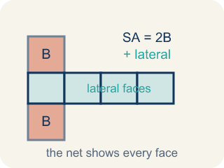
Surface Area of Prisms (Área de superficie de prismas) — The total area of all bases and lateral faces of a prism. Formula: SA = 2B + lateral area.
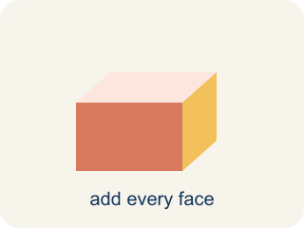
Surface area (Área de superficie) — The total area of all the flat sides of a solid.
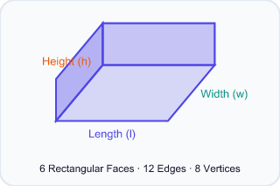
Rectangular prism (Prisma rectangular) — A solid box shape with six flat rectangle sides.

Triangular prism (Prisma triangular) — A solid with two triangle ends and three flat rectangle sides.

Face (Cara) — One flat side of a solid shape.
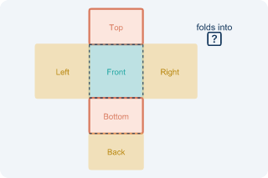
Net (Plantilla (desarrollo plano)) — A flat shape that folds up into a solid.

Lateral face (Cara lateral) — The side faces of a solid, not the top or bottom.

Practice
Show your work. Use the blank space under each problem.
1. What is the surface area of a rectangular prism with l = 5 cm, w = 4 cm, h = 3 cm?
A. 94 cm²
B. 60 cm²
C. 94 cm³
D. 47 cm²
______________________________________________________________________
2. How many faces does a triangular prism have?
A. 5
B. 4
C. 6
D. 3
______________________________________________________________________
3. Calculate the surface area of each rectangular prism time capsule.
Capsule | Length | Width | Height | Surface Area
Capsule E | 12 in | 8 in | 5 in
Capsule F | 9 cm | 6 cm | 6 cm
Capsule G | 15 ft | 4 ft | 3 ft
______________________________________________________________________
4. A triangular prism has triangular bases with base 6 in and height 4 in. The prism is 10 in long and the two slant sides of the triangle are each 5 in. What is the surface area?
A. 184 in²
B. 160 in²
C. 124 in²
D. 184 in³
______________________________________________________________________
5. Sort each item into the correct group.
Groups: Least → Greatest surface area
______________________________________________________________________
6. Spot the Common Mistake — Surface Area or Volume?
Step 1 (Dimensions): Rectangular prism time capsule: l = 7 in, w = 4 in, h = 3 in. Find the surface area.
Step 2 (Formula): Surface area adds all 6 faces: SA = 2lw + 2lh + 2wh.
Step 3 (Calculate): The student multiplied the three dimensions: 7 × 4 × 3 = 84, so they wrote SA = 84 in².
Which step has the mistake? Explain and fix it:
______________________________________________________________________
______________________________________________________________________
______________________________________________________________________
7. A rectangular time capsule box measures 3 in by 4 in by 5 in. How much wrapping paper covers its surface (no overlap)?
A. 94 in²
B. 60 in²
C. 47 in²
D. 94 in³
______________________________________________________________________
8. A rectangular capsule crate is 6 cm long, 5 cm wide, and 4 cm tall. How much cardboard is needed to cover all its faces?
A. 148 cm²
B. 120 cm²
C. 74 cm²
D. 148 cm³
______________________________________________________________________
9. A triangular prism is 10 in long. Its triangle ends have base 8 in, height 6 in, and sides 8, 6, and 10 in. Find its surface area.
A. 288 in²
B. 240 in²
C. 48 in²
D. 288 in³
______________________________________________________________________
10. Find each prism's surface area. Then sort it by whether it needs 96 in² of paper or less, or more than 96 in².
Groups: 96 in² of paper or less | More than 96 in²
• Rect capsule 3×4×5: SA = 94 in² → __________________
• Cube capsule 4×4×4: SA = 96 in² → __________________
• Rect capsule 6×5×4: SA = 148 in² → __________________
• Tri capsule (ends 8×6, length 10): SA = 288 in² → __________________
______________________________________________________________________

Answer Key (Teacher)
1. A. 94 cm²
SA = 2(5×4) + 2(5×3) + 2(4×3) = 40 + 30 + 24 = 94 cm².
Watch for: A common mistake in Surface Area of Prisms is confusing surface area with volume — multiplying l × w × h (which finds the space INSIDE the prism, in cubic units) instead of adding the areas of all the faces (SA = 2lw + 2lh + 2wh, in square units). A second common slip is forgetting to double one face pair, like writing 2(l×w) + 2(l×h) + (w×h) instead of + 2(w×h) — always count all 6 faces (or all 5 for a triangular prism) before you submit.
2. A. 5
A triangular prism has 5 faces: 2 triangular bases and 3 rectangular lateral faces.
Watch for: A common mistake in Surface Area of Prisms is confusing surface area with volume — multiplying l × w × h (which finds the space INSIDE the prism, in cubic units) instead of adding the areas of all the faces (SA = 2lw + 2lh + 2wh, in square units). A second common slip is forgetting to double one face pair, like writing 2(l×w) + 2(l×h) + (w×h) instead of + 2(w×h) — always count all 6 faces (or all 5 for a triangular prism) before you submit.
3. Calculate the surface area of each rectangular prism time capsule.
Capsule E — Surface Area: 392 in²
Capsule F — Surface Area: 288 cm²
Capsule G — Surface Area: 234 ft²

4. A. 184 in²
Triangular bases: 2 × (½ × 6 × 4) = 24 in². Three rectangular faces: 6(10) + 5(10) + 5(10) = 60 + 50 + 50 = 160 in². SA = 24 + 160 = 184 in².
Watch for: A common mistake in Surface Area of Prisms is confusing surface area with volume — multiplying l × w × h (which finds the space INSIDE the prism, in cubic units) instead of adding the areas of all the faces (SA = 2lw + 2lh + 2wh, in square units). A second common slip is forgetting to double one face pair, like writing 2(l×w) + 2(l×h) + (w×h) instead of + 2(w×h) — always count all 6 faces (or all 5 for a triangular prism) before you submit.
5. Correct groups:

6. Spot the Common Mistake — Surface Area or Volume?
The mistake is in Step 3.
Correct work: Multiplying l × w × h gives the VOLUME (84 in³), not surface area. Add all six faces: SA = 2(7×4) + 2(7×3) + 2(4×3) = 56 + 42 + 24 = 122 in².
Watch for: In the Calculate step the student multiplied 7 × 4 × 3, which fills the inside of the box — that is volume, 84 in³, not surface area. Surface area covers the outside, so add all six faces: 2(7×4) + 2(7×3) + 2(4×3) = 56 + 42 + 24 = 122 in².
7. A. 94 in²
SA = 2(lw + lh + wh) = 2(3×4 + 3×5 + 4×5) = 2(12 + 15 + 20) = 2(47) = 94 in².
Watch for: A common mistake in Surface Area of Prisms is confusing surface area with volume — multiplying l × w × h (which finds the space INSIDE the prism, in cubic units) instead of adding the areas of all the faces (SA = 2lw + 2lh + 2wh, in square units). A second common slip is forgetting to double one face pair, like writing 2(l×w) + 2(l×h) + (w×h) instead of + 2(w×h) — always count all 6 faces (or all 5 for a triangular prism) before you submit.
8. A. 148 cm²
SA = 2(6×5) + 2(6×4) + 2(5×4) = 60 + 48 + 40 = 148 cm².
Watch for: A common mistake in Surface Area of Prisms is confusing surface area with volume — multiplying l × w × h (which finds the space INSIDE the prism, in cubic units) instead of adding the areas of all the faces (SA = 2lw + 2lh + 2wh, in square units). A second common slip is forgetting to double one face pair, like writing 2(l×w) + 2(l×h) + (w×h) instead of + 2(w×h) — always count all 6 faces (or all 5 for a triangular prism) before you submit.
9. A. 288 in²
Two triangle ends: 2 × (½ × 8 × 6) = 48 in². Three rectangles: (8 + 6 + 10) × 10 = 24 × 10 = 240 in². SA = 48 + 240 = 288 in².
Watch for: A common mistake in Surface Area of Prisms is confusing surface area with volume — multiplying l × w × h (which finds the space INSIDE the prism, in cubic units) instead of adding the areas of all the faces (SA = 2lw + 2lh + 2wh, in square units). A second common slip is forgetting to double one face pair, like writing 2(l×w) + 2(l×h) + (w×h) instead of + 2(w×h) — always count all 6 faces (or all 5 for a triangular prism) before you submit.
10. Correct groups:
Rect capsule 3×4×5: SA = 94 in² → 96 in² of paper or less
Cube capsule 4×4×4: SA = 96 in² → 96 in² of paper or less
Rect capsule 6×5×4: SA = 148 in² → More than 96 in²
Tri capsule (ends 8×6, length 10): SA = 288 in² → More than 96 in²

