10.4–10.5 Catch-Up — Homework
Lesson 5-8-catchup • Standard 6.GR.4
Name: ______________________ Period: ______ Date: ____________

Today's Goals
Content: I can show I am caught up on Lessons 10.4–10.5 by using each lesson's big idea in mixed practice.
Language: I can explain which lesson's big idea I used and how, using key vocabulary from Lessons 10.4–10.5.

Key Words
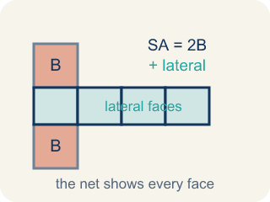
Surface Area of Prisms (Área de superficie de prismas) — The total area of all bases and lateral faces of a prism. Formula: SA = 2B + lateral area.
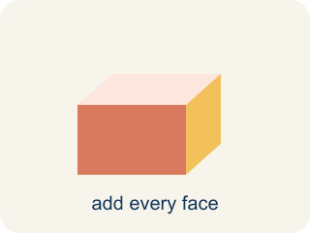
Surface area (Área de superficie) — The total area of all the flat sides of a solid.
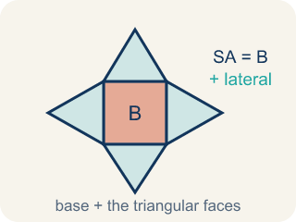
Surface Area of Pyramids (Área de superficie de pirámides) — The total area of a pyramid's base and triangular faces. Formula: SA = B + lateral area.
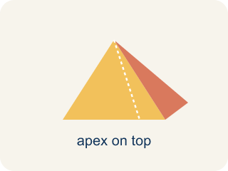
Pyramid (Pirámide) — A solid with a flat bottom and triangle sides that meet at one point on top.
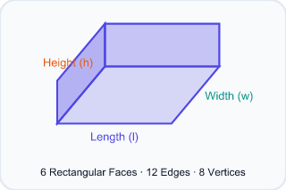
Rectangular prism (Prisma rectangular) — A solid box shape with six flat rectangle sides.
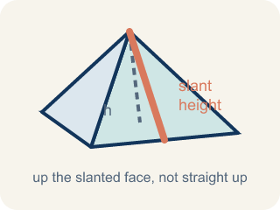
Slant height (Altura inclinada (apotema)) — The height of a side triangle, measured along its slanted face.

Practice
Show your work. Use the blank space under each problem.
1. (Lesson 10.4) What is the surface area of a rectangular prism with l = 5 cm, w = 4 cm, h = 3 cm?
A. 94 cm²
B. 60 cm²
C. 94 cm³
D. 47 cm²
______________________________________________________________________
2. (Lesson 10.4) How many faces does a triangular prism have?
A. 5
B. 4
C. 6
D. 3
______________________________________________________________________
3. (Lesson 10.4) A triangular prism has triangular bases with base 6 in and height 4 in. The prism is 10 in long and the two slant sides of the triangle are each 5 in. What is the surface area?
A. 184 in²
B. 160 in²
C. 124 in²
D. 184 in³
______________________________________________________________________
4. (Lesson 10.4) Spot the Common Mistake — Surface Area or Volume?
Step 1 (Dimensions): Rectangular prism time capsule: l = 7 in, w = 4 in, h = 3 in. Find the surface area.
Step 2 (Formula): Surface area adds all 6 faces: SA = 2lw + 2lh + 2wh.
Step 3 (Calculate): The student multiplied the three dimensions: 7 × 4 × 3 = 84, so they wrote SA = 84 in².
Which step has the mistake? Explain and fix it:
______________________________________________________________________
______________________________________________________________________
______________________________________________________________________
5. (Lesson 10.5) A square pyramid has a base area of 49 cm² and a total lateral area of 84 cm². What is the surface area?
A. 133 cm²
B. 84 cm²
C. 49 cm²
D. 133 cm³
______________________________________________________________________
6. (Lesson 10.5) Did You Halve the Triangle?
Step 1 (Box): Square pyramid: base edge = 8 in, slant height = 10 in
Step 2 (Base Area): 8 × 8 = 64 in²
Step 3 (One Triangular Face): 8 × 10 = 80 in² (forgot the ½)
Step 4 (Answer): SA = 64 + 4 × 80 = 64 + 320 = 384 in²
Which step has the mistake? Explain and fix it:
______________________________________________________________________
______________________________________________________________________
______________________________________________________________________
7. (Lesson 10.4) A rectangular time capsule box measures 3 in by 4 in by 5 in. How much wrapping paper covers its surface (no overlap)?
A. 94 in²
B. 60 in²
C. 47 in²
D. 94 in³
______________________________________________________________________
8. (Lesson 10.5) Your first gift box is a square pyramid with a base edge of 7 in and a slant height of 9 in. How much wrapping paper (total surface area) covers it?
A. 175 in²
B. 126 in²
C. 144 in²
D. 175 in³
______________________________________________________________________

Answer Key (Teacher)
1. A. 94 cm²
SA = 2(5×4) + 2(5×3) + 2(4×3) = 40 + 30 + 24 = 94 cm².
Watch for: A common mistake in Surface Area of Pyramids is finding the four triangular lateral faces correctly (½ × base edge × slant height, times 4) and then stopping — forgetting to add the base area at the end. This leaves the total surface area too small by exactly the base's area. Before you submit, ask: 'Did I add the base area to the four lateral faces, or did I stop after the sides?'
2. A. 5
A triangular prism has 5 faces: 2 triangular bases and 3 rectangular lateral faces.
Watch for: A common mistake in Surface Area of Pyramids is finding the four triangular lateral faces correctly (½ × base edge × slant height, times 4) and then stopping — forgetting to add the base area at the end. This leaves the total surface area too small by exactly the base's area. Before you submit, ask: 'Did I add the base area to the four lateral faces, or did I stop after the sides?'
3. A. 184 in²
Triangular bases: 2 × (½ × 6 × 4) = 24 in². Three rectangular faces: 6(10) + 5(10) + 5(10) = 60 + 50 + 50 = 160 in². SA = 24 + 160 = 184 in².
Watch for: A common mistake in Surface Area of Pyramids is finding the four triangular lateral faces correctly (½ × base edge × slant height, times 4) and then stopping — forgetting to add the base area at the end. This leaves the total surface area too small by exactly the base's area. Before you submit, ask: 'Did I add the base area to the four lateral faces, or did I stop after the sides?'
4. (Lesson 10.4) Spot the Common Mistake — Surface Area or Volume?
The mistake is in Step 3.
Correct work: Multiplying l × w × h gives the VOLUME (84 in³), not surface area. Add all six faces: SA = 2(7×4) + 2(7×3) + 2(4×3) = 56 + 42 + 24 = 122 in².
Watch for: In the Calculate step the student multiplied 7 × 4 × 3, which fills the inside of the box — that is volume, 84 in³, not surface area. Surface area covers the outside, so add all six faces: 2(7×4) + 2(7×3) + 2(4×3) = 56 + 42 + 24 = 122 in².
5. A. 133 cm²
SA = Base Area + Lateral Area = 49 + 84 = 133 cm².
Watch for: A common mistake in Surface Area of Pyramids is finding the four triangular lateral faces correctly (½ × base edge × slant height, times 4) and then stopping — forgetting to add the base area at the end. This leaves the total surface area too small by exactly the base's area. Before you submit, ask: 'Did I add the base area to the four lateral faces, or did I stop after the sides?'
6. (Lesson 10.5) Did You Halve the Triangle?
The mistake is in Step 3.
Correct work: A triangle's area is ½ × base × height, so each face is ½ × 8 × 10 = 40 in², not 80 in². The student left out the ½. Four faces: 4 × 40 = 160 in². Correct SA = 64 + 160 = 224 in².
Watch for: The face step multiplied 8 × 10 = 80 in², which is the area of a whole rectangle, not a triangle. A triangle is half of that rectangle, so each face is ½ × 8 × 10 = 40 in², four faces give 160 in², and the correct total is SA = 64 + 160 = 224 in².
7. A. 94 in²
SA = 2(lw + lh + wh) = 2(3×4 + 3×5 + 4×5) = 2(12 + 15 + 20) = 2(47) = 94 in².
Watch for: A common mistake in Surface Area of Pyramids is finding the four triangular lateral faces correctly (½ × base edge × slant height, times 4) and then stopping — forgetting to add the base area at the end. This leaves the total surface area too small by exactly the base's area. Before you submit, ask: 'Did I add the base area to the four lateral faces, or did I stop after the sides?'
8. A. 175 in²
Base: 7 × 7 = 49 in². One triangular face: ½ × 7 × 9 = 31.5 in². Four faces: 4 × 31.5 = 126 in². SA = 49 + 126 = 175 in². Surface area uses square units (in²).
Watch for: A common mistake in Surface Area of Pyramids is finding the four triangular lateral faces correctly (½ × base edge × slant height, times 4) and then stopping — forgetting to add the base area at the end. This leaves the total surface area too small by exactly the base's area. Before you submit, ask: 'Did I add the base area to the four lateral faces, or did I stop after the sides?'

