5.8 Small Group · Group 1 — Homework
Lesson 5-8-group1 • Standard 6.GR.4
Name: ______________________ Period: ______ Date: ____________

Today's Goals
Content: With my small group, I can find the surface area of a pyramid by adding the base area and the lateral faces — one step at a time, with support.
Language: I can talk through each step out loud using a sentence frame and the lesson's key words.

Key Words
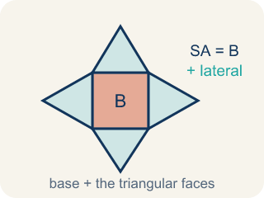
Surface Area of Pyramids (Área de superficie de pirámides) — The total area of a pyramid's base and triangular faces. Formula: SA = B + lateral area.
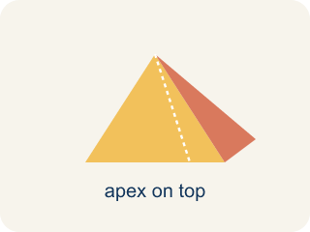
Pyramid (Pirámide) — A solid with a flat bottom and triangle sides that meet at one point on top.
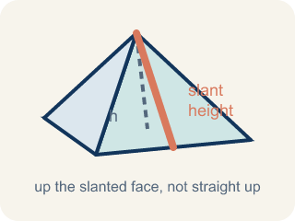
Slant height (Altura inclinada (apotema)) — The height of a side triangle, measured along its slanted face.
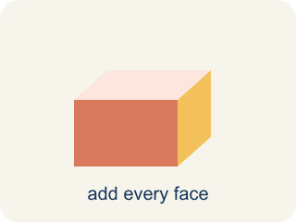
Lateral face (Cara lateral) — A triangle side of a pyramid, not the bottom.
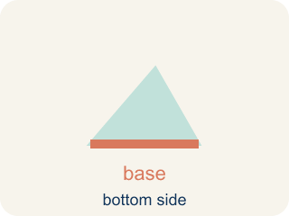
Base (Base) — The flat bottom of a pyramid.

Apex (Ápice) — The point at the top of a pyramid where the sides meet.

Lateral area (Área lateral) — The total area of just the side triangles, not the bottom.

Practice
Show your work. Use the blank space under each problem.
1. A square pyramid has a base edge of 5 in and a slant height of 7 in. What is the surface area?
A. 95 in²
B. 70 in²
C. 95 in³
D. 120 in²
______________________________________________________________________
2. How many lateral (triangular) faces does a square pyramid have?
A. 4
B. 3
C. 5
D. 6
______________________________________________________________________
3. Your first gift box is a square pyramid with a base edge of 7 in and a slant height of 9 in. How much wrapping paper (total surface area) covers it?
A. 175 in²
B. 126 in²
C. 144 in²
D. 175 in³
______________________________________________________________________
4. Before adding the base, you need the area of just one triangular face of a gift box with base edge 8 in and slant height 5 in. What is it?
A. 20 in²
B. 40 in²
C. 13 in²
D. 20 in³
______________________________________________________________________
5. A gift box is a square pyramid with a base edge of 9 in. What is the area of its square base (the part that sits on the table)?
A. 81 in²
B. 36 in²
C. 18 in²
D. 324 in²
______________________________________________________________________
6. Level 2 Extension — Slant Height vs. Base Edge
Step 1 (Box): Square pyramid gift box: base edge = 12 in, slant height = 9 in
Step 2 (Base Area): 12 × 12 = 144 in²
Step 3 (One Triangular Face): ½ × 9 × 9 = 40.5 in² (used 9 for both numbers)
Step 4 (Answer): SA = 144 + 4 × 40.5 = 144 + 162 = 306 in²
Which step has the mistake? Explain and fix it:
______________________________________________________________________
______________________________________________________________________
______________________________________________________________________
7. Find the Surface Area Error
Step 1 (Dimensions): Square pyramid: base edge = 10 in, slant height = 8 in
Step 2 (Base Area): 10 × 10 = 100 in²
Step 3 (Lateral Area): ½ × 10 × 8 = 40 in² (one face). Total lateral = 40 × 3 = 120 in²
Step 4 (Answer): SA = 100 + 120 = 220 in²
Which step has the mistake? Explain and fix it:
______________________________________________________________________
______________________________________________________________________
______________________________________________________________________
8. Two pyramids have the same base area (64 in²) but different slant heights. Pyramid A has slant height 6 in and Pyramid B has slant height 10 in. How much more surface area does Pyramid B have? Why does slant height affect surface area but NOT base area?
Sentence starter: Pyramid A: SA = 64 + 4(½ × 8 × 6) = 64 + ___ = ___ in². Pyramid B: SA = 64 + 4(½ × 8 × 10) = 64 + ___ = ___ in². Pyramid B has ___ more in² because ___. Slant height only affects ___ because ___.
______________________________________________________________________
______________________________________________________________________
______________________________________________________________________
______________________________________________________________________

Answer Key (Teacher)
1. A. 95 in²
Base: 5 × 5 = 25 in². Each lateral face: ½ × 5 × 7 = 17.5 in². Four faces: 4 × 17.5 = 70 in². SA = 25 + 70 = 95 in².
Watch for: A common mistake in Surface Area of Pyramids is finding the four triangular lateral faces correctly (½ × base edge × slant height, times 4) and then stopping — forgetting to add the base area at the end. This leaves the total surface area too small by exactly the base's area. Before you submit, ask: 'Did I add the base area to the four lateral faces, or did I stop after the sides?'
2. A. 4
A square pyramid has a square base and 4 triangular lateral faces — one for each side of the square.
Watch for: A common mistake in Surface Area of Pyramids is finding the four triangular lateral faces correctly (½ × base edge × slant height, times 4) and then stopping — forgetting to add the base area at the end. This leaves the total surface area too small by exactly the base's area. Before you submit, ask: 'Did I add the base area to the four lateral faces, or did I stop after the sides?'
3. A. 175 in²
Base: 7 × 7 = 49 in². One triangular face: ½ × 7 × 9 = 31.5 in². Four faces: 4 × 31.5 = 126 in². SA = 49 + 126 = 175 in². Surface area uses square units (in²).
Watch for: A common mistake in Surface Area of Pyramids is finding the four triangular lateral faces correctly (½ × base edge × slant height, times 4) and then stopping — forgetting to add the base area at the end. This leaves the total surface area too small by exactly the base's area. Before you submit, ask: 'Did I add the base area to the four lateral faces, or did I stop after the sides?'
4. A. 20 in²
Area of a triangle = ½ × base × height = ½ × 8 × 5 = 20 in². You use the slant height (5) as the triangle's height, not the pyramid's vertical height.
Watch for: A common mistake in Surface Area of Pyramids is finding the four triangular lateral faces correctly (½ × base edge × slant height, times 4) and then stopping — forgetting to add the base area at the end. This leaves the total surface area too small by exactly the base's area. Before you submit, ask: 'Did I add the base area to the four lateral faces, or did I stop after the sides?'
5. A. 81 in²
The base is a square, so base area = side × side = 9 × 9 = 81 in². You would still add the four triangular faces to get the full surface area.
Watch for: A common mistake in Surface Area of Pyramids is finding the four triangular lateral faces correctly (½ × base edge × slant height, times 4) and then stopping — forgetting to add the base area at the end. This leaves the total surface area too small by exactly the base's area. Before you submit, ask: 'Did I add the base area to the four lateral faces, or did I stop after the sides?'
6. Level 2 Extension — Slant Height vs. Base Edge
The mistake is in Step 3.
Correct work: Each triangular face uses the base edge (12) as its base and the slant height (9) as its height: ½ × 12 × 9 = 54 in². The student used the slant height (9) in place of the base edge by mistake. Four faces: 4 × 54 = 216 in². Correct SA = 144 + 216 = 360 in².
Watch for: The face step used 9 twice, but a lateral triangle takes its base from the base edge (12 in) and its height from the slant height (9 in), so each face is ½ × 12 × 9 = 54 in², not 40.5 in². Four faces give 216 in², and the correct total is SA = 144 + 216 = 360 in².
7. Find the Surface Area Error
The mistake is in Step 3.
Correct work: A square pyramid has 4 lateral faces, not 3. Total lateral = 40 × 4 = 160 in². Correct: SA = 100 + 160 = 260 in².
Watch for: The area of one face, ½ × 10 × 8 = 40 in², is right, but it was multiplied by 3 instead of 4. A square base has four sides, so four triangles meet at the top: 40 × 4 = 160 in², and SA = 100 + 160 = 260 in².
8. Open response — answers will vary.
Look for key words: surface area, lateral, base, slant height, triangle, area, bigger, taller.

