5.8 Small Group · Group 2 — Homework
Lesson 5-8-group2 • Standard 6.GR.4
Name: ______________________ Period: ______ Date: ____________

Today's Goals
Content: I can find the surface area of a pyramid by adding the base area and the lateral faces, explain why the method works, and use it on a problem I have not seen before.
Language: I can justify my answer to a skeptic and connect it to a second strategy or representation.

Key Words
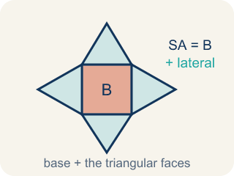
Surface Area of Pyramids (Área de superficie de pirámides) — The total area of a pyramid's base and triangular faces. Formula: SA = B + lateral area.
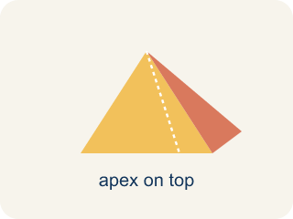
Pyramid (Pirámide) — A solid with a flat bottom and triangle sides that meet at one point on top.
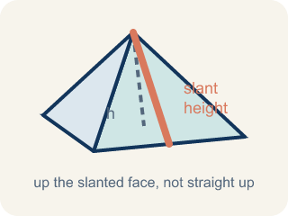
Slant height (Altura inclinada (apotema)) — The height of a side triangle, measured along its slanted face.
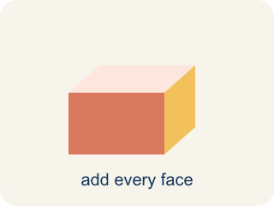
Lateral face (Cara lateral) — A triangle side of a pyramid, not the bottom.
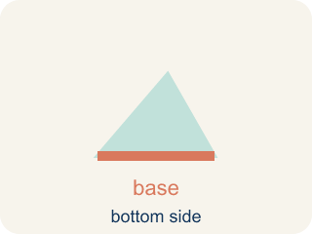
Base (Base) — The flat bottom of a pyramid.

Apex (Ápice) — The point at the top of a pyramid where the sides meet.

Lateral area (Área lateral) — The total area of just the side triangles, not the bottom.

Practice
Show your work. Use the blank space under each problem.
1. A square pyramid has a base area of 49 cm² and a total lateral area of 84 cm². What is the surface area?
A. 133 cm²
B. 84 cm²
C. 49 cm²
D. 133 cm³
______________________________________________________________________
2. Did You Halve the Triangle?
Step 1 (Box): Square pyramid: base edge = 8 in, slant height = 10 in
Step 2 (Base Area): 8 × 8 = 64 in²
Step 3 (One Triangular Face): 8 × 10 = 80 in² (forgot the ½)
Step 4 (Answer): SA = 64 + 4 × 80 = 64 + 320 = 384 in²
Which step has the mistake? Explain and fix it:
______________________________________________________________________
______________________________________________________________________
______________________________________________________________________
3. Find the Surface Area Error
Step 1 (Dimensions): Square pyramid: base edge = 10 in, slant height = 8 in
Step 2 (Base Area): 10 × 10 = 100 in²
Step 3 (Lateral Area): ½ × 10 × 8 = 40 in² (one face). Total lateral = 40 × 3 = 120 in²
Step 4 (Answer): SA = 100 + 120 = 220 in²
Which step has the mistake? Explain and fix it:
______________________________________________________________________
______________________________________________________________________
______________________________________________________________________
4. Two pyramids have the same base area (64 in²) but different slant heights. Pyramid A has slant height 6 in and Pyramid B has slant height 10 in. How much more surface area does Pyramid B have? Why does slant height affect surface area but NOT base area?
Sentence starter: Pyramid A: SA = 64 + 4(½ × 8 × 6) = 64 + ___ = ___ in². Pyramid B: SA = 64 + 4(½ × 8 × 10) = 64 + ___ = ___ in². Pyramid B has ___ more in² because ___. Slant height only affects ___ because ___.
______________________________________________________________________
______________________________________________________________________
______________________________________________________________________
______________________________________________________________________

Answer Key (Teacher)
1. A. 133 cm²
SA = Base Area + Lateral Area = 49 + 84 = 133 cm².
Watch for: A common mistake in Surface Area of Pyramids is finding the four triangular lateral faces correctly (½ × base edge × slant height, times 4) and then stopping — forgetting to add the base area at the end. This leaves the total surface area too small by exactly the base's area. Before you submit, ask: 'Did I add the base area to the four lateral faces, or did I stop after the sides?'
2. Did You Halve the Triangle?
The mistake is in Step 3.
Correct work: A triangle's area is ½ × base × height, so each face is ½ × 8 × 10 = 40 in², not 80 in². The student left out the ½. Four faces: 4 × 40 = 160 in². Correct SA = 64 + 160 = 224 in².
Watch for: The face step multiplied 8 × 10 = 80 in², which is the area of a whole rectangle, not a triangle. A triangle is half of that rectangle, so each face is ½ × 8 × 10 = 40 in², four faces give 160 in², and the correct total is SA = 64 + 160 = 224 in².
3. Find the Surface Area Error
The mistake is in Step 3.
Correct work: A square pyramid has 4 lateral faces, not 3. Total lateral = 40 × 4 = 160 in². Correct: SA = 100 + 160 = 260 in².
Watch for: The area of one face, ½ × 10 × 8 = 40 in², is right, but it was multiplied by 3 instead of 4. A square base has four sides, so four triangles meet at the top: 40 × 4 = 160 in², and SA = 100 + 160 = 260 in².
4. Open response — answers will vary.
Look for key words: surface area, lateral, base, slant height, triangle, area, bigger, taller.

