Determine Surface Area of Pyramids — Homework
Lesson 5-8 • Standard 6.GR.4
Name: ______________________ Period: ______ Date: ____________

Today's Goals
Content: I can find the surface area of a pyramid by adding the base area and the lateral faces.
Language: I can explain my work using the words pyramid, slant height, lateral face, and base.

Key Words
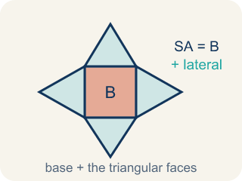
Surface Area of Pyramids (Área de superficie de pirámides) — The total area of a pyramid's base and triangular faces. Formula: SA = B + lateral area.
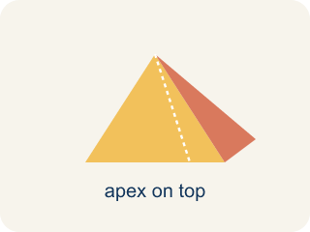
Pyramid (Pirámide) — A solid with a flat bottom and triangle sides that meet at one point on top.
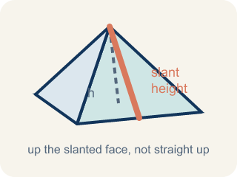
Slant height (Altura inclinada (apotema)) — The height of a side triangle, measured along its slanted face.
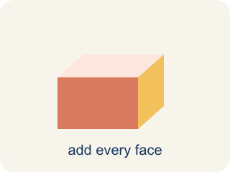
Lateral face (Cara lateral) — A triangle side of a pyramid, not the bottom.
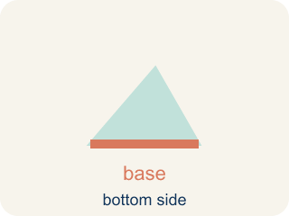
Base (Base) — The flat bottom of a pyramid.

Apex (Ápice) — The point at the top of a pyramid where the sides meet.

Lateral area (Área lateral) — The total area of just the side triangles, not the bottom.

Practice
Show your work. Use the blank space under each problem.
1. A square pyramid has a base edge of 5 in and a slant height of 7 in. What is the surface area?
A. 95 in²
B. 70 in²
C. 95 in³
D. 120 in²
______________________________________________________________________
2. How many lateral (triangular) faces does a square pyramid have?
A. 4
B. 3
C. 5
D. 6
______________________________________________________________________
3. Find the surface area of each square pyramid.
Pyramid | Base Edge | Slant Height | Base Area | Total SA
Pyramid X | 12 in | 10 in
Pyramid Y | 8 cm | 6 cm
Pyramid Z | 14 ft | 11 ft
______________________________________________________________________
4. A square pyramid has a base area of 49 cm² and a total lateral area of 84 cm². What is the surface area?
A. 133 cm²
B. 84 cm²
C. 49 cm²
D. 133 cm³
______________________________________________________________________
5. Sort each item into the correct group.
• undefined → __________________
• undefined → __________________
• undefined → __________________
• undefined → __________________
______________________________________________________________________
6. Did You Halve the Triangle?
Step 1 (Box): Square pyramid: base edge = 8 in, slant height = 10 in
Step 2 (Base Area): 8 × 8 = 64 in²
Step 3 (One Triangular Face): 8 × 10 = 80 in² (forgot the ½)
Step 4 (Answer): SA = 64 + 4 × 80 = 64 + 320 = 384 in²
Which step has the mistake? Explain and fix it:
______________________________________________________________________
______________________________________________________________________
______________________________________________________________________
7. Your first gift box is a square pyramid with a base edge of 7 in and a slant height of 9 in. How much wrapping paper (total surface area) covers it?
A. 175 in²
B. 126 in²
C. 144 in²
D. 175 in³
______________________________________________________________________
8. Before adding the base, you need the area of just one triangular face of a gift box with base edge 8 in and slant height 5 in. What is it?
A. 20 in²
B. 40 in²
C. 13 in²
D. 20 in³
______________________________________________________________________
9. A gift box is a square pyramid with a base edge of 9 in. What is the area of its square base (the part that sits on the table)?
A. 81 in²
B. 36 in²
C. 18 in²
D. 324 in²
______________________________________________________________________
10. Match each square-pyramid gift box (base edge × slant height) to its total surface area.
Item | Answer choices
____ Base 5 in, slant 8 in | D. 220 in²
____ Base 6 in, slant 7 in | C. 208 in²
____ Base 8 in, slant 9 in | B. 120 in²
____ Base 10 in, slant 6 in | A. 105 in²
______________________________________________________________________

Answer Key (Teacher)
1. A. 95 in²
Base: 5 × 5 = 25 in². Each lateral face: ½ × 5 × 7 = 17.5 in². Four faces: 4 × 17.5 = 70 in². SA = 25 + 70 = 95 in².
Watch for: A common mistake in Surface Area of Pyramids is finding the four triangular lateral faces correctly (½ × base edge × slant height, times 4) and then stopping — forgetting to add the base area at the end. This leaves the total surface area too small by exactly the base's area. Before you submit, ask: 'Did I add the base area to the four lateral faces, or did I stop after the sides?'
2. A. 4
A square pyramid has a square base and 4 triangular lateral faces — one for each side of the square.
Watch for: A common mistake in Surface Area of Pyramids is finding the four triangular lateral faces correctly (½ × base edge × slant height, times 4) and then stopping — forgetting to add the base area at the end. This leaves the total surface area too small by exactly the base's area. Before you submit, ask: 'Did I add the base area to the four lateral faces, or did I stop after the sides?'
3. Find the surface area of each square pyramid.
Pyramid X — Base Area: 144 in²
Pyramid X — Total SA: 384 in²
Pyramid Y — Base Area: 64 cm²
Pyramid Y — Total SA: 160 cm²
Pyramid Z — Base Area: 196 ft²
Pyramid Z — Total SA: 504 ft²

4. A. 133 cm²
SA = Base Area + Lateral Area = 49 + 84 = 133 cm².
Watch for: A common mistake in Surface Area of Pyramids is finding the four triangular lateral faces correctly (½ × base edge × slant height, times 4) and then stopping — forgetting to add the base area at the end. This leaves the total surface area too small by exactly the base's area. Before you submit, ask: 'Did I add the base area to the four lateral faces, or did I stop after the sides?'
5. Correct groups:
undefined → undefined
undefined → undefined
undefined → undefined
undefined → undefined

6. Did You Halve the Triangle?
The mistake is in Step 3.
Correct work: A triangle's area is ½ × base × height, so each face is ½ × 8 × 10 = 40 in², not 80 in². The student left out the ½. Four faces: 4 × 40 = 160 in². Correct SA = 64 + 160 = 224 in².
Watch for: The face step multiplied 8 × 10 = 80 in², which is the area of a whole rectangle, not a triangle. A triangle is half of that rectangle, so each face is ½ × 8 × 10 = 40 in², four faces give 160 in², and the correct total is SA = 64 + 160 = 224 in².
7. A. 175 in²
Base: 7 × 7 = 49 in². One triangular face: ½ × 7 × 9 = 31.5 in². Four faces: 4 × 31.5 = 126 in². SA = 49 + 126 = 175 in². Surface area uses square units (in²).
Watch for: A common mistake in Surface Area of Pyramids is finding the four triangular lateral faces correctly (½ × base edge × slant height, times 4) and then stopping — forgetting to add the base area at the end. This leaves the total surface area too small by exactly the base's area. Before you submit, ask: 'Did I add the base area to the four lateral faces, or did I stop after the sides?'
8. A. 20 in²
Area of a triangle = ½ × base × height = ½ × 8 × 5 = 20 in². You use the slant height (5) as the triangle's height, not the pyramid's vertical height.
Watch for: A common mistake in Surface Area of Pyramids is finding the four triangular lateral faces correctly (½ × base edge × slant height, times 4) and then stopping — forgetting to add the base area at the end. This leaves the total surface area too small by exactly the base's area. Before you submit, ask: 'Did I add the base area to the four lateral faces, or did I stop after the sides?'
9. A. 81 in²
The base is a square, so base area = side × side = 9 × 9 = 81 in². You would still add the four triangular faces to get the full surface area.
Watch for: A common mistake in Surface Area of Pyramids is finding the four triangular lateral faces correctly (½ × base edge × slant height, times 4) and then stopping — forgetting to add the base area at the end. This leaves the total surface area too small by exactly the base's area. Before you submit, ask: 'Did I add the base area to the four lateral faces, or did I stop after the sides?'
10. Matches:
Base 5 in, slant 8 in → 105 in²
Base 6 in, slant 7 in → 120 in²
Base 8 in, slant 9 in → 208 in²
Base 10 in, slant 6 in → 220 in²

