5.9 Small Group · Group 1 — Homework
Lesson 5-9-group1 • Standard 6.GR.1
Name: ______________________ Period: ______ Date: ____________

Today's Goals
Content: With my small group, I can find the area of a regular polygon by decomposing it into triangles — one step at a time, with support.
Language: I can talk through each step out loud using a sentence frame and the lesson's key words.

Key Words
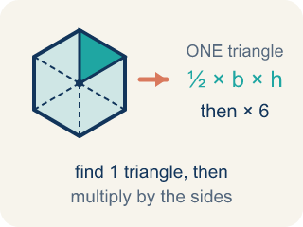
Area of Regular Polygons (Área de polígonos regulares) — The total space a regular polygon covers, found by splitting it into congruent triangles from the center. Formula: A = (½bh) × n — one triangle's area times the number of triangles.
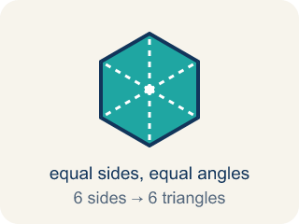
Regular Polygon (Polígono regular) — A closed flat shape made of straight sides, where every side is the same length and every angle is the same size.
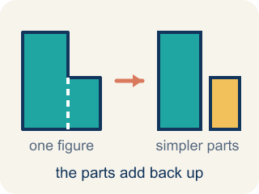
Decompose (Descomponer) — To break a shape into smaller, simpler shapes.
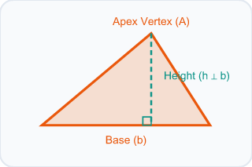
Triangle (Triángulo) — A shape with three sides.
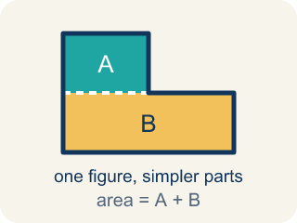
Composite (Compuesto) — Made by putting two or more simple shapes together.
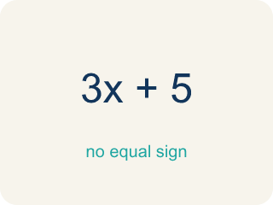
Formula (Fórmula) — A math rule written with symbols.

Practice
Show your work. Use the blank space under each problem.
1. A regular hexagon is divided into 6 equal triangles from the center. Each triangle has a base of 6 ft and a height of 5.2 ft. What is the area of one triangle?
A. 15.6 sq ft
B. 31.2 sq ft
C. 11.2 sq ft
D. 15.6 ft
______________________________________________________________________
2. Using the triangle from the previous question, what is the total area of the hexagonal skylight?
A. 93.6 sq ft
B. 15.6 sq ft
C. 187.2 sq ft
D. 62.4 sq ft
______________________________________________________________________
3. A regular pentagonal tile splits into 5 congruent triangles. Each triangle has a base of 4 in and a height of 6 in. What is the total area of the tile?
A. 60 in²
B. 12 in²
C. 24 in²
D. 120 in²
______________________________________________________________________
4. An octagon tile splits into equal triangles, each with base 6 ft and height 5 ft. How many triangles, and what is the total area?
A. 120 sq ft
B. 15 sq ft
C. 90 sq ft
D. 105 sq ft
______________________________________________________________________
5. Level 2 Extension — Find the Tile Area Error
Step 1 (Decompose the tile): A regular hexagonal tile = 6 congruent triangles
Step 2 (Identify one triangle): base = 8 in, height = 3.5 in
Step 3 (Find the area of one triangle): A = ½ × 8 × 3.5 = 14 sq in
Step 4 (State the total tile area): Total area = 14 sq in
Which step has the mistake? Explain and fix it:
______________________________________________________________________
______________________________________________________________________
______________________________________________________________________
6. Find the Area Error
Step 1 (Decompose the hexagon): A regular hexagon = 6 triangles
Step 2 (Find area of one triangle): b = 5 m, h = 4.3 m
Step 3 (Calculate one triangle): A = ½ × 5 × 4.3 = 10.75 sq m
Step 4 (Find total area): Total = 10.75 + 6 = 16.75 sq m
Which step has the mistake? Explain and fix it:
______________________________________________________________________
______________________________________________________________________
______________________________________________________________________
7. A regular hexagon and a regular pentagon both have triangles with the same base (6 ft) and the same height (5 ft). Which polygon has the greater total area? Explain why the number of sides matters.
Sentence starter: One triangle's area is ½ × ___ × ___ = ___. The hexagon has ___ triangles so its area is ___. The pentagon has ___ triangles so its area is ___. The ___ has more area because ___.
______________________________________________________________________
______________________________________________________________________
______________________________________________________________________
______________________________________________________________________
8. Each regular polygon below is cut into congruent triangles by drawing a line from the center to every corner. Sort by how many triangles it makes.
Groups: More than 5 triangles | 5 or fewer triangles
• Regular hexagon → __________________
• Regular octagon → __________________
• Equilateral triangle → __________________
• Square → __________________
• Regular pentagon → __________________
______________________________________________________________________

Answer Key (Teacher)
1. A. 15.6 sq ft
A = ½ × b × h = ½ × 6 × 5.2 = 15.6 square feet.
Watch for: A common mistake in Area of Regular Polygons is stopping after finding the area of ONE triangle and reporting that as the total area — or adding the number of triangles instead of multiplying. Remember: total area = (one triangle's area) × (number of sides), not (one triangle's area) + (number of sides).
2. A. 93.6 sq ft
Total area = 6 triangles × 15.6 sq ft = 93.6 square feet.
Watch for: A common mistake in Area of Regular Polygons is stopping after finding the area of ONE triangle and reporting that as the total area — or adding the number of triangles instead of multiplying. Remember: total area = (one triangle's area) × (number of sides), not (one triangle's area) + (number of sides).
3. A. 60 in²
One triangle = ½ × 4 × 6 = 12 in². A pentagon has 5 triangles, so total = 5 × 12 = 60 in².
Watch for: A common mistake in Area of Regular Polygons is stopping after finding the area of ONE triangle and reporting that as the total area — or adding the number of triangles instead of multiplying. Remember: total area = (one triangle's area) × (number of sides), not (one triangle's area) + (number of sides).
4. A. 120 sq ft
An octagon has 8 sides, so it splits into 8 triangles. One triangle = ½ × 6 × 5 = 15 sq ft. Total = 8 × 15 = 120 sq ft.
Watch for: A common mistake in Area of Regular Polygons is stopping after finding the area of ONE triangle and reporting that as the total area — or adding the number of triangles instead of multiplying. Remember: total area = (one triangle's area) × (number of sides), not (one triangle's area) + (number of sides).
5. Level 2 Extension — Find the Tile Area Error
The mistake is in Step 4.
Correct work: The student stopped after finding ONE triangle. A hexagon has 6 congruent triangles, so multiply by 6: Total = 6 × 14 = 84 sq in.
Watch for: The final step reported 14 sq in, which is only ONE of the hexagon's six congruent triangles. Multiplying by the triangle count finishes the job: Total = 6 × 14 = 84 sq in.
6. Find the Area Error
The mistake is in Step 4.
Correct work: To find total area, multiply (not add): Total = 10.75 × 6 = 64.5 sq m. Six equal triangles means 6 times one triangle's area.
Watch for: One triangle at 10.75 sq m is correct, but the last step added the 6 instead of using it as a count. Six congruent triangles means six copies of that area, so Total = 10.75 × 6 = 64.5 sq m.
7. Open response — answers will vary.
Look for key words: hexagon, pentagon, triangles, multiply, sides, decompose, area.
8. Correct groups:
Regular hexagon → More than 5 triangles
Regular octagon → More than 5 triangles
Equilateral triangle → 5 or fewer triangles
Square → 5 or fewer triangles
Regular pentagon → 5 or fewer triangles

