5.9 Small Group · Group 2 — Homework
Lesson 5-9-group2 • Standard 6.GR.1
Name: ______________________ Period: ______ Date: ____________

Today's Goals
Content: I can find the area of a regular polygon by decomposing it into triangles, explain why the method works, and use it on a problem I have not seen before.
Language: I can justify my answer to a skeptic and connect it to a second strategy or representation.

Key Words
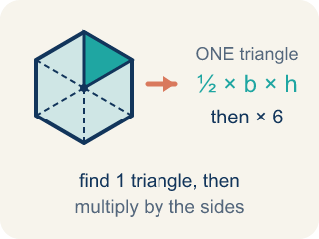
Area of Regular Polygons (Área de polígonos regulares) — The total space a regular polygon covers, found by splitting it into congruent triangles from the center. Formula: A = (½bh) × n — one triangle's area times the number of triangles.
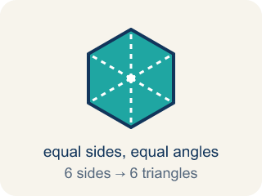
Regular Polygon (Polígono regular) — A closed flat shape made of straight sides, where every side is the same length and every angle is the same size.
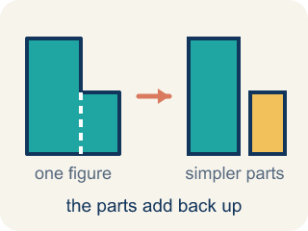
Decompose (Descomponer) — To break a shape into smaller, simpler shapes.
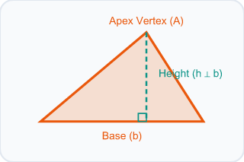
Triangle (Triángulo) — A shape with three sides.
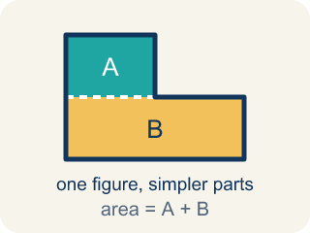
Composite (Compuesto) — Made by putting two or more simple shapes together.
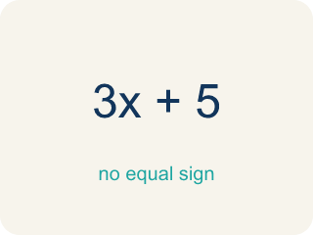
Formula (Fórmula) — A math rule written with symbols.

Practice
Show your work. Use the blank space under each problem.
1. Spot the Common Mistake
Step 1 (Decompose the pentagon): A regular pentagon = 5 congruent triangles
Step 2 (Identify one triangle): base = 6 ft, height = 4 ft
Step 3 (Find the area of one triangle): A = 6 × 4 = 24 sq ft
Step 4 (Find total area): Total area = 5 × 24 = 120 sq ft
Which step has the mistake? Explain and fix it:
______________________________________________________________________
______________________________________________________________________
______________________________________________________________________
2. Find the Area Error
Step 1 (Decompose the hexagon): A regular hexagon = 6 triangles
Step 2 (Find area of one triangle): b = 5 m, h = 4.3 m
Step 3 (Calculate one triangle): A = ½ × 5 × 4.3 = 10.75 sq m
Step 4 (Find total area): Total = 10.75 + 6 = 16.75 sq m
Which step has the mistake? Explain and fix it:
______________________________________________________________________
______________________________________________________________________
______________________________________________________________________
3. A regular hexagon and a regular pentagon both have triangles with the same base (6 ft) and the same height (5 ft). Which polygon has the greater total area? Explain why the number of sides matters.
Sentence starter: One triangle's area is ½ × ___ × ___ = ___. The hexagon has ___ triangles so its area is ___. The pentagon has ___ triangles so its area is ___. The ___ has more area because ___.
______________________________________________________________________
______________________________________________________________________
______________________________________________________________________
______________________________________________________________________
4. A regular hexagonal floor tile splits from its center into 6 congruent triangles, each with an area of 12 cm². What is the total area of the tile?
A. 72 cm²
B. 12 cm²
C. 36 cm²
D. 18 cm²
______________________________________________________________________

Answer Key (Teacher)
1. Spot the Common Mistake
The mistake is in Step 3.
Correct work: The student forgot to multiply by ½ when finding the triangle's area. A = ½ × 6 × 4 = 12 sq ft, so Total = 5 × 12 = 60 sq ft.
Watch for: In the step that finds one triangle's area, the student used 6 × 4 = 24 and left out the ½. A triangle is half of the rectangle with the same base and height, so A = ½ × 6 × 4 = 12 sq ft and the pentagon's total is 5 × 12 = 60 sq ft.
2. Find the Area Error
The mistake is in Step 4.
Correct work: To find total area, multiply (not add): Total = 10.75 × 6 = 64.5 sq m. Six equal triangles means 6 times one triangle's area.
Watch for: One triangle at 10.75 sq m is correct, but the last step added the 6 instead of using it as a count. Six congruent triangles means six copies of that area, so Total = 10.75 × 6 = 64.5 sq m.
3. Open response — answers will vary.
Look for key words: hexagon, pentagon, triangles, multiply, sides, decompose, area.
4. A. 72 cm²
A hexagon has 6 sides, so it splits into 6 equal triangles. Total = 6 × 12 = 72 cm².
Watch for: A common mistake in Area of Regular Polygons is stopping after finding the area of ONE triangle and reporting that as the total area — or adding the number of triangles instead of multiplying. Remember: total area = (one triangle's area) × (number of sides), not (one triangle's area) + (number of sides).

