Area of Regular Polygons — Homework
Lesson 5-9 • Standard 6.GR.1
Name: ______________________ Period: ______ Date: ____________

Today's Goals
Content: I can find the area of a regular polygon by decomposing it into triangles.
Language: I can explain my steps using the words regular polygon, decompose, triangle, and composite.

Key Words
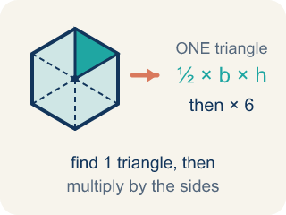
Area of Regular Polygons (Área de polígonos regulares) — The space a regular polygon covers. Split it from the center into identical triangles, find one triangle's area, then multiply by how many there are.
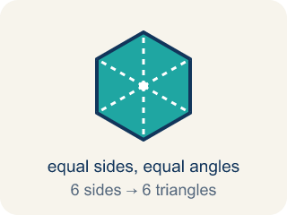
Regular Polygon (Polígono regular) — A closed flat shape made of straight sides, where every side is the same length and every angle is the same size.
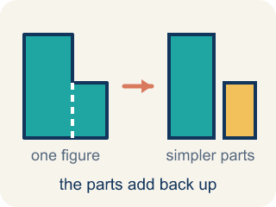
Decompose (Descomponer) — To break a shape into smaller, simpler shapes.
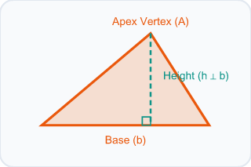
Triangle (Triángulo) — A shape with three sides.
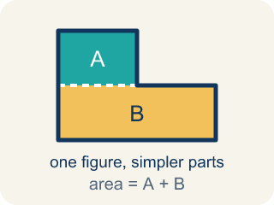
Composite (Compuesto) — Made by putting two or more simple shapes together.
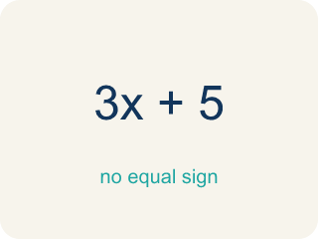
Formula (Fórmula) — A math rule written with symbols.

Practice
Show your work. Use the blank space under each problem.
1. A regular hexagon is divided into 6 equal triangles from the center. Each triangle has a base of 6 ft and a height of 5.2 ft. What is the area of one triangle?
A. 15.6 sq ft
B. 31.2 sq ft
C. 11.2 sq ft
D. 15.6 ft
______________________________________________________________________
2. Using the triangle from the previous question, what is the total area of the hexagonal skylight?
A. 93.6 sq ft
B. 15.6 sq ft
C. 187.2 sq ft
D. 62.4 sq ft
______________________________________________________________________
3. Complete the table.
Polygon | Number of Triangles | Triangle Base | Triangle Height | Area of One Triangle | Total Area
Hexagon | 6 | 6 ft | 5.2 ft
Pentagon | 5 | 8 ft | 5.5 ft
Square | 4 | 5 ft | 4 ft
Octagon | 8 | 4 ft | 4.8 ft
______________________________________________________________________
4. Match each polygon to its total area.
Item | Answer choices
____ Hexagon: 6 triangles, each ½×6×5.2 | F. 18 sq ft
____ Pentagon: 5 triangles, each ½×8×5.5 | E. 60 sq ft
____ Octagon: 8 triangles, each ½×4×4.8 | D. 40 sq ft
____ Square: 4 triangles, each ½×5×4 | C. 76.8 sq ft
____ Decagon: 10 triangles, each ½×3×4 | B. 110 sq ft
____ Equilateral triangle: 3 triangles, each ½×4×3 | A. 93.6 sq ft
______________________________________________________________________
5. Find the TOTAL area of each regular polygon, then sort it against the 90 sq ft cutoff.
Groups: Total area ≥ 90 sq ft | Total area < 90 sq ft
• Pentagon: 5 triangles, base 8 ft, height 5.5 ft → __________________
• Hexagon: 6 triangles, base 6 ft, height 5.2 ft → __________________
• Octagon: 8 triangles, base 4 ft, height 4.8 ft → __________________
• Square: 4 triangles, base 5 ft, height 4 ft → __________________
______________________________________________________________________
6. Spot the Common Mistake
Step 1 (Decompose the pentagon): A regular pentagon = 5 congruent triangles
Step 2 (Identify one triangle): base = 6 ft, height = 4 ft
Step 3 (Find the area of one triangle): A = 6 × 4 = 24 sq ft
Step 4 (Find total area): Total area = 5 × 24 = 120 sq ft
Which step has the mistake? Explain and fix it:
______________________________________________________________________
______________________________________________________________________
______________________________________________________________________
7. A regular hexagonal floor tile splits from its center into 6 congruent triangles, each with an area of 12 cm². What is the total area of the tile?
A. 72 cm²
B. 12 cm²
C. 36 cm²
D. 18 cm²
______________________________________________________________________
8. A regular pentagonal tile splits into 5 congruent triangles. Each triangle has a base of 4 in and a height of 6 in. What is the total area of the tile?
A. 60 in²
B. 12 in²
C. 24 in²
D. 120 in²
______________________________________________________________________
9. Each tile decomposes into congruent triangles from its center. Work out the area of ONE triangle, then sort the tile.
Groups: One triangle ≤ 12 sq ft | One triangle > 12 sq ft
• Square tile: base 4 ft, height 4 ft → __________________
• Hexagon tile: base 6 ft, height 4 ft → __________________
• Octagon tile: base 10 ft, height 3 ft → __________________
• Pentagon tile: base 8 ft, height 5 ft → __________________
______________________________________________________________________
10. Match each polygon tile to its total area.
Item | Answer choices
____ Square tile: 4 triangles, each ½×9×2 | D. 21 sq ft
____ Octagon tile: 8 triangles, each ½×3×4 | C. 45 sq ft
____ Hexagon tile: 6 triangles, each ½×5×3 | B. 48 sq ft
____ Equilateral triangle tile: 1 triangle, ½×7×6 | A. 36 sq ft
______________________________________________________________________

Answer Key (Teacher)
1. A. 15.6 sq ft
A = ½ × b × h = ½ × 6 × 5.2 = 15.6 square feet.
Watch for: A common mistake in Area of Regular Polygons is stopping after finding the area of ONE triangle and reporting that as the total area — or adding the number of triangles instead of multiplying. Remember: total area = (one triangle's area) × (number of sides), not (one triangle's area) + (number of sides).
2. A. 93.6 sq ft
Total area = 6 triangles × 15.6 sq ft = 93.6 square feet.
Watch for: A common mistake in Area of Regular Polygons is stopping after finding the area of ONE triangle and reporting that as the total area — or adding the number of triangles instead of multiplying. Remember: total area = (one triangle's area) × (number of sides), not (one triangle's area) + (number of sides).
3. Table
Hexagon — Area of One Triangle: 15.6 sq ft
Hexagon — Total Area: 93.6 sq ft
Pentagon — Area of One Triangle: 22 sq ft
Pentagon — Total Area: 110 sq ft
Square — Area of One Triangle: 10 sq ft
Square — Total Area: 40 sq ft
Octagon — Area of One Triangle: 9.6 sq ft
Octagon — Total Area: 76.8 sq ft

4. Matches:
Hexagon: 6 triangles, each ½×6×5.2 → 93.6 sq ft
Pentagon: 5 triangles, each ½×8×5.5 → 110 sq ft
Octagon: 8 triangles, each ½×4×4.8 → 76.8 sq ft
Square: 4 triangles, each ½×5×4 → 40 sq ft
Decagon: 10 triangles, each ½×3×4 → 60 sq ft
Equilateral triangle: 3 triangles, each ½×4×3 → 18 sq ft

5. Correct groups:
Pentagon: 5 triangles, base 8 ft, height 5.5 ft → Total area ≥ 90 sq ft
Hexagon: 6 triangles, base 6 ft, height 5.2 ft → Total area ≥ 90 sq ft
Octagon: 8 triangles, base 4 ft, height 4.8 ft → Total area < 90 sq ft
Square: 4 triangles, base 5 ft, height 4 ft → Total area < 90 sq ft

6. Spot the Common Mistake
The mistake is in Step 3.
Correct work: The student forgot to multiply by ½ when finding the triangle's area. A = ½ × 6 × 4 = 12 sq ft, so Total = 5 × 12 = 60 sq ft.
Watch for: In the step that finds one triangle's area, the student used 6 × 4 = 24 and left out the ½. A triangle is half of the rectangle with the same base and height, so A = ½ × 6 × 4 = 12 sq ft and the pentagon's total is 5 × 12 = 60 sq ft.
7. A. 72 cm²
A hexagon has 6 sides, so it splits into 6 equal triangles. Total = 6 × 12 = 72 cm².
Watch for: A common mistake in Area of Regular Polygons is stopping after finding the area of ONE triangle and reporting that as the total area — or adding the number of triangles instead of multiplying. Remember: total area = (one triangle's area) × (number of sides), not (one triangle's area) + (number of sides).
8. A. 60 in²
One triangle = ½ × 4 × 6 = 12 in². A pentagon has 5 triangles, so total = 5 × 12 = 60 in².
Watch for: A common mistake in Area of Regular Polygons is stopping after finding the area of ONE triangle and reporting that as the total area — or adding the number of triangles instead of multiplying. Remember: total area = (one triangle's area) × (number of sides), not (one triangle's area) + (number of sides).
9. Correct groups:
Square tile: base 4 ft, height 4 ft → One triangle ≤ 12 sq ft
Hexagon tile: base 6 ft, height 4 ft → One triangle ≤ 12 sq ft
Octagon tile: base 10 ft, height 3 ft → One triangle > 12 sq ft
Pentagon tile: base 8 ft, height 5 ft → One triangle > 12 sq ft

10. Matches:
Square tile: 4 triangles, each ½×9×2 → 36 sq ft
Octagon tile: 8 triangles, each ½×3×4 → 48 sq ft
Hexagon tile: 6 triangles, each ½×5×3 → 45 sq ft
Equilateral triangle tile: 1 triangle, ½×7×6 → 21 sq ft

