6.1 Small Group · Group 1 — Homework
Lesson 6-1-group1 • Standard 6.NOS.1
Name: ______________________ Period: ______ Date: ____________

Today's Goals
Content: With my small group, I can use models to interpret what it means to divide by a fraction — one step at a time, with support.
Language: I can talk through each step out loud using a sentence frame and the lesson's key words.

Key Words
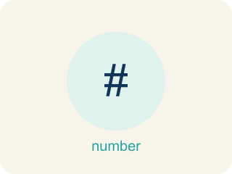
Division of Fractions (División de fracciones) — Finding how many groups of one fraction fit inside another amount.
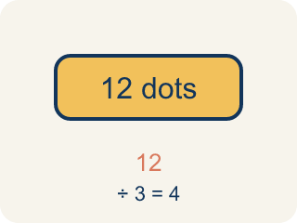
Dividend (Dividendo) — The number you are splitting up in a division problem.
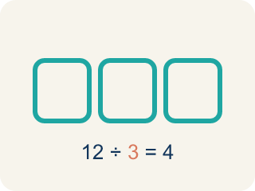
Divisor (Divisor) — The number you split by in a division problem.
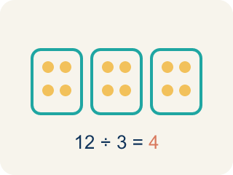
Quotient (Cociente) — The answer when you divide.
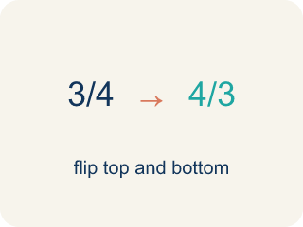
Reciprocal (Recíproco) — A fraction turned upside down.
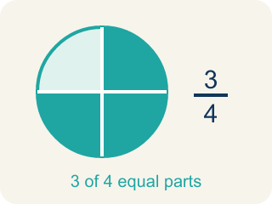
Unit fraction (Fracción unitaria) — A fraction with 1 on top, like 1/4.

Practice
Show your work. Use the blank space under each problem.
1. What does 3 ÷ 1/4 mean?
A. How many 1/4-size pieces fit into 3
B. 3 groups of 1/4
C. 3 minus 1/4
D. 1/4 of 3
______________________________________________________________________
2. Which expression means 'how many 1/3-size pieces are in 2'?
A. 2 ÷ 1/3
B. 2 × 1/3
C. 1/3 ÷ 2
D. 2 + 1/3
______________________________________________________________________
3. Agent Cole has 8 feet of evidence rope and cuts it into 1/3-foot pieces for tagging. What does 8 ÷ 1/3 mean?
A. How many 1/3-foot pieces fit into 8 feet
B. 1/3 of the 8 feet of rope
C. 8 feet shortened by 1/3 of a foot
D. 8 pieces that are each 1/3 foot long
______________________________________________________________________
4. Picture clue: a 5-inch fingerprint strip is split into 1/6-inch slivers under the microscope. Which division does the picture show, and what is the count?
A. 5 ÷ 1/6 = 30 slivers
B. 5 ÷ 6 = 5/6 of a sliver
C. 1/6 ÷ 5 = 1/30 sliver
D. 5 × 1/6 = 5/6 of an inch
______________________________________________________________________
5. Level 2 Extension — Which Question Is Being Asked?
Step 1 (Case file): A 9-foot strip of evidence tape is cut into 1/4-foot pieces. How many pieces?
Step 2 (Detective writes): This is 1/4 ÷ 9 — split the 1/4-foot piece among 9 sections.
Step 3 (Detective's answer): 1/36 of a foot per piece
Which step has the mistake? Explain and fix it:
______________________________________________________________________
______________________________________________________________________
______________________________________________________________________
6. Find the Interpretation Error
Step 1 (Problem): Interpret 4 ÷ 1/5
Step 2 (Student says): 4 ÷ 1/5 means 1/5 of 4
Step 3 (Student's answer): 4/5
Which step has the mistake? Explain and fix it:
______________________________________________________________________
______________________________________________________________________
______________________________________________________________________
7. Dividing 6 by 1/2 gives 12, but dividing 6 by 2 gives 3. How can dividing by a smaller number (1/2) give a bigger answer than dividing by a larger number (2)? Explain using a real-world example.
Sentence starter: When I divide 6 by 2, I am ___. When I divide 6 by 1/2, I am ___. The answer is bigger because ___.
______________________________________________________________________
______________________________________________________________________
______________________________________________________________________
______________________________________________________________________
8. Sort each statement: does dividing by the fraction give a result GREATER than the dividend, or LESS than the dividend?
Groups: Quotient GREATER Than Dividend | Quotient LESS Than Dividend
• 5 ÷ 1/3 = 15 (greater than 5) → __________________
• 8 ÷ 1/2 = 16 (greater than 8) → __________________
• 6 ÷ 1/4 = 24 (greater than 6) → __________________
• 4 ÷ 2 = 2 (less than 4) → __________________
• 10 ÷ 5 = 2 (less than 10) → __________________
• 12 ÷ 3 = 4 (less than 12) → __________________
______________________________________________________________________

Answer Key (Teacher)
1. A. How many 1/4-size pieces fit into 3
3 ÷ 1/4 asks: how many 1/4-size pieces fit into 3? The answer is 12, because each whole has 4 fourths, and 3 × 4 = 12.
Watch for: A common mistake in Interpret Division of Fractions is assuming that dividing always makes the answer smaller. For 4 ÷ 1/3, students reason 'dividing shrinks the number' and compute 4 ÷ 3 ≈ 1.3 instead of asking how many 1/3-foot pieces fit into 4 feet (each whole foot holds 3 thirds, so 4 × 3 = 12). Before you submit, check: if the divisor is a fraction smaller than 1, the quotient must be BIGGER than the dividend, not smaller.
2. A. 2 ÷ 1/3
Finding how many 1/3-size pieces fit into 2 is represented by 2 ÷ 1/3. The answer is 6.
Watch for: A common mistake in Interpret Division of Fractions is assuming that dividing always makes the answer smaller. For 4 ÷ 1/3, students reason 'dividing shrinks the number' and compute 4 ÷ 3 ≈ 1.3 instead of asking how many 1/3-foot pieces fit into 4 feet (each whole foot holds 3 thirds, so 4 × 3 = 12). Before you submit, check: if the divisor is a fraction smaller than 1, the quotient must be BIGGER than the dividend, not smaller.
3. A. How many 1/3-foot pieces fit into 8 feet
Dividing by 1/3 asks how many 1/3-foot pieces fit into 8 feet. Each foot holds 3 thirds, so 8 × 3 = 24 pieces.
Watch for: A common mistake in Interpret Division of Fractions is assuming that dividing always makes the answer smaller. For 4 ÷ 1/3, students reason 'dividing shrinks the number' and compute 4 ÷ 3 ≈ 1.3 instead of asking how many 1/3-foot pieces fit into 4 feet (each whole foot holds 3 thirds, so 4 × 3 = 12). Before you submit, check: if the divisor is a fraction smaller than 1, the quotient must be BIGGER than the dividend, not smaller.
4. A. 5 ÷ 1/6 = 30 slivers
How many 1/6-inch slivers fit into 5 inches? Each inch holds 6 sixths, so 5 × 6 = 30 slivers.
Watch for: A common mistake in Interpret Division of Fractions is assuming that dividing always makes the answer smaller. For 4 ÷ 1/3, students reason 'dividing shrinks the number' and compute 4 ÷ 3 ≈ 1.3 instead of asking how many 1/3-foot pieces fit into 4 feet (each whole foot holds 3 thirds, so 4 × 3 = 12). Before you submit, check: if the divisor is a fraction smaller than 1, the quotient must be BIGGER than the dividend, not smaller.
5. Level 2 Extension — Which Question Is Being Asked?
The mistake is in Step 2.
Correct work: The story asks 'how many 1/4-foot pieces fit into 9 feet,' so the dividend is the whole (9) and the divisor is the piece size (1/4): 9 ÷ 1/4. The detective swapped the dividend and divisor. The correct answer is 9 × 4 = 36 pieces.
Watch for: The "Detective writes" step reverses the two numbers. The 9-foot strip is the total being cut, so it is the dividend, and 1/4 foot is the size of each piece, so it is the divisor: 9 ÷ 1/4. Each foot holds 4 quarter-foot pieces, so the answer is 9 × 4 = 36 pieces — an answer smaller than a single foot, like 1/36, cannot describe a count of pieces.
6. Find the Interpretation Error
The mistake is in Step 2.
Correct work: 4 ÷ 1/5 means 'how many 1/5-size pieces fit into 4,' not '1/5 of 4.' The correct answer is 4 × 5 = 20.
Watch for: The "Student says" step rewrites division as multiplication: "1/5 of 4" means 1/5 × 4, which is a different question. 4 ÷ 1/5 asks how many 1/5-size pieces fit inside 4, and each whole holds 5 of them, so the quotient is 4 × 5 = 20. The answer 4/5 is smaller than the dividend, which cannot happen when you divide by a number less than 1.
7. Open response — answers will vary.
Look for key words: smaller pieces, more fit, halves, groups, 12, 3.
8. Correct groups:
5 ÷ 1/3 = 15 (greater than 5) → Quotient GREATER Than Dividend
8 ÷ 1/2 = 16 (greater than 8) → Quotient GREATER Than Dividend
6 ÷ 1/4 = 24 (greater than 6) → Quotient GREATER Than Dividend
4 ÷ 2 = 2 (less than 4) → Quotient LESS Than Dividend
10 ÷ 5 = 2 (less than 10) → Quotient LESS Than Dividend
12 ÷ 3 = 4 (less than 12) → Quotient LESS Than Dividend

