6.1 Small Group · Group 2 — Homework
Lesson 6-1-group2 • Standard 6.NOS.1
Name: ______________________ Period: ______ Date: ____________

Today's Goals
Content: I can use models to interpret what it means to divide by a fraction, explain how I can tell, and judge a case I have not seen before.
Language: I can justify my answer to a skeptic and connect it to a second strategy or representation.

Key Words
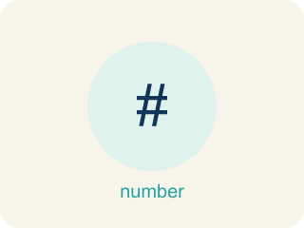
Division of Fractions (División de fracciones) — Finding how many groups of one fraction fit inside another amount.
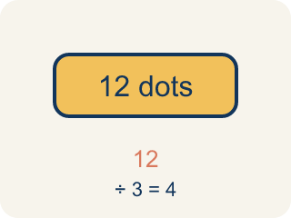
Dividend (Dividendo) — The number you are splitting up in a division problem.
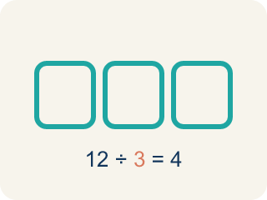
Divisor (Divisor) — The number you split by in a division problem.
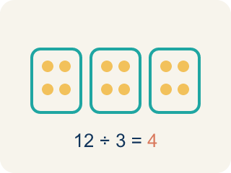
Quotient (Cociente) — The answer when you divide.
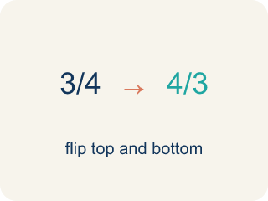
Reciprocal (Recíproco) — A fraction turned upside down.
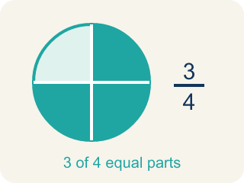
Unit fraction (Fracción unitaria) — A fraction with 1 on top, like 1/4.

Practice
Show your work. Use the blank space under each problem.
1. A shelf is 5 feet long. Books are each 1/4 foot wide. How many books fit on the shelf? Which expression represents this?
A. 5 ÷ 1/4 = 20 books
B. 5 × 1/4 = 1 1/4 books
C. 1/4 ÷ 5 = 1/20 book
D. 5 + 1/4 = 5 1/4 books
______________________________________________________________________
2. Spot the Common Mistake
Step 1 (Problem): How many 1/5-cup scoops fill a 6-cup container? Find 6 ÷ 1/5.
Step 2 (Student writes): I will flip the first number instead of the divisor: 6 ÷ 1/5 = 1/6 × 5 = 5/6 scoop.
Step 3 (Student's answer): 5/6 of a scoop
Which step has the mistake? Explain and fix it:
______________________________________________________________________
______________________________________________________________________
______________________________________________________________________
3. Find the Interpretation Error
Step 1 (Problem): Interpret 4 ÷ 1/5
Step 2 (Student says): 4 ÷ 1/5 means 1/5 of 4
Step 3 (Student's answer): 4/5
Which step has the mistake? Explain and fix it:
______________________________________________________________________
______________________________________________________________________
______________________________________________________________________
4. Dividing 6 by 1/2 gives 12, but dividing 6 by 2 gives 3. How can dividing by a smaller number (1/2) give a bigger answer than dividing by a larger number (2)? Explain using a real-world example.
Sentence starter: When I divide 6 by 2, I am ___. When I divide 6 by 1/2, I am ___. The answer is bigger because ___.
______________________________________________________________________
______________________________________________________________________
______________________________________________________________________
______________________________________________________________________

Answer Key (Teacher)
1. A. 5 ÷ 1/4 = 20 books
You are finding how many 1/4-foot pieces fit into 5 feet, which is 5 ÷ 1/4 = 5 × 4 = 20 books.
Watch for: A common mistake in Interpret Division of Fractions is assuming that dividing always makes the answer smaller. For 4 ÷ 1/3, students reason 'dividing shrinks the number' and compute 4 ÷ 3 ≈ 1.3 instead of asking how many 1/3-foot pieces fit into 4 feet (each whole foot holds 3 thirds, so 4 × 3 = 12). Before you submit, check: if the divisor is a fraction smaller than 1, the quotient must be BIGGER than the dividend, not smaller.
2. Spot the Common Mistake
The mistake is in Step 2.
Correct work: To divide, multiply by the reciprocal of the DIVISOR (1/5), not the dividend. The reciprocal of 1/5 is 5, so 6 ÷ 1/5 = 6 × 5 = 30 scoops.
Watch for: In the "Student writes" step the reciprocal was taken of the dividend 6 instead of the divisor 1/5. Only the divisor gets flipped: the reciprocal of 1/5 is 5, so 6 ÷ 1/5 = 6 × 5 = 30 scoops. That matches the story too — each cup holds 5 one-fifth scoops, and there are 6 cups.
3. Find the Interpretation Error
The mistake is in Step 2.
Correct work: 4 ÷ 1/5 means 'how many 1/5-size pieces fit into 4,' not '1/5 of 4.' The correct answer is 4 × 5 = 20.
Watch for: The "Student says" step rewrites division as multiplication: "1/5 of 4" means 1/5 × 4, which is a different question. 4 ÷ 1/5 asks how many 1/5-size pieces fit inside 4, and each whole holds 5 of them, so the quotient is 4 × 5 = 20. The answer 4/5 is smaller than the dividend, which cannot happen when you divide by a number less than 1.
4. Open response — answers will vary.
Look for key words: smaller pieces, more fit, halves, groups, 12, 3.

