6.10 Small Group · Group 1 — Homework
Lesson 6-10-group1 • Standard 6.NOS.1
Name: ______________________ Period: ______ Date: ____________

Today's Goals
Content: With my small group, I can divide mixed numbers by first changing them to improper fractions — one step at a time, with support.
Language: I can talk through each step out loud using a sentence frame and the lesson's key words.

Key Words
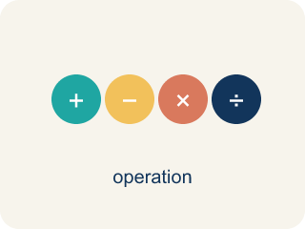
Divide Mixed Numbers (Dividir números mixtos) — Change mixed numbers to improper fractions, then multiply by the reciprocal.
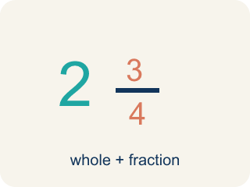
Mixed Number (Número mixto) — A whole number plus a fraction, like 2 1/3.
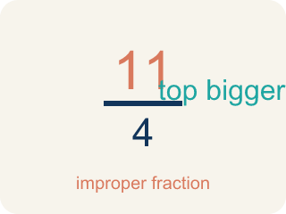
Improper Fraction (Fracción impropia) — A fraction where the top is bigger than or equal to the bottom, like 7/4.
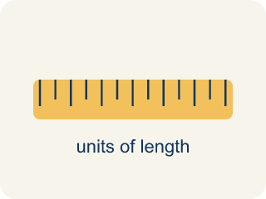
Convert (Convertir) — To change a number to a new form but keep the same value.
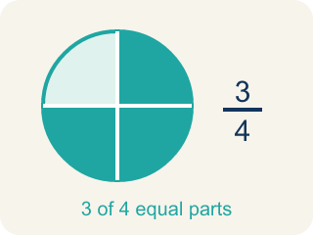
Simplify (Simplificar) — To make a fraction smaller using the same parts, like 2/4 = 1/2.
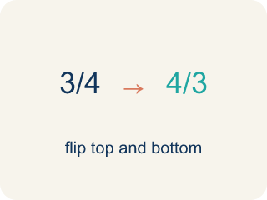
Reciprocal (Recíproco) — A fraction turned upside down. You use it in keep-change-flip.

Practice
Show your work. Use the blank space under each problem.
1. What is 1 1/2 ÷ 3/4?
A. 2
B. 1 1/8
C. 3/4
D. 9/8
______________________________________________________________________
2. Convert 3 2/5 to an improper fraction.
A. 17/5
B. 15/5
C. 6/5
D. 32/5
______________________________________________________________________
3. Mission 1: The stakeout shift is 4 1/2 hours long. Each agent covers a 1 1/2-hour watch. How many agent watches fill one shift?
A. 3
B. 6
C. 2 1/2
D. 4 1/2
______________________________________________________________________
4. Mission 2: A surveillance route is 3 miles long, split into 1 1/2-mile patrol sections. How many sections are on the route?
A. 2
B. 1 1/2
C. 4 1/2
D. 3
______________________________________________________________________
5. Mission 3: There are 7 1/2 feet of caution tape to seal a crime scene. Each doorway needs 2 1/2 feet. How many doorways can be sealed?
A. 3
B. 5
C. 2 1/2
D. 10
______________________________________________________________________
6. Level 2 Extension — The Rookie Detective's Mistake
Step 1 (Problem): 4 1/2 ÷ 1 1/2
Step 2 (Divide the whole parts): 4 ÷ 1 = 4
Step 3 (Divide the fraction parts): 1/2 ÷ 1/2 = 1
Step 4 (Combine): 4 + 1 = 5 watches
Which step has the mistake? Explain and fix it:
______________________________________________________________________
______________________________________________________________________
______________________________________________________________________
7. Find the Mixed Number Error
Step 1 (Problem): 2 1/3 ÷ 1/2
Step 2 (Convert): 2 1/3 = 6/3
Step 3 (Keep, Change, Flip): 6/3 × 2/1
Step 4 (Multiply): 12/3 = 4
Which step has the mistake? Explain and fix it:
______________________________________________________________________
______________________________________________________________________
______________________________________________________________________
8. A detective has a rope that is 5 1/4 feet long. She needs to cut it into pieces that are each 3/4 foot for tying evidence tags. How many pieces can she cut? Write the equation, show each step (convert, keep-change-flip, multiply, simplify), and verify your answer.
Sentence starter: First I convert 5 1/4 to ___. Then I use KCF: ___ × ___ = ___. The answer is ___ pieces. I can verify because ___ × 3/4 = 5 1/4.
______________________________________________________________________
______________________________________________________________________
______________________________________________________________________
______________________________________________________________________

Answer Key (Teacher)
1. A. 2
1 1/2 = 3/2. Then 3/2 ÷ 3/4 = 3/2 × 4/3 = 12/6 = 2.
Watch for: A common mistake in Divide Mixed Numbers is dividing the whole-number parts and fraction parts separately instead of converting first — for example, treating 4 1/2 ÷ 1 1/2 as (4 ÷ 1) + (1/2 ÷ 1/2) = 5. Always convert each mixed number to one improper fraction first, then divide using Keep, Change, Flip: 4 1/2 ÷ 1 1/2 = 9/2 ÷ 3/2 = 9/2 × 2/3 = 3.
2. A. 17/5
3 × 5 = 15, then 15 + 2 = 17. So 3 2/5 = 17/5.
Watch for: A common mistake in Divide Mixed Numbers is dividing the whole-number parts and fraction parts separately instead of converting first — for example, treating 4 1/2 ÷ 1 1/2 as (4 ÷ 1) + (1/2 ÷ 1/2) = 5. Always convert each mixed number to one improper fraction first, then divide using Keep, Change, Flip: 4 1/2 ÷ 1 1/2 = 9/2 ÷ 3/2 = 9/2 × 2/3 = 3.
3. A. 3
4 1/2 = 9/2 and 1 1/2 = 3/2. So 9/2 ÷ 3/2 = 9/2 × 2/3 = 18/6 = 3 watches.
Watch for: A common mistake in Divide Mixed Numbers is dividing the whole-number parts and fraction parts separately instead of converting first — for example, treating 4 1/2 ÷ 1 1/2 as (4 ÷ 1) + (1/2 ÷ 1/2) = 5. Always convert each mixed number to one improper fraction first, then divide using Keep, Change, Flip: 4 1/2 ÷ 1 1/2 = 9/2 ÷ 3/2 = 9/2 × 2/3 = 3.
4. A. 2
3 ÷ 1 1/2 = 3 ÷ 3/2 = 3 × 2/3 = 6/3 = 2 sections.
Watch for: A common mistake in Divide Mixed Numbers is dividing the whole-number parts and fraction parts separately instead of converting first — for example, treating 4 1/2 ÷ 1 1/2 as (4 ÷ 1) + (1/2 ÷ 1/2) = 5. Always convert each mixed number to one improper fraction first, then divide using Keep, Change, Flip: 4 1/2 ÷ 1 1/2 = 9/2 ÷ 3/2 = 9/2 × 2/3 = 3.
5. A. 3
7 1/2 = 15/2 and 2 1/2 = 5/2. So 15/2 ÷ 5/2 = 15/2 × 2/5 = 30/10 = 3 doorways.
Watch for: A common mistake in Divide Mixed Numbers is dividing the whole-number parts and fraction parts separately instead of converting first — for example, treating 4 1/2 ÷ 1 1/2 as (4 ÷ 1) + (1/2 ÷ 1/2) = 5. Always convert each mixed number to one improper fraction first, then divide using Keep, Change, Flip: 4 1/2 ÷ 1 1/2 = 9/2 ÷ 3/2 = 9/2 × 2/3 = 3.
6. Level 2 Extension — The Rookie Detective's Mistake
The mistake is in Step 2.
Correct work: You cannot divide whole parts and fraction parts separately. First convert: 4 1/2 = 9/2 and 1 1/2 = 3/2. Then Keep, Change, Flip: 9/2 × 2/3 = 18/6 = 3. The answer is 3 watches, not 5.
Watch for: The second step splits the problem into 4 ÷ 1 and 1/2 ÷ 1/2, but division does not distribute over the parts of a mixed number that way. Convert each one to a single fraction — 4 1/2 = 9/2 and 1 1/2 = 3/2 — then 9/2 × 2/3 = 18/6 = 3 watches, not 5.
7. Find the Mixed Number Error
The mistake is in Step 2.
Correct work: 2 1/3 = 7/3 (not 6/3). Multiply: 2 × 3 = 6, then ADD the numerator 1 to get 7. So 7/3 × 2/1 = 14/3 = 4 2/3.
Watch for: The Convert step is wrong: the student wrote 2 1/3 = 6/3, multiplying 2 × 3 but never adding the numerator. The correct conversion is (2 × 3 + 1)/3 = 7/3, so 7/3 × 2/1 = 14/3 = 4 2/3.
8. Open response — answers will vary.
Look for key words: convert, 21/4, reciprocal, 4/3, multiply, 7, verify.

