6.10 Small Group · Group 2 — Homework
Lesson 6-10-group2 • Standard 6.NOS.1
Name: ______________________ Period: ______ Date: ____________

Today's Goals
Content: I can divide mixed numbers by first changing them to improper fractions, explain why the method works, and use it on a problem I have not seen before.
Language: I can justify my answer to a skeptic and connect it to a second strategy or representation.

Key Words
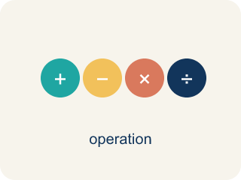
Divide Mixed Numbers (Dividir números mixtos) — Change mixed numbers to improper fractions, then multiply by the reciprocal.
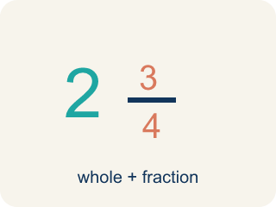
Mixed Number (Número mixto) — A whole number plus a fraction, like 2 1/3.
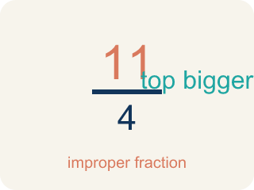
Improper Fraction (Fracción impropia) — A fraction where the top is bigger than or equal to the bottom, like 7/4.
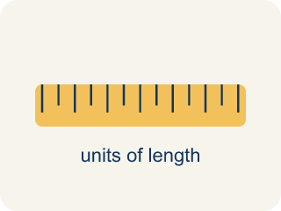
Convert (Convertir) — To change a number to a new form but keep the same value.
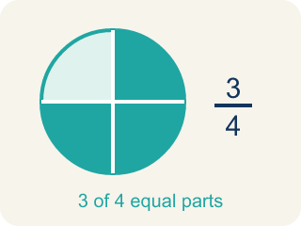
Simplify (Simplificar) — To make a fraction smaller using the same parts, like 2/4 = 1/2.
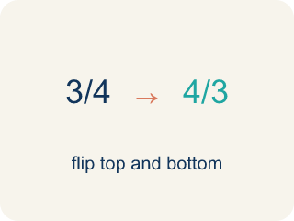
Reciprocal (Recíproco) — A fraction turned upside down. You use it in keep-change-flip.

Practice
Show your work. Use the blank space under each problem.
1. A baker has 2 1/4 cups of butter. Each batch of cookies needs 3/4 cup of butter. How many batches can the baker make?
A. 3 batches
B. 1 1/2 batches
C. 2 batches
D. 6 batches
______________________________________________________________________
2. Spot the Common Mistake
Step 1 (Problem): 3 1/3 ÷ 2/3
Step 2 (Keep, Change, Flip (skipped converting)): 3 1/3 × 3/2
Step 3 (Multiply the fraction part only): 1/3 × 3/2 = 3/6 = 1/2
Step 4 (Combine with the whole): 3 + 1/2 = 3 1/2
Which step has the mistake? Explain and fix it:
______________________________________________________________________
______________________________________________________________________
______________________________________________________________________
3. Find the Mixed Number Error
Step 1 (Problem): 2 1/3 ÷ 1/2
Step 2 (Convert): 2 1/3 = 6/3
Step 3 (Keep, Change, Flip): 6/3 × 2/1
Step 4 (Multiply): 12/3 = 4
Which step has the mistake? Explain and fix it:
______________________________________________________________________
______________________________________________________________________
______________________________________________________________________
4. A detective has a rope that is 5 1/4 feet long. She needs to cut it into pieces that are each 3/4 foot for tying evidence tags. How many pieces can she cut? Write the equation, show each step (convert, keep-change-flip, multiply, simplify), and verify your answer.
Sentence starter: First I convert 5 1/4 to ___. Then I use KCF: ___ × ___ = ___. The answer is ___ pieces. I can verify because ___ × 3/4 = 5 1/4.
______________________________________________________________________
______________________________________________________________________
______________________________________________________________________
______________________________________________________________________

Answer Key (Teacher)
1. A. 3 batches
Convert 2 1/4 = 9/4. Then 2 1/4 ÷ 3/4 = 9/4 × 4/3 = 36/12 = 3 batches.
Watch for: A common mistake in Divide Mixed Numbers is dividing the whole-number parts and fraction parts separately instead of converting first — for example, treating 4 1/2 ÷ 1 1/2 as (4 ÷ 1) + (1/2 ÷ 1/2) = 5. Always convert each mixed number to one improper fraction first, then divide using Keep, Change, Flip: 4 1/2 ÷ 1 1/2 = 9/2 ÷ 3/2 = 9/2 × 2/3 = 3.
2. Spot the Common Mistake
The mistake is in Step 2.
Correct work: The student divided before converting the mixed number. First convert: 3 1/3 = 10/3. Then 10/3 ÷ 2/3 = 10/3 × 3/2 = 30/6 = 5, not 3 1/2.
Watch for: The break happens at the second step: the student jumped straight to Keep, Change, Flip while 3 1/3 was still a mixed number, then multiplied only the fraction part. Convert first — 3 1/3 = 10/3 — then 10/3 × 3/2 = 30/6 = 5, not 3 1/2.
3. Find the Mixed Number Error
The mistake is in Step 2.
Correct work: 2 1/3 = 7/3 (not 6/3). Multiply: 2 × 3 = 6, then ADD the numerator 1 to get 7. So 7/3 × 2/1 = 14/3 = 4 2/3.
Watch for: The Convert step is wrong: the student wrote 2 1/3 = 6/3, multiplying 2 × 3 but never adding the numerator. The correct conversion is (2 × 3 + 1)/3 = 7/3, so 7/3 × 2/1 = 14/3 = 4 2/3.
4. Open response — answers will vary.
Look for key words: convert, 21/4, reciprocal, 4/3, multiply, 7, verify.

