Divide Mixed Numbers — Homework
Lesson 6-10 • Standard 6.NOS.1
Name: ______________________ Period: ______ Date: ____________

Today's Goals
Content: I can divide mixed numbers by first changing them to improper fractions.
Language: I can explain my steps using the words mixed number, improper fraction, convert, reciprocal, and simplify.

Key Words
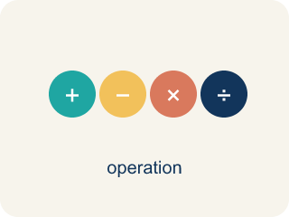
Divide Mixed Numbers (Dividir números mixtos) — Change mixed numbers to improper fractions, then multiply by the reciprocal.
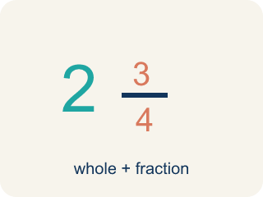
Mixed Number (Número mixto) — A whole number plus a fraction, like 2 1/3.
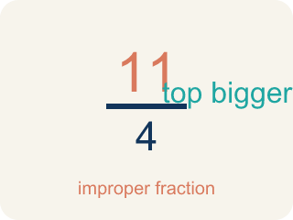
Improper Fraction (Fracción impropia) — A fraction where the top is bigger than or equal to the bottom, like 7/4.
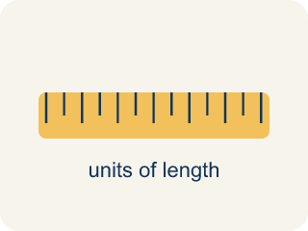
Convert (Convertir) — To change a number to a new form but keep the same value.
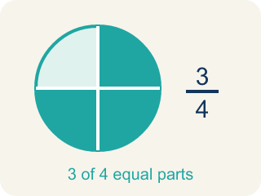
Simplify (Simplificar) — To make a fraction smaller using the same parts, like 2/4 = 1/2.
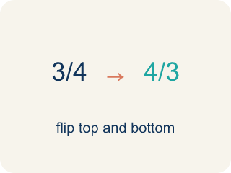
Reciprocal (Recíproco) — A fraction turned upside down. You use it in keep-change-flip.

Practice
Show your work. Use the blank space under each problem.
1. What is 1 1/2 ÷ 3/4?
A. 2
B. 1 1/8
C. 3/4
D. 9/8
______________________________________________________________________
2. Convert 3 2/5 to an improper fraction.
A. 17/5
B. 15/5
C. 6/5
D. 32/5
______________________________________________________________________
3. Convert each mixed number to an improper fraction, then divide.
Problem | Convert to Improper | Keep-Change-Flip | Quotient
3 1/2 ÷ 1/4 | 7/2 ÷ 1/4 | 7/2 × 4/1 = 28/2
1 3/4 ÷ 1/2 | 7/4 ÷ 1/2 | 7/4 × 2/1 = 14/4
2 1/3 ÷ 7/6 | 7/3 ÷ 7/6 | 7/3 × 6/7 = 42/21
4 1/5 ÷ 3/5 | 21/5 ÷ 3/5 | 21/5 × 5/3 = 105/15
______________________________________________________________________
4. Match each mixed number division to its quotient.
Item | Answer choices
____ 2 1/4 ÷ 3/4 | F. 6
____ 4 1/2 ÷ 9/8 | E. 7
____ 1 2/3 ÷ 5/6 | D. 5
____ 3 1/3 ÷ 2/3 | C. 2
____ 5 1/4 ÷ 3/4 | B. 4
____ 1 1/2 ÷ 1/4 | A. 3
______________________________________________________________________
5. A baker has 2 1/4 cups of butter. Each batch of cookies needs 3/4 cup of butter. How many batches can the baker make?
A. 3 batches
B. 1 1/2 batches
C. 2 batches
D. 6 batches
______________________________________________________________________
6. Spot the Common Mistake
Step 1 (Problem): 3 1/3 ÷ 2/3
Step 2 (Keep, Change, Flip (skipped converting)): 3 1/3 × 3/2
Step 3 (Multiply the fraction part only): 1/3 × 3/2 = 3/6 = 1/2
Step 4 (Combine with the whole): 3 + 1/2 = 3 1/2
Which step has the mistake? Explain and fix it:
______________________________________________________________________
______________________________________________________________________
______________________________________________________________________
7. Mission 1: The stakeout shift is 4 1/2 hours long. Each agent covers a 1 1/2-hour watch. How many agent watches fill one shift?
A. 3
B. 6
C. 2 1/2
D. 4 1/2
______________________________________________________________________
8. Mission 2: A surveillance route is 3 miles long, split into 1 1/2-mile patrol sections. How many sections are on the route?
A. 2
B. 1 1/2
C. 4 1/2
D. 3
______________________________________________________________________
9. Mission 3: There are 7 1/2 feet of caution tape to seal a crime scene. Each doorway needs 2 1/2 feet. How many doorways can be sealed?
A. 3
B. 5
C. 2 1/2
D. 10
______________________________________________________________________
10. Mission 4: Match each suspect's case-file number (a mixed number) to its decoded improper fraction.
Item | Answer choices
____ 5 1/4 | D. 14/3
____ 2 3/5 | C. 19/6
____ 3 1/6 | B. 13/5
____ 4 2/3 | A. 21/4
______________________________________________________________________

Answer Key (Teacher)
1. A. 2
1 1/2 = 3/2. Then 3/2 ÷ 3/4 = 3/2 × 4/3 = 12/6 = 2.
Watch for: A common mistake in Divide Mixed Numbers is dividing the whole-number parts and fraction parts separately instead of converting first — for example, treating 4 1/2 ÷ 1 1/2 as (4 ÷ 1) + (1/2 ÷ 1/2) = 5. Always convert each mixed number to one improper fraction first, then divide using Keep, Change, Flip: 4 1/2 ÷ 1 1/2 = 9/2 ÷ 3/2 = 9/2 × 2/3 = 3.
2. A. 17/5
3 × 5 = 15, then 15 + 2 = 17. So 3 2/5 = 17/5.
Watch for: A common mistake in Divide Mixed Numbers is dividing the whole-number parts and fraction parts separately instead of converting first — for example, treating 4 1/2 ÷ 1 1/2 as (4 ÷ 1) + (1/2 ÷ 1/2) = 5. Always convert each mixed number to one improper fraction first, then divide using Keep, Change, Flip: 4 1/2 ÷ 1 1/2 = 9/2 ÷ 3/2 = 9/2 × 2/3 = 3.
3. Convert each mixed number to an improper fraction, then divide.
→ 14
→ 3 1/2
→ 2
→ 7

4. Matches:
2 1/4 ÷ 3/4 → 3
4 1/2 ÷ 9/8 → 4
1 2/3 ÷ 5/6 → 2
3 1/3 ÷ 2/3 → 5
5 1/4 ÷ 3/4 → 7
1 1/2 ÷ 1/4 → 6

5. A. 3 batches
Convert 2 1/4 = 9/4. Then 2 1/4 ÷ 3/4 = 9/4 × 4/3 = 36/12 = 3 batches.
Watch for: A common mistake in Divide Mixed Numbers is dividing the whole-number parts and fraction parts separately instead of converting first — for example, treating 4 1/2 ÷ 1 1/2 as (4 ÷ 1) + (1/2 ÷ 1/2) = 5. Always convert each mixed number to one improper fraction first, then divide using Keep, Change, Flip: 4 1/2 ÷ 1 1/2 = 9/2 ÷ 3/2 = 9/2 × 2/3 = 3.
6. Spot the Common Mistake
The mistake is in Step 2.
Correct work: The student divided before converting the mixed number. First convert: 3 1/3 = 10/3. Then 10/3 ÷ 2/3 = 10/3 × 3/2 = 30/6 = 5, not 3 1/2.
Watch for: The break happens at the second step: the student jumped straight to Keep, Change, Flip while 3 1/3 was still a mixed number, then multiplied only the fraction part. Convert first — 3 1/3 = 10/3 — then 10/3 × 3/2 = 30/6 = 5, not 3 1/2.
7. A. 3
4 1/2 = 9/2 and 1 1/2 = 3/2. So 9/2 ÷ 3/2 = 9/2 × 2/3 = 18/6 = 3 watches.
Watch for: A common mistake in Divide Mixed Numbers is dividing the whole-number parts and fraction parts separately instead of converting first — for example, treating 4 1/2 ÷ 1 1/2 as (4 ÷ 1) + (1/2 ÷ 1/2) = 5. Always convert each mixed number to one improper fraction first, then divide using Keep, Change, Flip: 4 1/2 ÷ 1 1/2 = 9/2 ÷ 3/2 = 9/2 × 2/3 = 3.
8. A. 2
3 ÷ 1 1/2 = 3 ÷ 3/2 = 3 × 2/3 = 6/3 = 2 sections.
Watch for: A common mistake in Divide Mixed Numbers is dividing the whole-number parts and fraction parts separately instead of converting first — for example, treating 4 1/2 ÷ 1 1/2 as (4 ÷ 1) + (1/2 ÷ 1/2) = 5. Always convert each mixed number to one improper fraction first, then divide using Keep, Change, Flip: 4 1/2 ÷ 1 1/2 = 9/2 ÷ 3/2 = 9/2 × 2/3 = 3.
9. A. 3
7 1/2 = 15/2 and 2 1/2 = 5/2. So 15/2 ÷ 5/2 = 15/2 × 2/5 = 30/10 = 3 doorways.
Watch for: A common mistake in Divide Mixed Numbers is dividing the whole-number parts and fraction parts separately instead of converting first — for example, treating 4 1/2 ÷ 1 1/2 as (4 ÷ 1) + (1/2 ÷ 1/2) = 5. Always convert each mixed number to one improper fraction first, then divide using Keep, Change, Flip: 4 1/2 ÷ 1 1/2 = 9/2 ÷ 3/2 = 9/2 × 2/3 = 3.
10. Matches:
5 1/4 → 21/4
2 3/5 → 13/5
3 1/6 → 19/6
4 2/3 → 14/3

