2.4–2.5 Catch-Up — Homework
Lesson 6-11-catchup • Standard 6.NOS.1
Name: ______________________ Period: ______ Date: ____________

Today's Goals
Content: I can show I am caught up on Lessons 2.4–2.5 by using each lesson's big idea in mixed practice.
Language: I can explain which lesson's big idea I used and how, using key vocabulary from Lessons 2.4–2.5.

Key Words
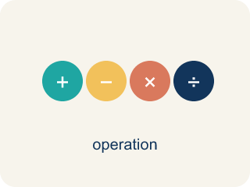
Divide Mixed Numbers (Dividir números mixtos) — Change mixed numbers to improper fractions, then multiply by the reciprocal.
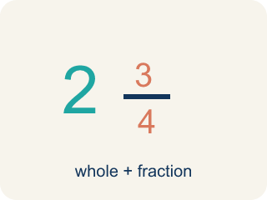
Mixed Number (Número mixto) — A whole number plus a fraction, like 2 1/3.
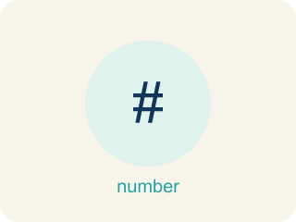
Fraction Division Problem Solving (Resolución de problemas de división de fracciones) — Use fraction division to find an unknown number of groups or the size of each group.
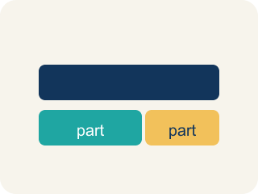
Model (Modelo) — A picture or math way to show a problem so you can solve it.
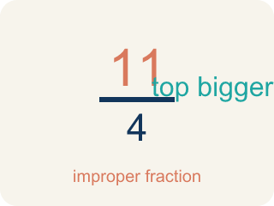
Improper Fraction (Fracción impropia) — A fraction where the top is bigger than or equal to the bottom, like 7/4.
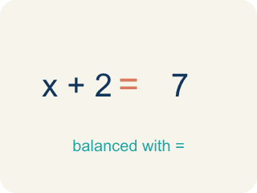
Equation (Ecuación) — A math sentence with an equal sign showing both sides are the same.

Practice
Show your work. Use the blank space under each problem.
1. (Lesson 2.4) What is 1 1/2 ÷ 3/4?
A. 2
B. 1 1/8
C. 3/4
D. 9/8
______________________________________________________________________
2. (Lesson 2.4) Convert 3 2/5 to an improper fraction.
A. 17/5
B. 15/5
C. 6/5
D. 32/5
______________________________________________________________________
3. (Lesson 2.4) A baker has 2 1/4 cups of butter. Each batch of cookies needs 3/4 cup of butter. How many batches can the baker make?
A. 3 batches
B. 1 1/2 batches
C. 2 batches
D. 6 batches
______________________________________________________________________
4. (Lesson 2.4) Spot the Common Mistake
Step 1 (Problem): 3 1/3 ÷ 2/3
Step 2 (Keep, Change, Flip (skipped converting)): 3 1/3 × 3/2
Step 3 (Multiply the fraction part only): 1/3 × 3/2 = 3/6 = 1/2
Step 4 (Combine with the whole): 3 + 1/2 = 3 1/2
Which step has the mistake? Explain and fix it:
______________________________________________________________________
______________________________________________________________________
______________________________________________________________________
5. (Lesson 2.5) Marcus solved 2/3 ÷ 1/4 and got 8/3 = 2 2/3. He says 'That can't be right because I started with less than 1.' Is Marcus's math correct? Is his reasoning correct?
A. His math is correct (2 2/3), but his reasoning is wrong — dividing by a small fraction gives a larger result
B. His math and reasoning are both correct — the answer should be less than 1
C. His math is wrong — the answer should be 1/6
D. His math is wrong — the answer should be 8/12
______________________________________________________________________
6. (Lesson 2.5) Spot the Common Mistake
Step 1 (Problem): A chemist has 3/4 liter of solution. Each test tube holds 1/8 liter. How many test tubes can be filled?
Step 2 (Student's equation): 3/4 ÷ 1/8 = 3/4 × 1/8
Step 3 (Solve): 3/4 × 1/8 = 3/32
Step 4 (Answer): 3/32 of a test tube
Which step has the mistake? Explain and fix it:
______________________________________________________________________
______________________________________________________________________
______________________________________________________________________
7. (Lesson 2.4) Mission 1: The stakeout shift is 4 1/2 hours long. Each agent covers a 1 1/2-hour watch. How many agent watches fill one shift?
A. 3
B. 6
C. 2 1/2
D. 4 1/2
______________________________________________________________________
8. (Lesson 2.5) Room 1 — Evidence Locker: Agent Torres has 7/8 pound of casting clay to lift footprints. Each cast uses 1/8 pound. How many casts can she make to unlock the door?
A. 7
B. 6
C. 8
D. 1/7
______________________________________________________________________

Answer Key (Teacher)
1. A. 2
1 1/2 = 3/2. Then 3/2 ÷ 3/4 = 3/2 × 4/3 = 12/6 = 2.
Watch for: A common mistake in Fraction Division Problem Solving is reversing which fraction is the dividend and which is the divisor when setting up the equation from a word problem. For example: a pitcher holds 3/4 cup of punch, and each serving is 1/8 cup — how many servings? The correct setup is total ÷ group size = 3/4 ÷ 1/8 = 3/4 × 8/1 = 24/4 = 6 servings. A student who reverses the setup calculates 1/8 ÷ 3/4 = 1/8 × 4/3 = 4/24 = 1/6, an answer smaller than 1 that can't possibly be a serving count. Before you submit, check: does my answer make sense as a NUMBER OF GROUPS? If the setup gives a fraction less than 1 for a 'how many' question, you likely swapped the dividend and divisor.
2. A. 17/5
3 × 5 = 15, then 15 + 2 = 17. So 3 2/5 = 17/5.
Watch for: A common mistake in Fraction Division Problem Solving is reversing which fraction is the dividend and which is the divisor when setting up the equation from a word problem. For example: a pitcher holds 3/4 cup of punch, and each serving is 1/8 cup — how many servings? The correct setup is total ÷ group size = 3/4 ÷ 1/8 = 3/4 × 8/1 = 24/4 = 6 servings. A student who reverses the setup calculates 1/8 ÷ 3/4 = 1/8 × 4/3 = 4/24 = 1/6, an answer smaller than 1 that can't possibly be a serving count. Before you submit, check: does my answer make sense as a NUMBER OF GROUPS? If the setup gives a fraction less than 1 for a 'how many' question, you likely swapped the dividend and divisor.
3. A. 3 batches
Convert 2 1/4 = 9/4. Then 2 1/4 ÷ 3/4 = 9/4 × 4/3 = 36/12 = 3 batches.
Watch for: A common mistake in Fraction Division Problem Solving is reversing which fraction is the dividend and which is the divisor when setting up the equation from a word problem. For example: a pitcher holds 3/4 cup of punch, and each serving is 1/8 cup — how many servings? The correct setup is total ÷ group size = 3/4 ÷ 1/8 = 3/4 × 8/1 = 24/4 = 6 servings. A student who reverses the setup calculates 1/8 ÷ 3/4 = 1/8 × 4/3 = 4/24 = 1/6, an answer smaller than 1 that can't possibly be a serving count. Before you submit, check: does my answer make sense as a NUMBER OF GROUPS? If the setup gives a fraction less than 1 for a 'how many' question, you likely swapped the dividend and divisor.
4. (Lesson 2.4) Spot the Common Mistake
The mistake is in Step 2.
Correct work: The student divided before converting the mixed number. First convert: 3 1/3 = 10/3. Then 10/3 ÷ 2/3 = 10/3 × 3/2 = 30/6 = 5, not 3 1/2.
Watch for: The break happens at the second step: the student jumped straight to Keep, Change, Flip while 3 1/3 was still a mixed number, then multiplied only the fraction part. Convert first — 3 1/3 = 10/3 — then 10/3 × 3/2 = 30/6 = 5, not 3 1/2.
5. A. His math is correct (2 2/3), but his reasoning is wrong — dividing by a small fraction gives a larger result
2/3 ÷ 1/4 = 2/3 × 4/1 = 8/3 = 2 2/3. This IS correct. When you divide by a number less than 1, the quotient is greater than the dividend.
Watch for: A common mistake in Fraction Division Problem Solving is reversing which fraction is the dividend and which is the divisor when setting up the equation from a word problem. For example: a pitcher holds 3/4 cup of punch, and each serving is 1/8 cup — how many servings? The correct setup is total ÷ group size = 3/4 ÷ 1/8 = 3/4 × 8/1 = 24/4 = 6 servings. A student who reverses the setup calculates 1/8 ÷ 3/4 = 1/8 × 4/3 = 4/24 = 1/6, an answer smaller than 1 that can't possibly be a serving count. Before you submit, check: does my answer make sense as a NUMBER OF GROUPS? If the setup gives a fraction less than 1 for a 'how many' question, you likely swapped the dividend and divisor.
6. (Lesson 2.5) Spot the Common Mistake
The mistake is in Step 2.
Correct work: The student set up the division correctly but forgot to flip the divisor. Keep, Change, Flip means multiply by the reciprocal of 1/8, which is 8/1: 3/4 ÷ 1/8 = 3/4 × 8/1 = 24/4 = 6 test tubes. Check: 6 × 1/8 = 6/8 = 3/4.
Watch for: The setup 3/4 ÷ 1/8 was right, but the divisor was never flipped. Keep-Change-Flip means multiplying by the reciprocal of 1/8, which is 8/1: 3/4 × 8/1 = 24/4 = 6 test tubes. Checking confirms it, since 6 × 1/8 = 6/8 = 3/4.
7. A. 3
4 1/2 = 9/2 and 1 1/2 = 3/2. So 9/2 ÷ 3/2 = 9/2 × 2/3 = 18/6 = 3 watches.
Watch for: A common mistake in Fraction Division Problem Solving is reversing which fraction is the dividend and which is the divisor when setting up the equation from a word problem. For example: a pitcher holds 3/4 cup of punch, and each serving is 1/8 cup — how many servings? The correct setup is total ÷ group size = 3/4 ÷ 1/8 = 3/4 × 8/1 = 24/4 = 6 servings. A student who reverses the setup calculates 1/8 ÷ 3/4 = 1/8 × 4/3 = 4/24 = 1/6, an answer smaller than 1 that can't possibly be a serving count. Before you submit, check: does my answer make sense as a NUMBER OF GROUPS? If the setup gives a fraction less than 1 for a 'how many' question, you likely swapped the dividend and divisor.
8. A. 7
The total (7/8 lb) is the dividend and each cast (1/8 lb) is the divisor: 7/8 ÷ 1/8 = 7/8 × 8/1 = 56/8 = 7 casts.
Watch for: A common mistake in Fraction Division Problem Solving is reversing which fraction is the dividend and which is the divisor when setting up the equation from a word problem. For example: a pitcher holds 3/4 cup of punch, and each serving is 1/8 cup — how many servings? The correct setup is total ÷ group size = 3/4 ÷ 1/8 = 3/4 × 8/1 = 24/4 = 6 servings. A student who reverses the setup calculates 1/8 ÷ 3/4 = 1/8 × 4/3 = 4/24 = 1/6, an answer smaller than 1 that can't possibly be a serving count. Before you submit, check: does my answer make sense as a NUMBER OF GROUPS? If the setup gives a fraction less than 1 for a 'how many' question, you likely swapped the dividend and divisor.

