6.11 Small Group · Group 1 — Homework
Lesson 6-11-group1 • Standard 6.NOS.1
Name: ______________________ Period: ______ Date: ____________

Today's Goals
Content: With my small group, I can solve real-world problems by writing and solving fraction division equations — one step at a time, with support.
Language: I can talk through each step out loud using a sentence frame and the lesson's key words.

Key Words
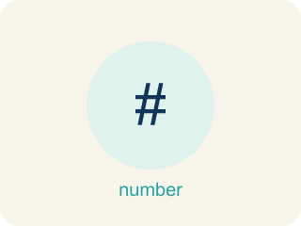
Fraction Division Problem Solving (Resolución de problemas de división de fracciones) — Use fraction division to find an unknown number of groups or the size of each group.
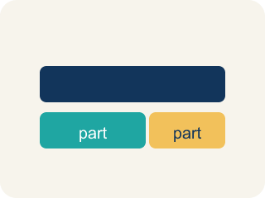
Model (Modelo) — A picture or math way to show a problem so you can solve it.
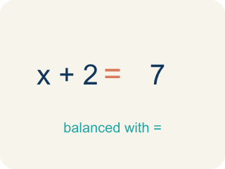
Equation (Ecuación) — A math sentence with an equal sign showing both sides are the same.

Solution (Solución) — A number that makes the equation or inequality true.
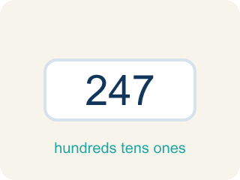
Reasonableness (Razonabilidad) — Checking if your answer makes sense.

Inverse operations (Operaciones inversas) — Two math actions that undo each other, like × and ÷.

Practice
Show your work. Use the blank space under each problem.
1. A ribbon is 4/5 of a yard long. Each bow uses 1/10 of a yard. Which equation finds how many bows can be made?
A. 4/5 ÷ 1/10
B. 1/10 ÷ 4/5
C. 4/5 × 1/10
D. 4/5 + 1/10
______________________________________________________________________
2. A detective has 1/2 gallon of solution. Each test uses 1/8 gallon. How many tests can be run?
A. 4
B. 1/16
C. 16
D. 1/4
______________________________________________________________________
3. Room 1 — Evidence Locker: Agent Torres has 7/8 pound of casting clay to lift footprints. Each cast uses 1/8 pound. How many casts can she make to unlock the door?
A. 7
B. 6
C. 8
D. 1/7
______________________________________________________________________
4. Room 2 — Surveillance Map: A suspect's trail is 5/6 of a mile. Hidden checkpoints are spaced every 1/6 of a mile. How many checkpoints are on the trail?
A. 5
B. 6
C. 1/5
D. 4
______________________________________________________________________
5. Room 5 — Final Keypad: The vault key code equals the number of 3/10-liter vials Torres can fill from a 9/10-liter bottle of fingerprint solution. What is the code?
A. 3
B. 9
C. 1/3
D. 6
______________________________________________________________________
6. Level 2 Extension — Escape the Wrong Operation
Step 1 (Problem): A tank holds 4/5 gallon of testing fluid. Each test uses 1/10 gallon. How many tests can be run to escape the lab?
Step 2 (Student's equation): 4/5 × 1/10
Step 3 (Solve): 4/5 × 1/10 = 4/50 = 2/25
Step 4 (Answer): 2/25 of a test
Which step has the mistake? Explain and fix it:
______________________________________________________________________
______________________________________________________________________
______________________________________________________________________
7. Find the Problem-Solving Error
Step 1 (Problem): A tank has 3/4 gallon of water. Each bucket holds 1/6 gallon. How many buckets can be filled?
Step 2 (Student's equation): 1/6 ÷ 3/4
Step 3 (Solve): 1/6 × 4/3 = 4/18 = 2/9
Step 4 (Answer): 2/9 buckets
Which step has the mistake? Explain and fix it:
______________________________________________________________________
______________________________________________________________________
______________________________________________________________________
8. Write your own fraction division word problem where the answer is 8. Then show the equation, solve it step by step, and explain how you know your answer is reasonable.
Sentence starter: My word problem: ___. The equation is ___ ÷ ___ = ___. I solved it using KCF: ___ × ___ = ___. The answer 8 is reasonable because ___.
______________________________________________________________________
______________________________________________________________________
______________________________________________________________________
______________________________________________________________________

Answer Key (Teacher)
1. A. 4/5 ÷ 1/10
The total (4/5 yard) is divided into groups of 1/10 yard each. The equation is 4/5 ÷ 1/10 = 4/5 × 10/1 = 40/5 = 8 bows.
Watch for: A common mistake in Fraction Division Problem Solving is reversing which fraction is the dividend and which is the divisor when setting up the equation from a word problem. For example: a pitcher holds 3/4 cup of punch, and each serving is 1/8 cup — how many servings? The correct setup is total ÷ group size = 3/4 ÷ 1/8 = 3/4 × 8/1 = 24/4 = 6 servings. A student who reverses the setup calculates 1/8 ÷ 3/4 = 1/8 × 4/3 = 4/24 = 1/6, an answer smaller than 1 that can't possibly be a serving count. Before you submit, check: does my answer make sense as a NUMBER OF GROUPS? If the setup gives a fraction less than 1 for a 'how many' question, you likely swapped the dividend and divisor.
2. A. 4
1/2 ÷ 1/8 = 1/2 × 8/1 = 8/2 = 4 tests.
Watch for: A common mistake in Fraction Division Problem Solving is reversing which fraction is the dividend and which is the divisor when setting up the equation from a word problem. For example: a pitcher holds 3/4 cup of punch, and each serving is 1/8 cup — how many servings? The correct setup is total ÷ group size = 3/4 ÷ 1/8 = 3/4 × 8/1 = 24/4 = 6 servings. A student who reverses the setup calculates 1/8 ÷ 3/4 = 1/8 × 4/3 = 4/24 = 1/6, an answer smaller than 1 that can't possibly be a serving count. Before you submit, check: does my answer make sense as a NUMBER OF GROUPS? If the setup gives a fraction less than 1 for a 'how many' question, you likely swapped the dividend and divisor.
3. A. 7
The total (7/8 lb) is the dividend and each cast (1/8 lb) is the divisor: 7/8 ÷ 1/8 = 7/8 × 8/1 = 56/8 = 7 casts.
Watch for: A common mistake in Fraction Division Problem Solving is reversing which fraction is the dividend and which is the divisor when setting up the equation from a word problem. For example: a pitcher holds 3/4 cup of punch, and each serving is 1/8 cup — how many servings? The correct setup is total ÷ group size = 3/4 ÷ 1/8 = 3/4 × 8/1 = 24/4 = 6 servings. A student who reverses the setup calculates 1/8 ÷ 3/4 = 1/8 × 4/3 = 4/24 = 1/6, an answer smaller than 1 that can't possibly be a serving count. Before you submit, check: does my answer make sense as a NUMBER OF GROUPS? If the setup gives a fraction less than 1 for a 'how many' question, you likely swapped the dividend and divisor.
4. A. 5
The total distance (5/6 mile) is the dividend and the checkpoint spacing (1/6 mile) is the divisor: 5/6 ÷ 1/6 = 5/6 × 6/1 = 30/6 = 5 checkpoints.
Watch for: A common mistake in Fraction Division Problem Solving is reversing which fraction is the dividend and which is the divisor when setting up the equation from a word problem. For example: a pitcher holds 3/4 cup of punch, and each serving is 1/8 cup — how many servings? The correct setup is total ÷ group size = 3/4 ÷ 1/8 = 3/4 × 8/1 = 24/4 = 6 servings. A student who reverses the setup calculates 1/8 ÷ 3/4 = 1/8 × 4/3 = 4/24 = 1/6, an answer smaller than 1 that can't possibly be a serving count. Before you submit, check: does my answer make sense as a NUMBER OF GROUPS? If the setup gives a fraction less than 1 for a 'how many' question, you likely swapped the dividend and divisor.
5. A. 3
The total (9/10 liter) is the dividend and each vial (3/10 liter) is the divisor: 9/10 ÷ 3/10 = 9/10 × 10/3 = 90/30 = 3 vials, so the code is 3.
Watch for: A common mistake in Fraction Division Problem Solving is reversing which fraction is the dividend and which is the divisor when setting up the equation from a word problem. For example: a pitcher holds 3/4 cup of punch, and each serving is 1/8 cup — how many servings? The correct setup is total ÷ group size = 3/4 ÷ 1/8 = 3/4 × 8/1 = 24/4 = 6 servings. A student who reverses the setup calculates 1/8 ÷ 3/4 = 1/8 × 4/3 = 4/24 = 1/6, an answer smaller than 1 that can't possibly be a serving count. Before you submit, check: does my answer make sense as a NUMBER OF GROUPS? If the setup gives a fraction less than 1 for a 'how many' question, you likely swapped the dividend and divisor.
6. Level 2 Extension — Escape the Wrong Operation
The mistake is in Step 2.
Correct work: The question asks how many 1/10-gallon groups fit into 4/5 gallon, so this is division, not multiplication. The equation should be 4/5 ÷ 1/10 = 4/5 × 10/1 = 40/5 = 8 tests.
Watch for: The question asks how many 1/10-gallon groups fit inside 4/5 gallon, which calls for division, not multiplication. Multiplying produced 2/25, less than a single test, which cannot be right. The correct equation is 4/5 ÷ 1/10 = 4/5 × 10/1 = 40/5 = 8 tests.
7. Find the Problem-Solving Error
The mistake is in Step 2.
Correct work: The equation should be 3/4 ÷ 1/6 (total ÷ group size). Then 3/4 × 6/1 = 18/4 = 4 1/2 buckets.
Watch for: The dividend and divisor are swapped. The 3/4 gallon is the total being split up and 1/6 gallon is one bucket, so the equation must be 3/4 ÷ 1/6 = 3/4 × 6/1 = 18/4 = 4 1/2 buckets. An answer of 2/9 of a bucket is a warning sign, since a 1/6-gallon bucket clearly fits inside 3/4 gallon more than once.
8. Open response — answers will vary.
Look for key words: divide, = 8, reasonable, word problem, equation, reciprocal.

