6.11 Small Group · Group 2 — Homework
Lesson 6-11-group2 • Standard 6.NOS.1
Name: ______________________ Period: ______ Date: ____________

Today's Goals
Content: I can solve real-world problems by writing and solving fraction division equations, explain what each part stands for, and build one for a situation I have not seen before.
Language: I can justify my answer to a skeptic and connect it to a second strategy or representation.

Key Words
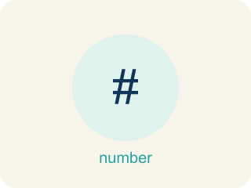
Fraction Division Problem Solving (Resolución de problemas de división de fracciones) — Use fraction division to find an unknown number of groups or the size of each group.
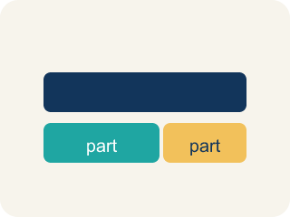
Model (Modelo) — A picture or math way to show a problem so you can solve it.
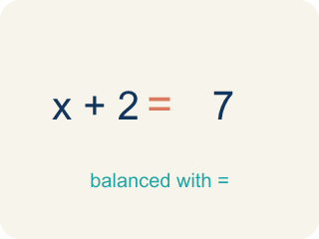
Equation (Ecuación) — A math sentence with an equal sign showing both sides are the same.

Solution (Solución) — A number that makes the equation or inequality true.
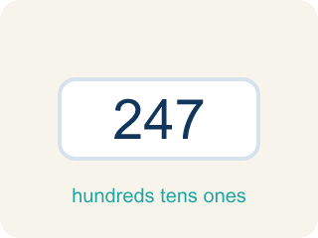
Reasonableness (Razonabilidad) — Checking if your answer makes sense.

Inverse operations (Operaciones inversas) — Two math actions that undo each other, like × and ÷.

Practice
Show your work. Use the blank space under each problem.
1. Marcus solved 2/3 ÷ 1/4 and got 8/3 = 2 2/3. He says 'That can't be right because I started with less than 1.' Is Marcus's math correct? Is his reasoning correct?
A. His math is correct (2 2/3), but his reasoning is wrong — dividing by a small fraction gives a larger result
B. His math and reasoning are both correct — the answer should be less than 1
C. His math is wrong — the answer should be 1/6
D. His math is wrong — the answer should be 8/12
______________________________________________________________________
2. Spot the Common Mistake
Step 1 (Problem): A chemist has 3/4 liter of solution. Each test tube holds 1/8 liter. How many test tubes can be filled?
Step 2 (Student's equation): 3/4 ÷ 1/8 = 3/4 × 1/8
Step 3 (Solve): 3/4 × 1/8 = 3/32
Step 4 (Answer): 3/32 of a test tube
Which step has the mistake? Explain and fix it:
______________________________________________________________________
______________________________________________________________________
______________________________________________________________________
3. Find the Problem-Solving Error
Step 1 (Problem): A tank has 3/4 gallon of water. Each bucket holds 1/6 gallon. How many buckets can be filled?
Step 2 (Student's equation): 1/6 ÷ 3/4
Step 3 (Solve): 1/6 × 4/3 = 4/18 = 2/9
Step 4 (Answer): 2/9 buckets
Which step has the mistake? Explain and fix it:
______________________________________________________________________
______________________________________________________________________
______________________________________________________________________
4. Write your own fraction division word problem where the answer is 8. Then show the equation, solve it step by step, and explain how you know your answer is reasonable.
Sentence starter: My word problem: ___. The equation is ___ ÷ ___ = ___. I solved it using KCF: ___ × ___ = ___. The answer 8 is reasonable because ___.
______________________________________________________________________
______________________________________________________________________
______________________________________________________________________
______________________________________________________________________

Answer Key (Teacher)
1. A. His math is correct (2 2/3), but his reasoning is wrong — dividing by a small fraction gives a larger result
2/3 ÷ 1/4 = 2/3 × 4/1 = 8/3 = 2 2/3. This IS correct. When you divide by a number less than 1, the quotient is greater than the dividend.
Watch for: A common mistake in Fraction Division Problem Solving is reversing which fraction is the dividend and which is the divisor when setting up the equation from a word problem. For example: a pitcher holds 3/4 cup of punch, and each serving is 1/8 cup — how many servings? The correct setup is total ÷ group size = 3/4 ÷ 1/8 = 3/4 × 8/1 = 24/4 = 6 servings. A student who reverses the setup calculates 1/8 ÷ 3/4 = 1/8 × 4/3 = 4/24 = 1/6, an answer smaller than 1 that can't possibly be a serving count. Before you submit, check: does my answer make sense as a NUMBER OF GROUPS? If the setup gives a fraction less than 1 for a 'how many' question, you likely swapped the dividend and divisor.
2. Spot the Common Mistake
The mistake is in Step 2.
Correct work: The student set up the division correctly but forgot to flip the divisor. Keep, Change, Flip means multiply by the reciprocal of 1/8, which is 8/1: 3/4 ÷ 1/8 = 3/4 × 8/1 = 24/4 = 6 test tubes. Check: 6 × 1/8 = 6/8 = 3/4.
Watch for: The setup 3/4 ÷ 1/8 was right, but the divisor was never flipped. Keep-Change-Flip means multiplying by the reciprocal of 1/8, which is 8/1: 3/4 × 8/1 = 24/4 = 6 test tubes. Checking confirms it, since 6 × 1/8 = 6/8 = 3/4.
3. Find the Problem-Solving Error
The mistake is in Step 2.
Correct work: The equation should be 3/4 ÷ 1/6 (total ÷ group size). Then 3/4 × 6/1 = 18/4 = 4 1/2 buckets.
Watch for: The dividend and divisor are swapped. The 3/4 gallon is the total being split up and 1/6 gallon is one bucket, so the equation must be 3/4 ÷ 1/6 = 3/4 × 6/1 = 18/4 = 4 1/2 buckets. An answer of 2/9 of a bucket is a warning sign, since a 1/6-gallon bucket clearly fits inside 3/4 gallon more than once.
4. Open response — answers will vary.
Look for key words: divide, = 8, reasonable, word problem, equation, reciprocal.

