1.1–1.3 Catch-Up — Homework
Lesson 6-12-catchup • Standard 6.NOS.4
Name: ______________________ Period: ______ Date: ____________

Today's Goals
Content: I can show I am caught up on Lessons 1.1–1.3 by using each lesson's big idea in mixed practice.
Language: I can explain which lesson's big idea I used and how, using key vocabulary from Lessons 1.1–1.3.

Key Words
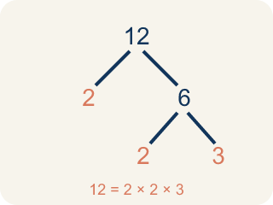
Prime Factorization (Factorización prima) — Writing a whole number as a product of only prime numbers.
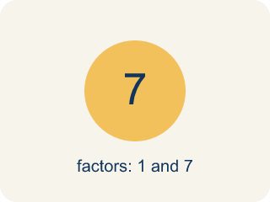
Prime number (Número primo) — A number bigger than 1 that you can only divide by 1 and itself.
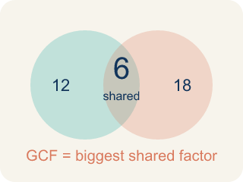
Greatest Common Factor (Máximo común divisor) — The greatest whole number that divides two or more numbers with no remainder.
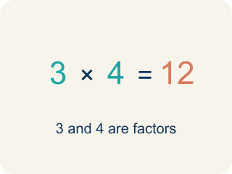
Factor (Factor) — A factor of a whole number divides it evenly, with no remainder. For example, 3 is a factor of 12 because 12 ÷ 3 = 4.
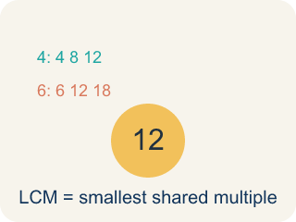
Least Common Multiple (Mínimo común múltiplo) — The least positive number that is a multiple of two or more numbers.
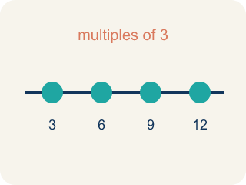
Multiple (Múltiplo) — What you get when you multiply a number by 1, 2, 3, and so on.
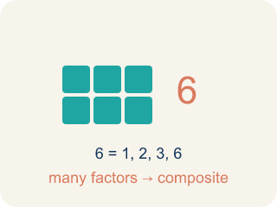
Composite number (Número compuesto) — A number bigger than 1 that you can divide by more than just 1 and itself.

Practice
Show your work. Use the blank space under each problem.
1. (Lesson 1.1) Which of the following is a prime number?
A. 17
B. 15
C. 21
D. 9
______________________________________________________________________
2. (Lesson 1.1) What is the prime factorization of 30?
A. 2 × 3 × 5
B. 5 × 6
C. 2 × 15
D. 3 × 10
______________________________________________________________________
3. (Lesson 1.1) Two students found different factor trees for 60. Student A started with 2 × 30. Student B started with 6 × 10. Which statement is true?
A. Both get the same prime factorization: 2 × 2 × 3 × 5
B. Only Student A gets the correct prime factorization
C. Only Student B gets the correct prime factorization
D. They will get different prime factorizations
______________________________________________________________________
4. (Lesson 1.1) Spot the Common Mistake
Step 1 (Find the prime factorization of 45, using exponents): Start: 45
Step 2 (First split): 45 = 5 × 9
Step 3 (Break down 9): 9 = 3 × 3, so 45 = 5 × 3 × 3
Step 4 (Write with exponents): 45 = 3² × 5²
Which step has the mistake? Explain and fix it:
______________________________________________________________________
______________________________________________________________________
______________________________________________________________________
5. (Lesson 1.2) A teacher has 36 pencils and 48 erasers. She wants to make identical supply bags with no items left over. What is the greatest number of bags she can make?
A. 12 bags
B. 6 bags
C. 4 bags
D. 36 bags
______________________________________________________________________
6. (Lesson 1.2) Spot the Common Mistake — GCF or LCM?
Step 1 (The problem): Find the GCF of 8 and 20.
Step 2 (List factors of 8): 1, 2, 4, 8
Step 3 (List factors of 20): 1, 2, 4, 5, 10, 20
Step 4 (Choose the answer): Jordan multiplies 8 × 20 = 160 and says the GCF of 8 and 20 is 160.
Which step has the mistake? Explain and fix it:
______________________________________________________________________
______________________________________________________________________
______________________________________________________________________
7. (Lesson 1.3) Two buses leave the station at 8:00 AM. Bus A returns every 15 minutes and Bus B returns every 20 minutes. When is the next time both buses are at the station together?
A. 9:00 AM (60 minutes later)
B. 8:30 AM (30 minutes later)
C. 8:40 AM (40 minutes later)
D. 9:20 AM (80 minutes later)
______________________________________________________________________
8. (Lesson 1.3) Spot Maya's Mistake — LCM of 6 and 9
Step 1 (Problem): Find the LCM of 6 and 9.
Step 2 (Multiples of 6): 6, 12, 18, 24
Step 3 (Multiples of 9): 9, 18, 27
Step 4 (Choose the answer): Maya saw that 9 is bigger than 6, so she wrote LCM = 9.
Which step has the mistake? Explain and fix it:
______________________________________________________________________
______________________________________________________________________
______________________________________________________________________
9. (Lesson 1.1) The first lock panel shows 90. What is the prime factorization of 90?
A. 2 × 3 × 3 × 5
B. 2 × 45
C. 9 × 10
D. 3 × 30
______________________________________________________________________
10. (Lesson 1.2) Mission Control must split 24 oxygen tanks and 36 ration packs into identical crew pods with none left over. What is the GCF of 24 and 36?
A. 12
B. 6
C. 8
D. 72
______________________________________________________________________

Answer Key (Teacher)
1. A. 17
17 has exactly two factors: 1 and 17. 15 = 3 × 5, 21 = 3 × 7, and 9 = 3 × 3, so they are all composite.
Watch for: A common mistake in Least Common Multiple is multiplying the two numbers together instead of listing multiples to find the smallest shared one. For example, for 4 and 6, a student calculates 4 × 6 = 24 and calls that the LCM, but the actual least common multiple is 12 (multiples of 4: 4, 8, 12; multiples of 6: 6, 12 — 12 is the first number that appears in both lists). This shortcut only works when the two numbers share no common factors (like 4 and 9, where the LCM really is 36 = 4 × 9); for numbers like 4 and 6 that share a factor of 2, multiplying overshoots the true LCM. Always list multiples of both numbers and pick the first one that appears in both lists.
2. A. 2 × 3 × 5
30 = 2 × 15 = 2 × 3 × 5. All three factors (2, 3, 5) are prime, so 2 × 3 × 5 is the prime factorization.
Watch for: A common mistake in Least Common Multiple is multiplying the two numbers together instead of listing multiples to find the smallest shared one. For example, for 4 and 6, a student calculates 4 × 6 = 24 and calls that the LCM, but the actual least common multiple is 12 (multiples of 4: 4, 8, 12; multiples of 6: 6, 12 — 12 is the first number that appears in both lists). This shortcut only works when the two numbers share no common factors (like 4 and 9, where the LCM really is 36 = 4 × 9); for numbers like 4 and 6 that share a factor of 2, multiplying overshoots the true LCM. Always list multiples of both numbers and pick the first one that appears in both lists.
3. A. Both get the same prime factorization: 2 × 2 × 3 × 5
The Fundamental Theorem of Arithmetic says every composite number has exactly one prime factorization. No matter how you start the factor tree, you always end with 2 × 2 × 3 × 5.
Watch for: A common mistake in Least Common Multiple is multiplying the two numbers together instead of listing multiples to find the smallest shared one. For example, for 4 and 6, a student calculates 4 × 6 = 24 and calls that the LCM, but the actual least common multiple is 12 (multiples of 4: 4, 8, 12; multiples of 6: 6, 12 — 12 is the first number that appears in both lists). This shortcut only works when the two numbers share no common factors (like 4 and 9, where the LCM really is 36 = 4 × 9); for numbers like 4 and 6 that share a factor of 2, multiplying overshoots the true LCM. Always list multiples of both numbers and pick the first one that appears in both lists.
4. (Lesson 1.1) Spot the Common Mistake
The mistake is in Step 4.
Correct work: 45 = 5 × 3 × 3 has one 5 and two 3's — not two 5's. The exponent on a prime factor shows how many times that factor appears, so the correct form is 45 = 3² × 5 (the 5 has no exponent shown because it appears only once).
Watch for: An exponent records how many times a prime appears, and the last step gave the 5 an exponent of 2 even though 45 = 3 × 3 × 5 contains only one 5. Two 3s and one 5 means the correct form is 45 = 3² × 5.
5. A. 12 bags
GCF(36, 48) = 12. She can make 12 bags, each with 3 pencils and 4 erasers.
Watch for: A common mistake in Least Common Multiple is multiplying the two numbers together instead of listing multiples to find the smallest shared one. For example, for 4 and 6, a student calculates 4 × 6 = 24 and calls that the LCM, but the actual least common multiple is 12 (multiples of 4: 4, 8, 12; multiples of 6: 6, 12 — 12 is the first number that appears in both lists). This shortcut only works when the two numbers share no common factors (like 4 and 9, where the LCM really is 36 = 4 × 9); for numbers like 4 and 6 that share a factor of 2, multiplying overshoots the true LCM. Always list multiples of both numbers and pick the first one that appears in both lists.
6. (Lesson 1.2) Spot the Common Mistake — GCF or LCM?
The mistake is in Step 4.
Correct work: Multiplying the two numbers does not give the GCF. The GCF is the largest factor the numbers SHARE. The common factors of 8 and 20 are 1, 2, and 4, so the GCF is 4 — and a factor can never be larger than the numbers themselves.
Watch for: Jordan multiplied 8 × 20 to get 160, but multiplying two numbers produces a common multiple, not a common factor. A factor of 8 can never be larger than 8 itself. The factors 8 and 20 share are 1, 2, and 4, so GCF(8, 20) = 4.
7. A. 9:00 AM (60 minutes later)
LCM(15, 20) = 60 minutes. Both buses return together 60 minutes after 8:00 AM, at 9:00 AM.
Watch for: A common mistake in Least Common Multiple is multiplying the two numbers together instead of listing multiples to find the smallest shared one. For example, for 4 and 6, a student calculates 4 × 6 = 24 and calls that the LCM, but the actual least common multiple is 12 (multiples of 4: 4, 8, 12; multiples of 6: 6, 12 — 12 is the first number that appears in both lists). This shortcut only works when the two numbers share no common factors (like 4 and 9, where the LCM really is 36 = 4 × 9); for numbers like 4 and 6 that share a factor of 2, multiplying overshoots the true LCM. Always list multiples of both numbers and pick the first one that appears in both lists.
8. (Lesson 1.3) Spot Maya's Mistake — LCM of 6 and 9
The mistake is in Step 4.
Correct work: The LCM is not just the larger number. Check: 9 is in the multiples of 9, but it is NOT in the multiples of 6 (6, 12, 18...). The first number in BOTH lists is 18, so the LCM of 6 and 9 is 18.
Watch for: In the last step Maya chose 9 just because it is the larger number, but 9 never appears in the multiples of 6 (6, 12, 18, 24). The LCM has to be in both lists, and the first number in both is 18, so the LCM of 6 and 9 is 18.
9. A. 2 × 3 × 3 × 5
90 = 2 × 45 = 2 × 9 × 5 = 2 × 3 × 3 × 5. Every factor is prime, so the lock accepts 2 × 3 × 3 × 5.
Watch for: A common mistake in Least Common Multiple is multiplying the two numbers together instead of listing multiples to find the smallest shared one. For example, for 4 and 6, a student calculates 4 × 6 = 24 and calls that the LCM, but the actual least common multiple is 12 (multiples of 4: 4, 8, 12; multiples of 6: 6, 12 — 12 is the first number that appears in both lists). This shortcut only works when the two numbers share no common factors (like 4 and 9, where the LCM really is 36 = 4 × 9); for numbers like 4 and 6 that share a factor of 2, multiplying overshoots the true LCM. Always list multiples of both numbers and pick the first one that appears in both lists.
10. A. 12
Factors of 24: 1, 2, 3, 4, 6, 8, 12, 24. Factors of 36: 1, 2, 3, 4, 6, 9, 12, 18, 36. The greatest shared factor is 12, so 12 pods can be filled equally.
Watch for: A common mistake in Least Common Multiple is multiplying the two numbers together instead of listing multiples to find the smallest shared one. For example, for 4 and 6, a student calculates 4 × 6 = 24 and calls that the LCM, but the actual least common multiple is 12 (multiples of 4: 4, 8, 12; multiples of 6: 6, 12 — 12 is the first number that appears in both lists). This shortcut only works when the two numbers share no common factors (like 4 and 9, where the LCM really is 36 = 4 × 9); for numbers like 4 and 6 that share a factor of 2, multiplying overshoots the true LCM. Always list multiples of both numbers and pick the first one that appears in both lists.

