6.13 Small Group · Group 1 — Homework
Lesson 6-13-group1 • Standard 6.NOS.4
Name: ______________________ Period: ______ Date: ____________

Today's Goals
Content: With my small group, I can write a number as a product of its prime factors using a factor tree — one step at a time, with support.
Language: I can talk through each step out loud using a sentence frame and the lesson's key words.

Key Words
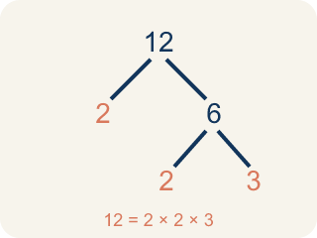
Prime Factorization (Factorización prima) — Writing a whole number as a product of only prime numbers.
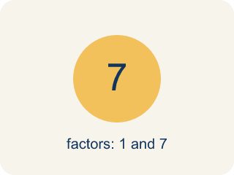
Prime number (Número primo) — A number bigger than 1 that you can only divide by 1 and itself.
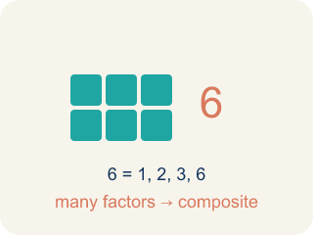
Composite number (Número compuesto) — A number bigger than 1 that you can divide by more than just 1 and itself.
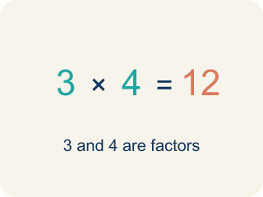
Factor (Factor) — A factor of a whole number divides it evenly, with no remainder. For example, 3 is a factor of 12 because 12 ÷ 3 = 4.

Factor tree (Árbol de factores) — A picture that splits a number into its prime numbers, step by step.
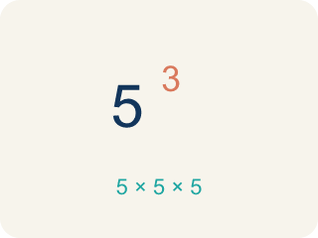
Exponent (Exponente) — A small number that tells how many times to multiply a number by itself.

Practice
Show your work. Use the blank space under each problem.
1. Which of the following is a prime number?
A. 17
B. 15
C. 21
D. 9
______________________________________________________________________
2. What is the prime factorization of 30?
A. 2 × 3 × 5
B. 5 × 6
C. 2 × 15
D. 3 × 10
______________________________________________________________________
3. The first lock panel shows 90. What is the prime factorization of 90?
A. 2 × 3 × 3 × 5
B. 2 × 45
C. 9 × 10
D. 3 × 30
______________________________________________________________________
4. The second panel needs a number whose prime factorization is 2² × 3². Which number unlocks it?
A. 36
B. 24
C. 12
D. 18
______________________________________________________________________
5. The final lock asks for the prime factorization of 78 written as a product of primes. Which is correct?
A. 2 × 3 × 13
B. 2 × 39
C. 3 × 26
D. 6 × 13
______________________________________________________________________
6. Level 2 Extension — Fix the Broken Factor Tree
Step 1 (Find prime factorization of 96): Start: 96
Step 2 (First split): 96 = 8 × 12
Step 3 (Break down 8): 8 = 2 × 2 × 2
Step 4 (Break down 12): 12 = 2 × 6
Step 5 (Final answer): 96 = 2 × 2 × 2 × 2 × 6
Which step has the mistake? Explain and fix it:
______________________________________________________________________
______________________________________________________________________
______________________________________________________________________
7. Find Marcus's Mistake
Step 1 (Find prime factorization of 48): Start: 48
Step 2 (First split): 48 = 6 × 8
Step 3 (Break down 6): 6 = 2 × 3
Step 4 (Break down 8): 8 = 2 × 4
Step 5 (Final answer): 48 = 2 × 3 × 2 × 4
Which step has the mistake? Explain and fix it:
______________________________________________________________________
______________________________________________________________________
______________________________________________________________________
8. Choose any two-digit composite number. Show TWO different factor trees that both lead to the same prime factorization. Explain why every composite number has only one prime factorization.
Sentence starter: I chose the number ___. My first factor tree starts with ___ × ___, and my second starts with ___ × ___. Both give the same prime factorization: ___. This happens because ___.
______________________________________________________________________
______________________________________________________________________
______________________________________________________________________
______________________________________________________________________

Answer Key (Teacher)
1. A. 17
17 has exactly two factors: 1 and 17. 15 = 3 × 5, 21 = 3 × 7, and 9 = 3 × 3, so they are all composite.
Watch for: A common mistake in Prime Factorization is stopping the factor tree too soon — leaving a composite number like 4, 6, 8, or 9 in the final answer instead of continuing to split it. For example, writing 20 = 4 × 5 as the prime factorization (4 is composite) instead of finishing with 20 = 2 × 2 × 5. Before you submit, check every number in your final answer: if any factor can still be broken into smaller factors, the tree isn't finished yet.
2. A. 2 × 3 × 5
30 = 2 × 15 = 2 × 3 × 5. All three factors (2, 3, 5) are prime, so 2 × 3 × 5 is the prime factorization.
Watch for: A common mistake in Prime Factorization is stopping the factor tree too soon — leaving a composite number like 4, 6, 8, or 9 in the final answer instead of continuing to split it. For example, writing 20 = 4 × 5 as the prime factorization (4 is composite) instead of finishing with 20 = 2 × 2 × 5. Before you submit, check every number in your final answer: if any factor can still be broken into smaller factors, the tree isn't finished yet.
3. A. 2 × 3 × 3 × 5
90 = 2 × 45 = 2 × 9 × 5 = 2 × 3 × 3 × 5. Every factor is prime, so the lock accepts 2 × 3 × 3 × 5.
Watch for: A common mistake in Prime Factorization is stopping the factor tree too soon — leaving a composite number like 4, 6, 8, or 9 in the final answer instead of continuing to split it. For example, writing 20 = 4 × 5 as the prime factorization (4 is composite) instead of finishing with 20 = 2 × 2 × 5. Before you submit, check every number in your final answer: if any factor can still be broken into smaller factors, the tree isn't finished yet.
4. A. 36
2² × 3² = 4 × 9 = 36, so 36 is the code for this panel.
Watch for: A common mistake in Prime Factorization is stopping the factor tree too soon — leaving a composite number like 4, 6, 8, or 9 in the final answer instead of continuing to split it. For example, writing 20 = 4 × 5 as the prime factorization (4 is composite) instead of finishing with 20 = 2 × 2 × 5. Before you submit, check every number in your final answer: if any factor can still be broken into smaller factors, the tree isn't finished yet.
5. A. 2 × 3 × 13
78 = 2 × 39 = 2 × 3 × 13. All three factors are prime, so 2 × 3 × 13 unlocks the final panel.
Watch for: A common mistake in Prime Factorization is stopping the factor tree too soon — leaving a composite number like 4, 6, 8, or 9 in the final answer instead of continuing to split it. For example, writing 20 = 4 × 5 as the prime factorization (4 is composite) instead of finishing with 20 = 2 × 2 × 5. Before you submit, check every number in your final answer: if any factor can still be broken into smaller factors, the tree isn't finished yet.
6. Level 2 Extension — Fix the Broken Factor Tree
The mistake is in Step 4.
Correct work: 12 = 2 × 6, but 6 is not prime. 6 = 2 × 3, so 12 = 2 × 2 × 3. The complete prime factorization is 96 = 2 × 2 × 2 × 2 × 2 × 3 = 2⁵ × 3.
Watch for: The 12 branch stopped while 6 was still composite: 6 = 2 × 3, so 12 = 2 × 2 × 3, not 2 × 6. Finishing that branch gives 96 = 2 × 2 × 2 × 2 × 2 × 3 = 2⁵ × 3.
7. Find Marcus's Mistake
The mistake is in Step 4.
Correct work: 8 = 2 × 4, but 4 is not prime. 4 = 2 × 2, so 8 = 2 × 2 × 2. The correct prime factorization is 48 = 2 × 2 × 2 × 2 × 3 = 2⁴ × 3.
Watch for: Marcus stopped the 8 branch while a composite factor was still in it: 4 is not prime because 4 = 2 × 2, so 8 = 2 × 2 × 2, not 2 × 4. Finishing that branch gives 48 = 2 × 2 × 2 × 2 × 3 = 2⁴ × 3.
8. Open response — answers will vary.
Look for key words: factor tree, prime factorization, same, only one, composite, break down.

