6.13 Small Group · Group 2 — Homework
Lesson 6-13-group2 • Standard 6.NOS.4
Name: ______________________ Period: ______ Date: ____________

Today's Goals
Content: I can write a number as a product of its prime factors using a factor tree, explain what each part stands for, and build one for a situation I have not seen before.
Language: I can justify my answer to a skeptic and connect it to a second strategy or representation.

Key Words
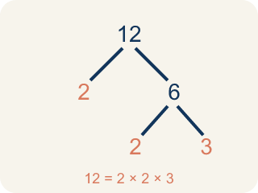
Prime Factorization (Factorización prima) — Writing a whole number as a product of only prime numbers.
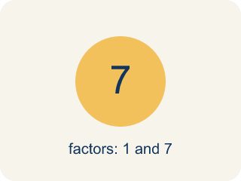
Prime number (Número primo) — A number bigger than 1 that you can only divide by 1 and itself.
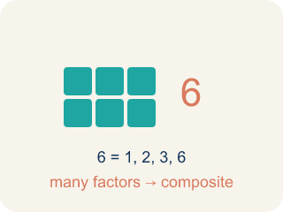
Composite number (Número compuesto) — A number bigger than 1 that you can divide by more than just 1 and itself.
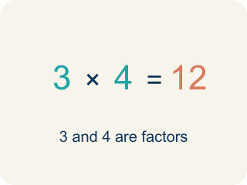
Factor (Factor) — A factor of a whole number divides it evenly, with no remainder. For example, 3 is a factor of 12 because 12 ÷ 3 = 4.

Factor tree (Árbol de factores) — A picture that splits a number into its prime numbers, step by step.
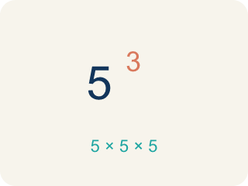
Exponent (Exponente) — A small number that tells how many times to multiply a number by itself.

Practice
Show your work. Use the blank space under each problem.
1. Two students found different factor trees for 60. Student A started with 2 × 30. Student B started with 6 × 10. Which statement is true?
A. Both get the same prime factorization: 2 × 2 × 3 × 5
B. Only Student A gets the correct prime factorization
C. Only Student B gets the correct prime factorization
D. They will get different prime factorizations
______________________________________________________________________
2. Spot the Common Mistake
Step 1 (Find the prime factorization of 45, using exponents): Start: 45
Step 2 (First split): 45 = 5 × 9
Step 3 (Break down 9): 9 = 3 × 3, so 45 = 5 × 3 × 3
Step 4 (Write with exponents): 45 = 3² × 5²
Which step has the mistake? Explain and fix it:
______________________________________________________________________
______________________________________________________________________
______________________________________________________________________
3. Find Marcus's Mistake
Step 1 (Find prime factorization of 48): Start: 48
Step 2 (First split): 48 = 6 × 8
Step 3 (Break down 6): 6 = 2 × 3
Step 4 (Break down 8): 8 = 2 × 4
Step 5 (Final answer): 48 = 2 × 3 × 2 × 4
Which step has the mistake? Explain and fix it:
______________________________________________________________________
______________________________________________________________________
______________________________________________________________________
4. Choose any two-digit composite number. Show TWO different factor trees that both lead to the same prime factorization. Explain why every composite number has only one prime factorization.
Sentence starter: I chose the number ___. My first factor tree starts with ___ × ___, and my second starts with ___ × ___. Both give the same prime factorization: ___. This happens because ___.
______________________________________________________________________
______________________________________________________________________
______________________________________________________________________
______________________________________________________________________

Answer Key (Teacher)
1. A. Both get the same prime factorization: 2 × 2 × 3 × 5
The Fundamental Theorem of Arithmetic says every composite number has exactly one prime factorization. No matter how you start the factor tree, you always end with 2 × 2 × 3 × 5.
Watch for: A common mistake in Prime Factorization is stopping the factor tree too soon — leaving a composite number like 4, 6, 8, or 9 in the final answer instead of continuing to split it. For example, writing 20 = 4 × 5 as the prime factorization (4 is composite) instead of finishing with 20 = 2 × 2 × 5. Before you submit, check every number in your final answer: if any factor can still be broken into smaller factors, the tree isn't finished yet.
2. Spot the Common Mistake
The mistake is in Step 4.
Correct work: 45 = 5 × 3 × 3 has one 5 and two 3's — not two 5's. The exponent on a prime factor shows how many times that factor appears, so the correct form is 45 = 3² × 5 (the 5 has no exponent shown because it appears only once).
Watch for: An exponent records how many times a prime appears, and the last step gave the 5 an exponent of 2 even though 45 = 3 × 3 × 5 contains only one 5. Two 3s and one 5 means the correct form is 45 = 3² × 5.
3. Find Marcus's Mistake
The mistake is in Step 4.
Correct work: 8 = 2 × 4, but 4 is not prime. 4 = 2 × 2, so 8 = 2 × 2 × 2. The correct prime factorization is 48 = 2 × 2 × 2 × 2 × 3 = 2⁴ × 3.
Watch for: Marcus stopped the 8 branch while a composite factor was still in it: 4 is not prime because 4 = 2 × 2, so 8 = 2 × 2 × 2, not 2 × 4. Finishing that branch gives 48 = 2 × 2 × 2 × 2 × 3 = 2⁴ × 3.
4. Open response — answers will vary.
Look for key words: factor tree, prime factorization, same, only one, composite, break down.

