Prime Factorization — Homework
Lesson 6-13 • Standard 6.NOS.4
Name: ______________________ Period: ______ Date: ____________

Today's Goals
Content: I can write a number as a product of its prime factors using a factor tree.
Language: I can explain how I broke a number down using the words prime number, composite number, factor, and exponent.

Key Words
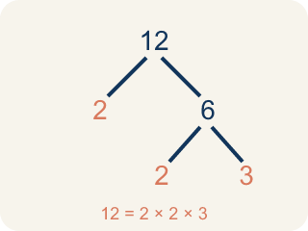
Prime Factorization (Factorización prima) — Writing a whole number as a product of only prime numbers.
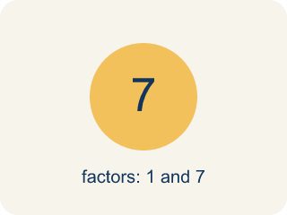
Prime number (Número primo) — A number bigger than 1 that you can only divide by 1 and itself.
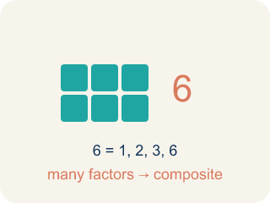
Composite number (Número compuesto) — A number bigger than 1 that you can divide by more than just 1 and itself.
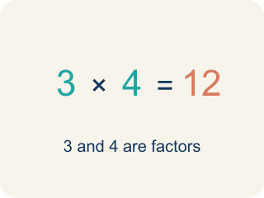
Factor (Factor) — A factor of a whole number divides it evenly, with no remainder. For example, 3 is a factor of 12 because 12 ÷ 3 = 4.

Factor tree (Árbol de factores) — A picture that splits a number into its prime numbers, step by step.
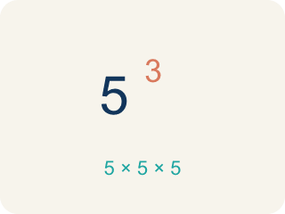
Exponent (Exponente) — A small number that tells how many times to multiply a number by itself.

Practice
Show your work. Use the blank space under each problem.
1. Which of the following is a prime number?
A. 17
B. 15
C. 21
D. 9
______________________________________________________________________
2. What is the prime factorization of 30?
A. 2 × 3 × 5
B. 5 × 6
C. 2 × 15
D. 3 × 10
______________________________________________________________________
3. Match each number to its prime factorization.
Item | Answer choices
____ 12 | F. 2 × 5 × 5
____ 18 | E. 3 × 3 × 5
____ 20 | D. 2 × 2 × 7
____ 28 | C. 2 × 2 × 5
____ 45 | B. 2 × 3 × 3
____ 50 | A. 2 × 2 × 3
______________________________________________________________________
4. Build the factor tree. Write each number as a product of primes.
Number | First Split | Prime Factorization
24 | 4 × 6
36 | 4 × 9
40 | 5 × 8
56 | 7 × 8
______________________________________________________________________
5. Sort each number: can it be expressed as a product of exactly TWO prime factors, or does it need THREE or more?
Groups: Product of Exactly Two Primes | Product of Three or More Primes
• 6 (= 2 × 3) → __________________
• 10 (= 2 × 5) → __________________
• 15 (= 3 × 5) → __________________
• 35 (= 5 × 7) → __________________
• 12 (= 2 × 2 × 3) → __________________
• 30 (= 2 × 3 × 5) → __________________
• 24 (= 2 × 2 × 2 × 3) → __________________
• 60 (= 2 × 2 × 3 × 5) → __________________
______________________________________________________________________
6. Two students found different factor trees for 60. Student A started with 2 × 30. Student B started with 6 × 10. Which statement is true?
A. Both get the same prime factorization: 2 × 2 × 3 × 5
B. Only Student A gets the correct prime factorization
C. Only Student B gets the correct prime factorization
D. They will get different prime factorizations
______________________________________________________________________
7. Spot the Common Mistake
Step 1 (Find the prime factorization of 45, using exponents): Start: 45
Step 2 (First split): 45 = 5 × 9
Step 3 (Break down 9): 9 = 3 × 3, so 45 = 5 × 3 × 3
Step 4 (Write with exponents): 45 = 3² × 5²
Which step has the mistake? Explain and fix it:
______________________________________________________________________
______________________________________________________________________
______________________________________________________________________
8. The first lock panel shows 90. What is the prime factorization of 90?
A. 2 × 3 × 3 × 5
B. 2 × 45
C. 9 × 10
D. 3 × 30
______________________________________________________________________
9. The second panel needs a number whose prime factorization is 2² × 3². Which number unlocks it?
A. 36
B. 24
C. 12
D. 18
______________________________________________________________________
10. Sort the station ID numbers: drag each one into PRIME (only 1 and itself) or COMPOSITE (more than two factors) to clear the scanner.
Groups: Prime Numbers | Composite Numbers
• 19 → __________________
• 37 → __________________
• 41 → __________________
• 63 → __________________
• 44 → __________________
• 99 → __________________
______________________________________________________________________

Answer Key (Teacher)
1. A. 17
17 has exactly two factors: 1 and 17. 15 = 3 × 5, 21 = 3 × 7, and 9 = 3 × 3, so they are all composite.
Watch for: A common mistake in Prime Factorization is stopping the factor tree too soon — leaving a composite number like 4, 6, 8, or 9 in the final answer instead of continuing to split it. For example, writing 20 = 4 × 5 as the prime factorization (4 is composite) instead of finishing with 20 = 2 × 2 × 5. Before you submit, check every number in your final answer: if any factor can still be broken into smaller factors, the tree isn't finished yet.
2. A. 2 × 3 × 5
30 = 2 × 15 = 2 × 3 × 5. All three factors (2, 3, 5) are prime, so 2 × 3 × 5 is the prime factorization.
Watch for: A common mistake in Prime Factorization is stopping the factor tree too soon — leaving a composite number like 4, 6, 8, or 9 in the final answer instead of continuing to split it. For example, writing 20 = 4 × 5 as the prime factorization (4 is composite) instead of finishing with 20 = 2 × 2 × 5. Before you submit, check every number in your final answer: if any factor can still be broken into smaller factors, the tree isn't finished yet.
3. Matches:
12 → 2 × 2 × 3
18 → 2 × 3 × 3
20 → 2 × 2 × 5
28 → 2 × 2 × 7
45 → 3 × 3 × 5
50 → 2 × 5 × 5

4. Build the factor tree. Write each number as a product of primes.
24 → 2 × 2 × 2 × 3
36 → 2 × 2 × 3 × 3
40 → 2 × 2 × 2 × 5
56 → 2 × 2 × 2 × 7

5. Correct groups:
6 (= 2 × 3) → Product of Exactly Two Primes
10 (= 2 × 5) → Product of Exactly Two Primes
15 (= 3 × 5) → Product of Exactly Two Primes
35 (= 5 × 7) → Product of Exactly Two Primes
12 (= 2 × 2 × 3) → Product of Three or More Primes
30 (= 2 × 3 × 5) → Product of Three or More Primes
24 (= 2 × 2 × 2 × 3) → Product of Three or More Primes
60 (= 2 × 2 × 3 × 5) → Product of Three or More Primes

6. A. Both get the same prime factorization: 2 × 2 × 3 × 5
The Fundamental Theorem of Arithmetic says every composite number has exactly one prime factorization. No matter how you start the factor tree, you always end with 2 × 2 × 3 × 5.
Watch for: A common mistake in Prime Factorization is stopping the factor tree too soon — leaving a composite number like 4, 6, 8, or 9 in the final answer instead of continuing to split it. For example, writing 20 = 4 × 5 as the prime factorization (4 is composite) instead of finishing with 20 = 2 × 2 × 5. Before you submit, check every number in your final answer: if any factor can still be broken into smaller factors, the tree isn't finished yet.
7. Spot the Common Mistake
The mistake is in Step 4.
Correct work: 45 = 5 × 3 × 3 has one 5 and two 3's — not two 5's. The exponent on a prime factor shows how many times that factor appears, so the correct form is 45 = 3² × 5 (the 5 has no exponent shown because it appears only once).
Watch for: An exponent records how many times a prime appears, and the last step gave the 5 an exponent of 2 even though 45 = 3 × 3 × 5 contains only one 5. Two 3s and one 5 means the correct form is 45 = 3² × 5.
8. A. 2 × 3 × 3 × 5
90 = 2 × 45 = 2 × 9 × 5 = 2 × 3 × 3 × 5. Every factor is prime, so the lock accepts 2 × 3 × 3 × 5.
Watch for: A common mistake in Prime Factorization is stopping the factor tree too soon — leaving a composite number like 4, 6, 8, or 9 in the final answer instead of continuing to split it. For example, writing 20 = 4 × 5 as the prime factorization (4 is composite) instead of finishing with 20 = 2 × 2 × 5. Before you submit, check every number in your final answer: if any factor can still be broken into smaller factors, the tree isn't finished yet.
9. A. 36
2² × 3² = 4 × 9 = 36, so 36 is the code for this panel.
Watch for: A common mistake in Prime Factorization is stopping the factor tree too soon — leaving a composite number like 4, 6, 8, or 9 in the final answer instead of continuing to split it. For example, writing 20 = 4 × 5 as the prime factorization (4 is composite) instead of finishing with 20 = 2 × 2 × 5. Before you submit, check every number in your final answer: if any factor can still be broken into smaller factors, the tree isn't finished yet.
10. Correct groups:
19 → Prime Numbers
37 → Prime Numbers
41 → Prime Numbers
63 → Composite Numbers
44 → Composite Numbers
99 → Composite Numbers

